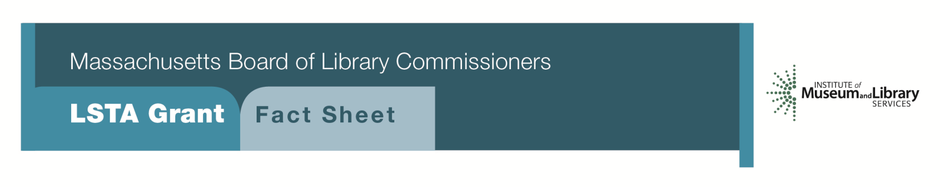
Anytime STEM Learning: Supporting Science, Technology, Engineering & Math in Libraries

PROGRAM DESCRIPTION
Libraries can offer science learning experiences that enrich the STEM learning ecosystem with grants up to $7500. Children are the center of a model that shapes and influences the pace of their learning based on their interests. Libraries offer hands-on, inquiry based experiential learning and connect STEM to everyday life outside of formal educational settings.
Two focus areas are:
“Full Steam Ahead” programs that target ages 0-5 should collaborate with local preschools and museums, local businesses, and others, as appropriate, to promote improved STEAM learning. Projects require at least eight science-based programs and include activity stations featuring simple STEAM topics. Additional activities might include creating a StoryWalk®, development of STEAM kits, LEGO contests, and science programming using outside performers. Projects should create an environment that engages the natural curiosity of young children to observe experiment, build, solve problems, make predictions and explore sequence, pattern and design. Adult caregivers will serve as facilitators but the emphasis is in allowing children to engage in activities that provide an ongoing foundation for brain development.
“Science is Everywhere” programs target kindergarten to grade eight and are appropriate for public or school libraries. Libraries will work with a science educator or person with appropriate skills to develop at least eight science-based programs. Libraries will coordinate activities with their public or school library counterpart. Libraries should look for support from museums, local business/industry as appropriate and could include providing specialized museum passes and outside programming.

Eligibility
Public libraries that meet standard eligibility requirements for Direct Grant programs are eligible to apply for the Anytime STEM Learning grant for up to $7,500. School libraries that have an approved plan on file and a certified school librarian as project director are eligible for the Science is Everywhere grant.

Libraries must have identified an interest in supporting science educational goals for preschool children (Pre-K) and/or language about STEM for the target population as part of their long range plan.
Interested?
Applicants submit a Letter of Intent form with the “Anytime STEM Learning ” option checked off. If you need more information about this program, call Shelley Quezada at the MBLC 1-800-952-7403 ext. 235 or email shelley.quezada@state.ma.us.

BACKGROUND
An explosion of out of formal school programs is taking place in settings such as local preschools, Boys and Girls clubs, YMCA/YWCA sites and in public libraries. These programs have a positive impact on youth development by enabling students to be introduced to project-based learning activities frequently missing from traditional school programs. Programs designed to meet our country’s future needs must begin in communities where young children are introduced at an early age to a range of opportunities that will promote the next generation of engineers and technologists. Early exposure to exciting career choices could also expand the number of women, minorities, and low-income students entering STEM professions. Library programs that support the importance of science and technology can help encourage an interest in these very important content areas.

Even the youngest children can take an early look at “frontier occupations” such as alternative energy, green transportation, biotechnology, nanotechnology, robotics, or aquaculture. Library programs can offer materials that help improve non-fiction reading and provide a place to explore hands-on STEM activities outside the classroom in a setting that is both fun and informative. The library may purchase and/or develop a selection of Kits on a range of topics including Legos or K’Nex models. Funds may be used to increase the collection of print and non-print materials that reflect STEM topics. The project may include one or more field trips to local museums, planetariums, or appropriate science institutions. Family programs featuring speakers on relevant STEM topics may also be offered to the wider community as part of this project.

2018-2022 Massachusetts Long Range Plan
GOAL 4 Building the Workforce
Project 2 STEM: Science Technology Engineering and Mathematics

