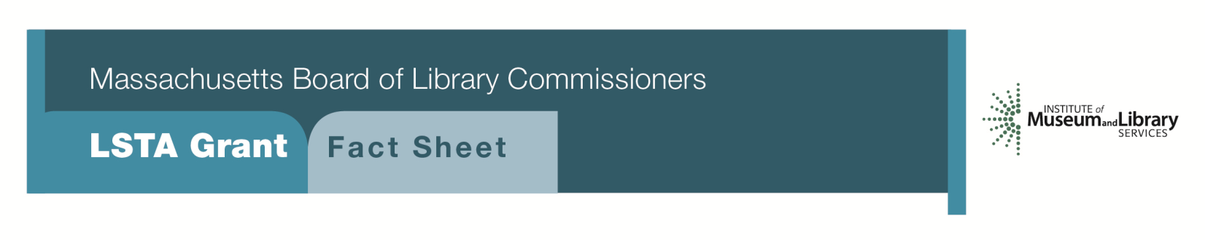
Town-Wide Preservation Assessment and Collection Identification

PROGRAM DESCRIPTION

This program, focusing on the preservation assessment of collections, is the first step in the process of preserving, arranging and describing, and eventually digitizing historically significant local collections in Massachusetts for access through the Digital Commonwealth, a non-profit collaborative organization that provides resources and services to support the creation, management, and dissemination of cultural heritage materials held by Massachusetts libraries, museums, historical societies, and archives (www.digitalcommonwealth.org). Through this program, the public library and other local repositories will receive a preservation assessment conducted by an MBLC-hired consultant, who will:

- Focus attention on preservation needs and identify the type of work that these might entail, including actual conservation treatment as well as storage, handling, and security suggestions.
- Help the staff determine the treatment priorities of those items in need of work and the steps necessary to accomplish it.
- Evaluate the buildings and make suggestions for steps to be taken to prolong the life of the materials, including environmental conditions and controls.
- Review policies and procedures for collection management, including collecting areas, donation of materials; methods of achieving intellectual control; preservation; accessioning and deaccessioning of collections; exhibition practices; and digitization guidelines as appropriate and make recommendations as to their revision or creation.
- Examine emergency preparedness and any existing disaster plans for collections.
- Review housekeeping and pest management practices and evaluate storage and handling practices for bound volumes, documents, manuscripts, photographic materials, and audiovisual materials.
- Assist in identifying collections of historical significance within the collecting areas of the repositories that would be in need of arrangement and description before they could become candidates for digitization and posting to Digital Commonwealth.
- Be available to answer questions and to assist in developing the Preservation Long-Range Plan(s).

- Provide a report to each repository, and if feasible and appropriate, one for the community’s repositories as a whole. The report will delineate the findings of the assessment and will provide short, medium, and long-term recommendations to improve the long-term viability of each repository’s collections. Actions may involve low cost/no cost steps or address significant issues such as building improvements or the installation of environmental controls.

A five-year Preservation Long-Range Plan for each participating institution (as well as one for the community as a whole, if feasible and appropriate) based on the recommendations of the consultant’s report(s), is required as an outcome of this grant. This plan should include Goals, Objectives, and Activities with a timeline and should address building concerns; storage, enclosures, and handling practices; environmental issues; emergency preparedness; preservation policy and planning; and in-house repairs, conservation treatments, and reformatting needs.

Having contracted for a preservation assessment, received the consultant’s report, and developed Preservation Long-Range Plans, the library and its partner organizations will position themselves to apply for grant funding to address the consultant’s recommendations. LSTA funds may be available to prepare the library’s collections for digitization, including arrangement and description, any necessary conservation work, and metadata creation. Further work and assistance for all participating institutions may be available through the State Historical Records Advisory Board’s (SHRAB) Roving Archivist program as well as from the Boston Public Library’s digitization program, which contributes to Digital Commonwealth. See www.sec.state.ma.us/arc/arcshrab/shrabidx.htm for details on the former.

Program Eligibility

Public libraries meeting the standard eligibility requirements for the Direct Grant programs may apply on behalf of the repositories in their community. All participating institutions must submit a letter of commitment as part of the application process. Once the project is underway, they will need to complete a Pre-Assessment Questionnaire provided by the consultants to be filed with the Board of Library Commissioners.

Priorities and Funding

Under this program, priority will be given to materials of local, state, regional, or national importance that contribute to an understanding of our historic and cultural heritage. Preference will be given to collections in the following order and subject areas: 1) collections documenting significant Massachusetts or local historical, geographical, cultural, economic, and natural developments and/or collections with direct application and relevance to Massachusetts or the local community; 2) unique collections representing resources unavailable in any other repository; and 3) collections located in Massachusetts repositories that provide a unique and/or cohesive resource, independent of subject area.

Interested?

Applicants must submit a Letter of Intent with “Town-Wide Preservation Assessment” option checked off. If you need more information about this program contact Gregor Trinkaus-Randall at the MBLC, 1-800-952-7403 x 236 or by email at gregor.trinkaus-randall@state.ma.us.

Background

The documentary heritage of Massachusetts is essentially intact from its founding. Throughout the Commonwealth, repositories house irreplaceable collections of books, as well as private and public documents that serve as a rich resource for researchers involved in local, state, regional, national, and international studies. The staffs of libraries, historical societies, municipal departments, museums, and other repositories have long collected materials that document their immediate and adjoining locales, as well as focusing on specific collecting areas. Although much of this material is monographs and pamphlets, a significant portion is manuscript material (town records, personal and organizational papers), photographs, posters, ticket stubs, broadsides, audio/visual materials, etc. Many of these collections are in need of conservation work to prolong their lives and to enable them to be handled. Moreover, many will not see the light of day without a special program to identify them, provide for their arrangement and description, identify their preservation and conservation needs, and digitize them to make them available for research. Furthermore, the staff of these institutions may not have the appropriate training to address these issues.

2018-2022 Massachusetts Long Range Plan Goal and Objective

Goal 6: Connecting Communities

