ONLINE FY2024
FINANCIAL REPORT and STATE AID COMPLIANCE FORM
The online Financial Report and State Aid Compliance form will be available to fill out on August 7, 2023 and will close on Friday, October 6, 2023.
Please note: The signature page and Compliance form PDF only must be printed out (see directions below), signed in pen by the Library Director and the Trustee Chair, scanned then sent as an attachment to uechi.ng@mass.gov . The final day to email the FY2024 Compliance form signature page is Friday, October 6, 2023.
Please observe the following:
- Enter data for FY2023, even if it is the same as FY2022 data.
- Enter zero only if the number is actually zero, otherwise leave blank.
- No need to enter N/A, just leave blank.
- Write a note whenever the edit check (variation in data from last year) pop-up appears. We rely on those notes for explanation so we do not have to give you a call. The edit check language will tell you where to write the note (Federal or State).
Questions? Contact Jen Inglis jennifer.inglis@mass.gov
or Mary Rose Quinn maryrose.quinn@mass.gov

Reminder:
No mailing paper forms

We will not be accepting paper forms again this year. Before you lock your forms in Collect, be sure to print out the signature page and Compliance form. Please have the library director and chairperson for the Trustees sign the form, scan and send to uechi.ng@mass.gov as an email attachment.

New This Year:

COVID19 Questions have been removed from the survey.

Summer Reading Program Questions

Summer Reading questions now include more age categories to mirror the age categories in the ARIS.

Instructions for filling out the Financial Report online
Login to the survey at:
https://collectconnect.baker-taylor.com/login.aspx

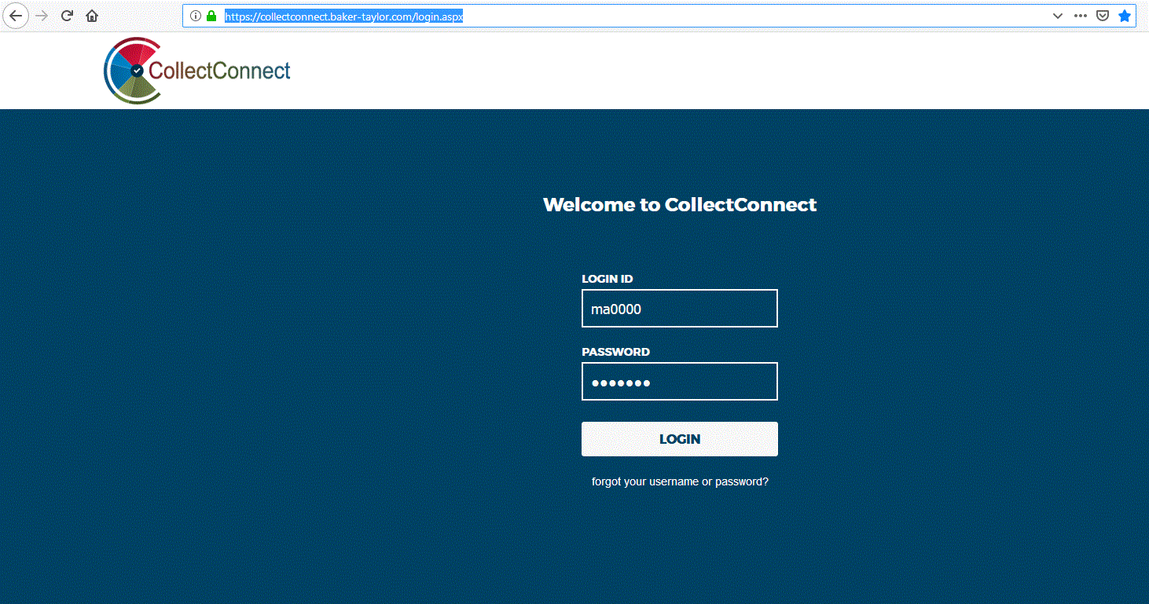
When you reach the login screen enter your username and password—This was sent to library directors in mid-June. You can also contact Jen Inglis, Uechi Ng, or Mary Rose Quinn if needed.

Click on “Login”.

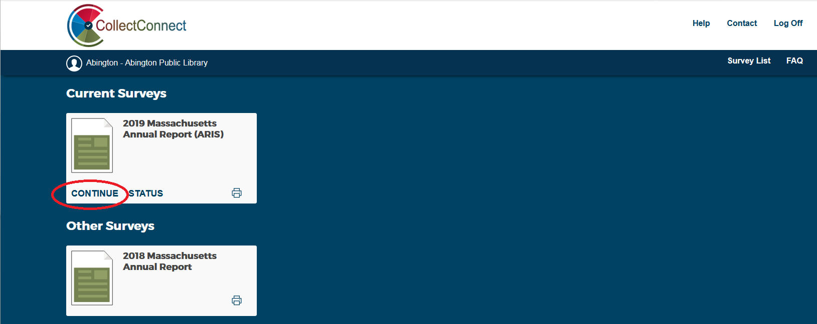

After entering the username and password you will see a set of surveys. Choose the “2024 Massachusetts Financial Report” and click on “Continue”.

- Enter data by using the Survey Navigation sidebar to access the questions section by section. Click on the “Save” button after each section.
- When you have finished entering all your data, click on “Show Status”. Show Status checks for any unanswered questions and required edit checks. Resolve any edit checks needed by providing an explanation in the appropriate note field. The edit check will indicate which field is to be used.
- You only need to print out the signature page and compliance form PDF. Please be sure to do this before you submit the form. You should keep a copy of the Financial Report and State Aid application for your own records.
- When all of your data has been checked, and you have printed out the Signature Page and PDF, you are ready to submit the form. Click on the Submit button. This will lock the survey. If you need it reopened, contact Jen Inglis or Uechi Ng at the MBLC.
- Please have the library director and chairperson for the Trustees sign the form, scan and send the signature page and Compliance Form PDF only to uechi.ng@mass.gov as an email attachment.
- In the same email, send a copy of official budget documentation that shows your FY2024 appropriation. Please total and highlight the library’s appropriation. Make sure it matches what you submitted!
- You are done!
Your library will receive a confirmation from Uechi when the signed copy is accepted by the MBLC.
Tips & Hints to Fill Out Online Forms:
Navigating the Form:
- Select the section to be filled out from the “Survey Navigation” column on the left side of the screen.
- Use the Next and Previous buttons to move through the form, one section at a time.
- Move from field to field on the form by clicking on a field. You can also use the Tab or Enter key to proceed through fields one at a time.
Data Entry
- Greyed out fields automatically total your data.
- A pop-up window will prompt you to explain why data may be out of usual range. Edit checks ensure that entered values are within a usual range (i.e. if $500,000,000 is entered instead of $50,000 for book expenditures). Please tell us WHY something has changes not just that the number is correct or that you have checked it. Make sure to put the information in the appropriate note.
- Data entry options are in a drop-down menu format (e.g. for yes/no questions).
- Information that doesn't change often, such as addresses and phone numbers, will be pre-filled. If you need to update your information and the field is locked, contact the MBLC to make changes for you.
- Previous year's data can be turned on and off using the “Show/Hide Last Year’s Data” button.
Add Notes to Questions
- Click on the note pad icon to the right of the question. There are three types of notes: Federal, State, Local
Federal notes are for the questions we send to IMLS to be included in the PLS survey.
State notes are asked for a couple of questions – Changes in NRC reporting or meeting room usage.
Local notes are where you can enter notes that may be helpful in answering that question in the future. For example, these notes might explain who keeps track of materials expenses or who provides benefits information, etc. Local notes carry over from the previous year.
- Make as many notes to yourself as needed.
- Notes should be used whenever the data changes significantly from year to year. Using notes to explain data prevents the MBLC from having to contact your library to verify if data is correct.
- Remember to “Show Status” before you “Submit” and lock the survey. Fix any problems that appear on the Show Status page.
Show Status
Before you submit your survey, make sure you “show status” to make sure you have resolved any edit checks, have answered all the questions, and resolved any flagged issues. You are ready to submit when you have three green checkmarks on the “show status” screen:
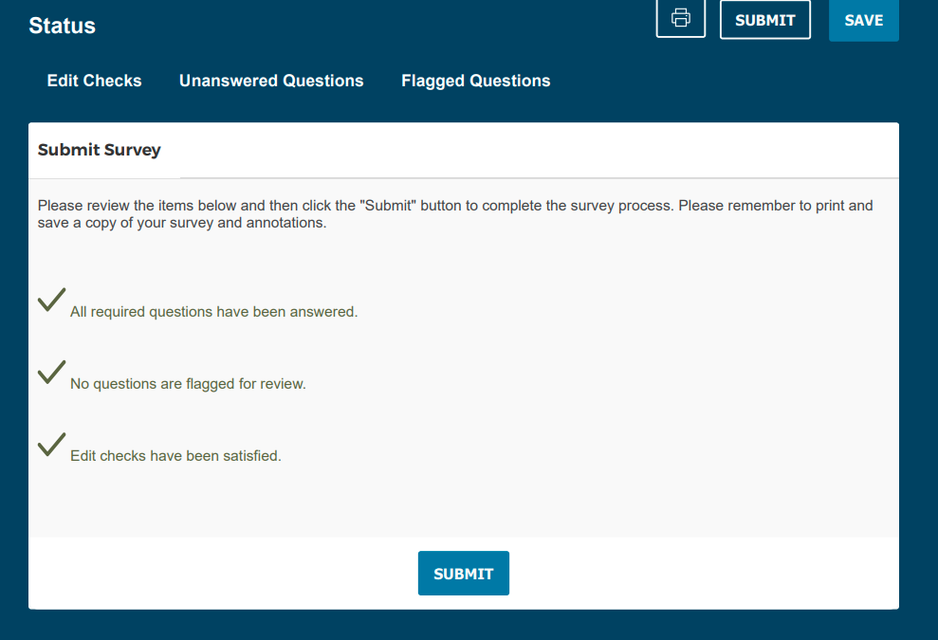

Submit Data
- After you have completed the form, and have check its status, please print out the signature page BEFORE you click on “Submit” in the upper right-hand corner of the input screen.
- Once you click on “Submit”, you will not be able to change any values.
- If a change is required after the data is submitted, please contact Jen Inglis or Uechi Ng at the MBLC to unlock the form to make changes yourself, or to request changes be made for you.
- Note that we may not be able to unlock the form immediately.

