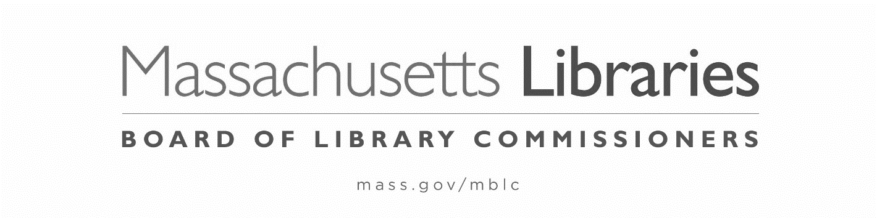

Date: August 2023
To: Directors of Public Libraries
From: Mary Rose Quinn, Head of State Programs/Government Liaison

FY2024 Municipal Appropriation Requirement (MAR) Waiver packet

Please see the following FY2024 MAR waiver materials:
- Policy Determining Eligibility for a Waiver of the FY2024 Municipal Appropriation Requirement (MAR)
- Petition for Waiver of the FY2024 Municipal Appropriation Requirement
- FY2023/2024 Disproportionate Cut Worksheet

FY2024 MAR compliance: To determine if your municipality is in compliance with the FY2024 MAR, complete the MAR Worksheet on page 2 of the FY2024 State Aid to Public Libraries Compliance Form.

Not meeting FY2024 MAR: If the municipal appropriation to the library does not meet the FY2024 MAR, a waiver of the FY2024 MAR must be applied for and granted or the municipality will not be certified to participate in the FY2024 State Aid to Public Libraries Program.

The Waiver Application Process: To request a waiver of the FY2024 MAR, in addition to the Compliance Form and Financial Report due on October 6, 2023, you must complete, obtain appropriate signatures, and submit the items below electronically according to their postmark deadline dates:

The following item must be submitted by October 6, 2023:
- Petition for Waiver of the FY2024 Municipal Appropriation Requirement

The following 4 items must be submitted by November 3, 2023 (*additional items are required if you are applying for a waiver in consecutive year):
- FY2023/FY2024 Disproportionate Cut Worksheet (to be filled out by the municipality)
- A letter or statement from a municipal official describing the budget process leading to the municipality’s inability to meet the MAR and provides evidence that any reduction to the library’s budget is not disproportionate relative to other budget changes in the overall municipal budget.
- One letter or statement from the Library Director and the Library Trustee Chair explaining the library’s FY2024 budget process and reasons that the municipality did not meet the FY2024 MAR.
- Municipal budget documentation for FY2023 and FY2024 that shows the appropriation to each municipal department
- *Waiver Year 2 and/or Waiver Year 3 form

Ineligibility: Non-compliance with the hours open or materials expenditure requirements (below the accommodated and “flexibility” levels) means that the municipality and its library are ineligible for State Aid to Public Libraries and are ineligible to apply for a waiver of the MAR.

As indicated above, the waiver petition, state aid application, and financial report must be submitted by October 6, 2023.
All other MAR waiver materials must be submitted by November 3, 2023.

