MINUTES OF THE BOARD OF LIBRARY COMMISSIONERS

Date : March 2, 2017

Time : 10:00 A.M.

Place : Board of Library Commissioners
Boston, Massachusetts

Present : Mary Ann Cluggish, Chairman; N. Janeen Resnick, Vice Chairman; Roland A. Ochsenbein, Secretary; Francis R. Murphy; Carol B. Caro; Mary Kronholm; Gregory J. Shesko; Alice M. Welch

Absent: George T. Comeau, Esq.

Staff Present:

Dianne Carty, Director; Celeste Bruno, Communications Director; Amy Clayton, Administrative Assistant; Terry D’Angelo, Administrative Assistant; Tracey Dimant, Head of Operations and Budget; Susan Gibson, Accountant V; Paul Kissman, Library Information Specialist; Rachel Masse, Assistant to the Director; Matthew Perry, Outreach Coordinator; Mary Rose Quinn, Head of State Programs/Government Liaison; Deborah Roth, Contracts Specialist; Gregor Trinkaus-Randall, Preservation Specialist; Ruth Urell, Head of Library Advisory and Development; Erin Williams-Hart, Trustee/Friends Information Specialist

Observers Present:

Callan Bignoli, Assistant Library Director of Technology, Public Library of Brookline; Patricia Feeley, Collaborative Services Librarian, Boston Public Library (BPL); Em Claire Knowles, Board of Directors, Massachusetts Center for the Book; Greg Pronevitz, Executive Director, Massachusetts Library System (MLS); Sharon Shaloo, Executive Director, Massachusetts Center for the Book

Call to Order

Chairman Cluggish called the meeting to order at 10:00 A.M. and welcomed attendees.

Approval of Minutes- February 2, 2017

Commissioner Caro moved and Commissioner Shesko seconded that the Massachusetts Board of Library Commissioners approve the minutes for the monthly business meeting February 2, 2017 as corrected.

The Board voted approval.

Chairman’s Report
Commissioner Cluggish thanked Tracey Dimant for her help with the materials for Mass Center for the Book.

She attended the dedication for the Eastham Library on February 4, 2017 and said it is a must see library. She also attended the State Aid Review Meeting in Shrewsbury on February 16, 2017.

Commissioner Cluggish spoke about the over 3,000 Valentines that were delivered to Legislators that told them why people love their library.

DIRECTOR’S REPORT

Meetings since the last Board meeting.
- February 2 –Meeting with Rep. Kate Hogan and Courtney Rainey, Rep. Hogan’s aide
- February 7 –Meeting with Sean Cuff, Senate Budget Analyst and Bran Shim, AnF Budget Analyst
- February 8 –Conference call with Alan Brickman
- February 13–Conference call with MLS Executive Board
- February 14 –Meeting of Commonwealth eBook Collection Steering Committee
- February 16 –Meeting With Southeast Superintendents at East Bridgewater Junior/Senior High School
- February 17–Legislative Breakfast at Bigelow Free Library in Clinton
- February 24–MLA Legislative Committee Meeting
- March 1 –MBLC staff meeting with Alan Brickman
- March 1—Meeting regarding the Commonwealth eBook Collections in Massachusetts
- March 2–Alan Brickman will meet with Commissioners during Board meeting and the planning committee after the Board meeting

Director Carty and Celeste Bruno met with Rep. Kate Hogan and her aide, Courtney Rainey to discuss the upcoming Library Legislative Caucus meeting. The caucus has not yet been re-scheduled. Director Carty will be setting up a phone call with the line item representatives to discuss the agenda for the meeting.

The director search committee has reviewed resumes. They have scheduled times next week for initial telephone screening interviews.

Liz Babbitt and Mary Rose are working on a draft of the State Aid Review report. Director Carty will review and will then send it on to the State Aid Review Committee prior to next month’s meeting.
The strategic planning process is still on track with the timetable. Alan Brickman will meet with staff as a follow-up to the meeting he had with them previously. In addition, Alan will meet with the Board, the planning committee, a group from the library community and the administrators from the networks.

Next week the first of the teams will begin to meet to review the applications for the Public Library Construction grant round. The Board will vote on provisional grant awards in July.

The date for the Ways and Means budget hearings has not yet been set.

LEGISLATIVE REPORT

The Massachusetts Senate launched the second annual Commonwealth Conversation Tour. The next scheduled events will be in the South Coast communities of Taunton, New Bedford, Norton, Mansfield, and Bristol Community College. I will send out information to the appropriate Directors for these and future events as they are scheduled.
The Massachusetts Budget and Policy Center has issued a report regarding the impact on the State budget due to possible Federal funding cuts. In the report, Partnership in Peril: Federal Funding at Risk for State Programs Relied on By Massachusetts Residents, Kids Count Director, Nancy Wagman details how “the state and Federal governments operate together to support the important work of expanding opportunity and ensuring the wellbeing of the residents of the Commonwealth….” She states, “This fiscal year, one of every four dollars that supports the state’s budget comes from the federal government, close to $11 billion in federal funds.” The MBLC’s annual LSTA funding is more than $3.2 million. The report lists this funding in Appendix B: Off Budget Federal Funds to Massachusetts. The report can be found at:
http://massbudget.org/report_window.php?loc=Partnership-in-Peril-Federal-Funding-at-Risk.html
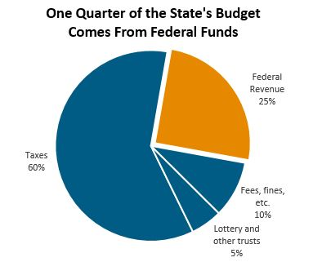
Chart from Mass Budget and Policy Center Report
January revenue collections overall tracked close to the revised benchmark projections. January 2017 revenues totaled $2.703 billion, which is $1 million (0.05%) below the monthly benchmark. Fiscal year-to-date collections were $14.661 billion, $33 million (0.2%) below the benchmark. January is generally the third largest tax collection month, ranking just behind June and April.
Mid-February tax collections for the month-to-date period were $604 million, up $40 million or 7.0% versus the same period last year. On a fiscal year-to-date basis, Total Tax collections through February 15th were $15.265 billion, which is $424 million or 2.9% greater than the same period last year.

In addition to the Commonwealth Conversation Tour, the following is a list of upcoming events of interest to the Commissioners and the library community:
- New date has not been announced for Caucus but either March 28 or 30 is probable.
- Library Legislative Day, Tuesday, March 7
- BLIND Legislative Day is Thursday, March 16 (Blind Legislative Information Networking Day) at the State House (Great Hall)
- National Library Legislative Day (NLLD) May 1 and 2 in Washington, DC
- MLA pre-conference on Advocacy, Sunday, May 21 in Hyannis followed by MLA Conference
- The last Legislative Breakfast for the year is March 3 in Fitchburg
Consideration of FY2018 Plan of Service and Program and Budget for the Massachusetts Center for the Book

Sharon Shaloo, Executive Director of the Massachusetts Center for the Book presented the following:

The Massachusetts Center for the Book, the Commonwealth affiliate of the Center for the Book in the Library of Congress, is a public-private partnership charged with the development, support, and promotion of cultural programing designed to advance the cause of books and reading and enhance the outreach potential of public libraries in Massachusetts. Funded by an appropriation from the General Court, Budget Line 7000-9508, administered by the Board of Library Commissioners.

The Massachusetts Center for the Book (MCB) began its second year of funding under an appropriation that was increased to $200,000 (from the $125,000 appropriated in FY 15). The increase was a boost to the capacity of MCB, for we could now begin to expand staffing and increase activity that would position us for the potential we all believe MCB to have for positive impact in the library community.

As a statewide programming service that supports and enhances the outreach and partnership activities of Massachusetts libraries, MCB is transforming into an organization focused less on administering new programs and more on developing programs that can be offered in and through libraries to enhance activity in their buildings and throughout their communities.

We concentrate our activity in three areas: (1) reading promotion , including not only the immersive reading sparked by the annual Massachusetts Book Awards and letters About Literature programs but also new family literacy efforts that draw on the wonderful books about Massachusetts produced by the authors among us; (2) literary placemaking , including the development of maps , trails and archives, to increase cultural tourism as well as to leverage library resources in community redevelopment efforts; and (3) national and regional collaborations to enhance cultural activity in Massachusetts libraries.
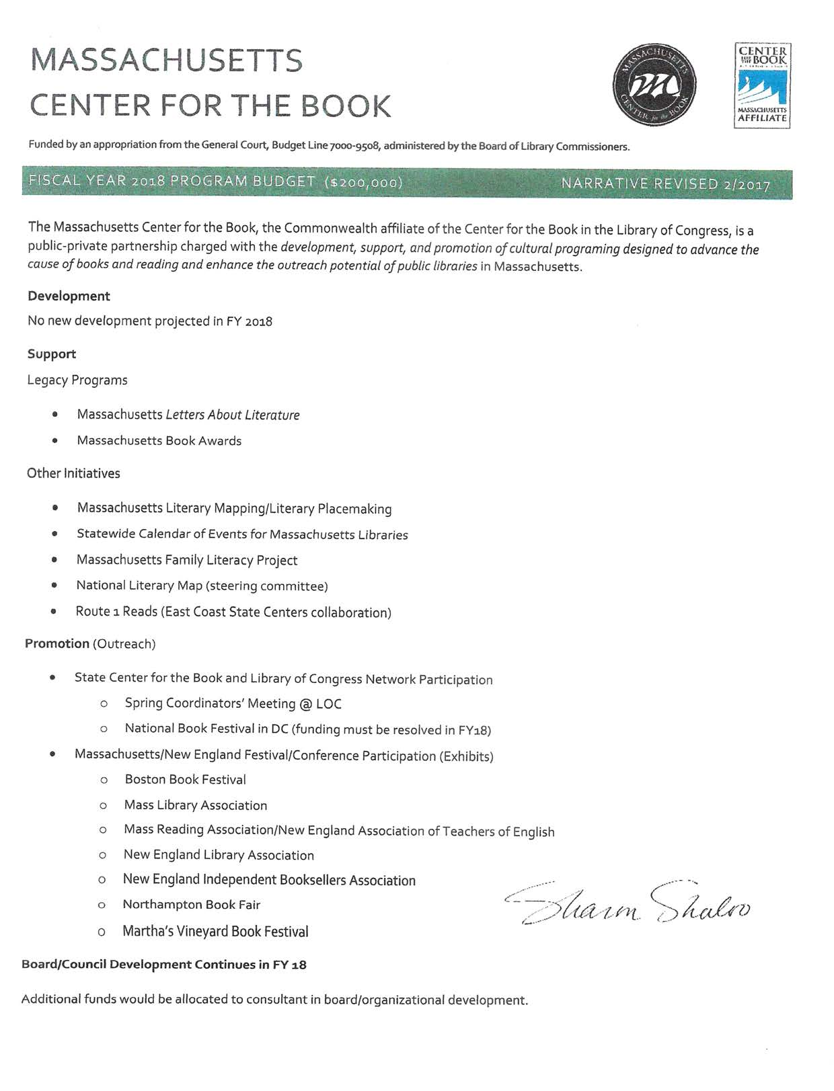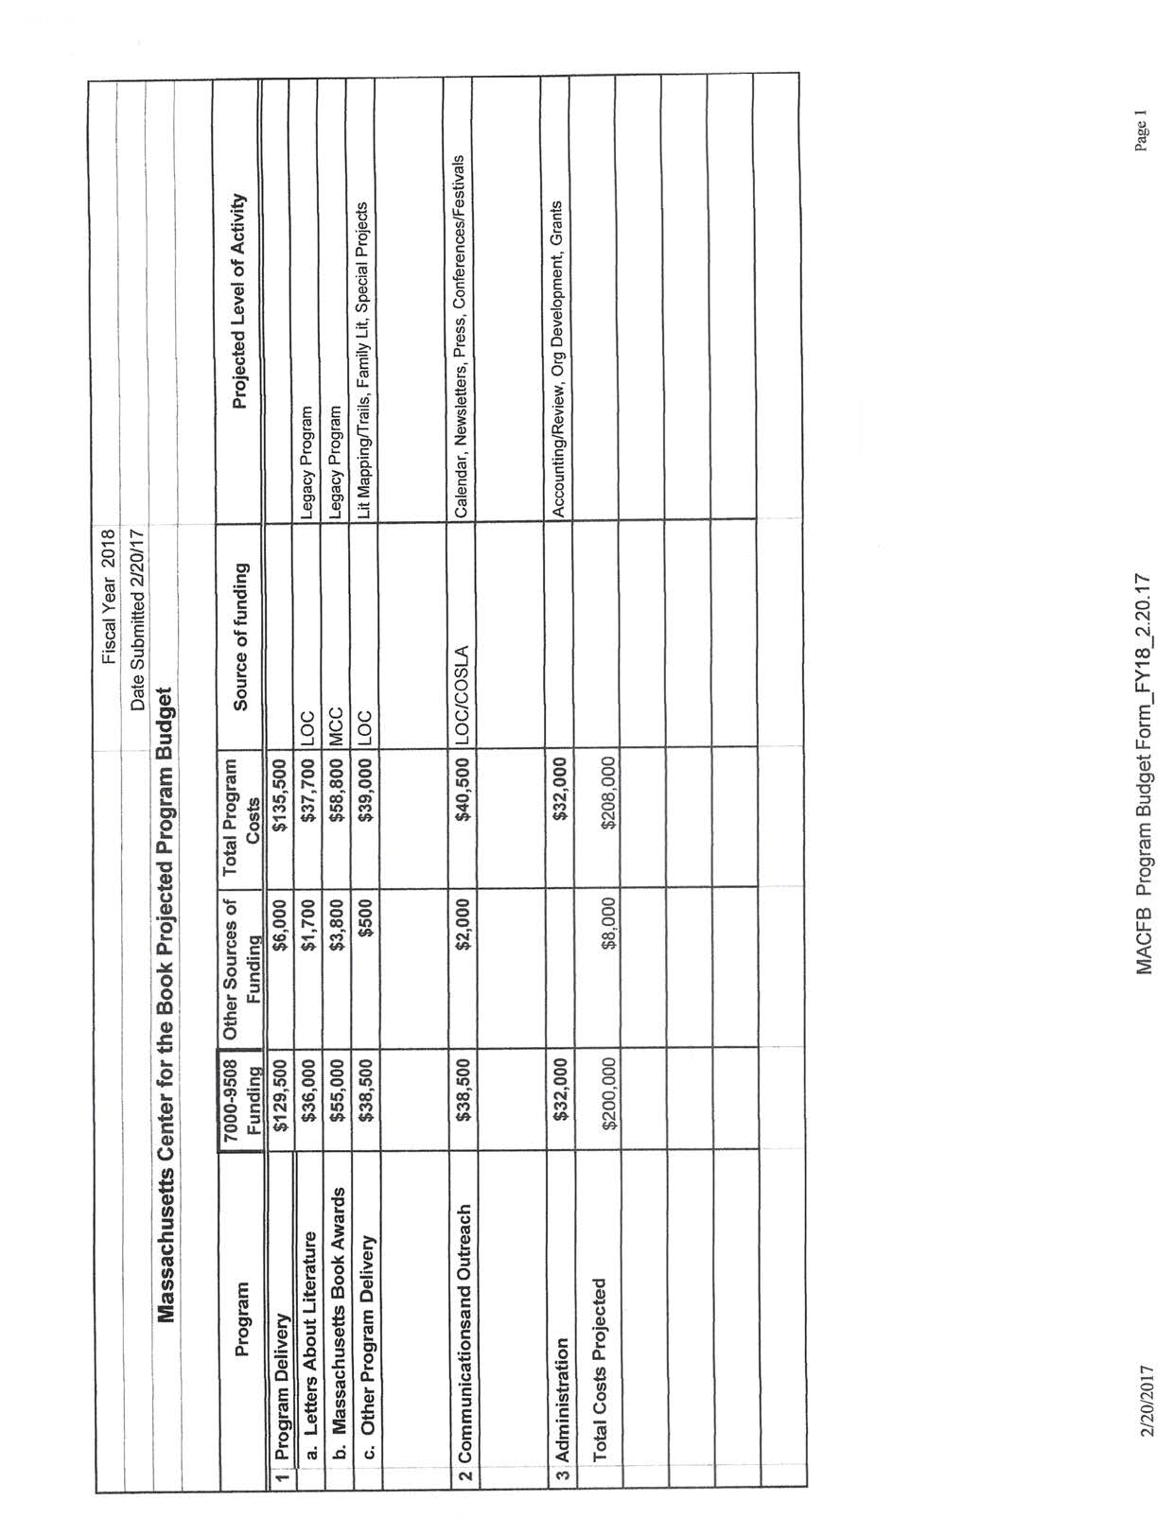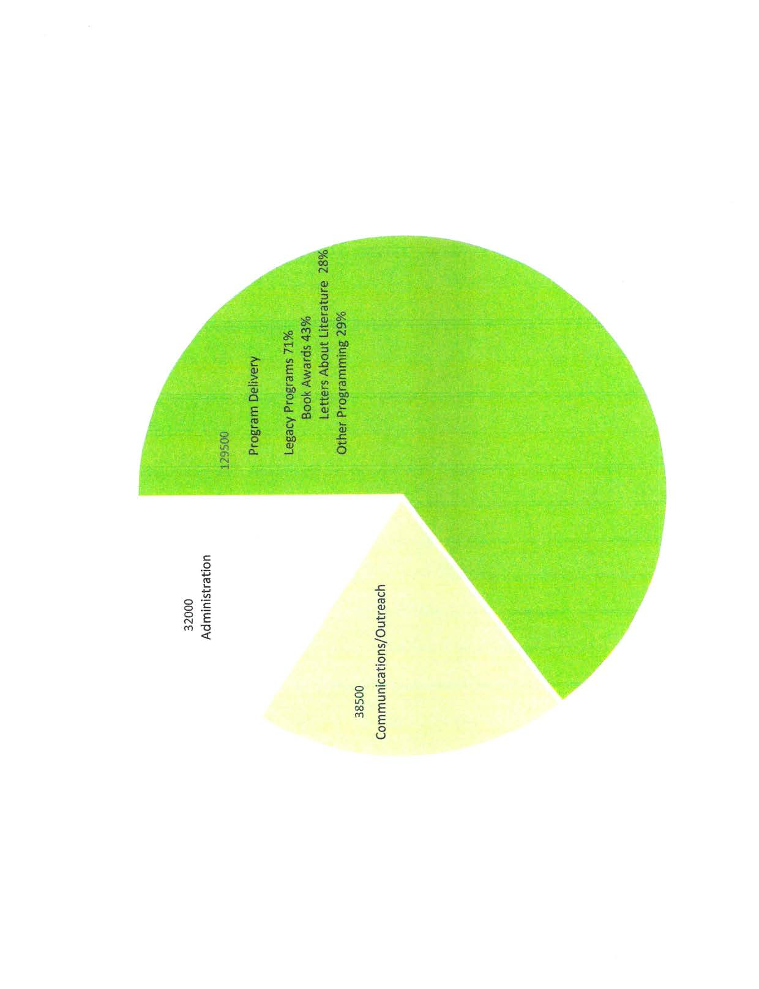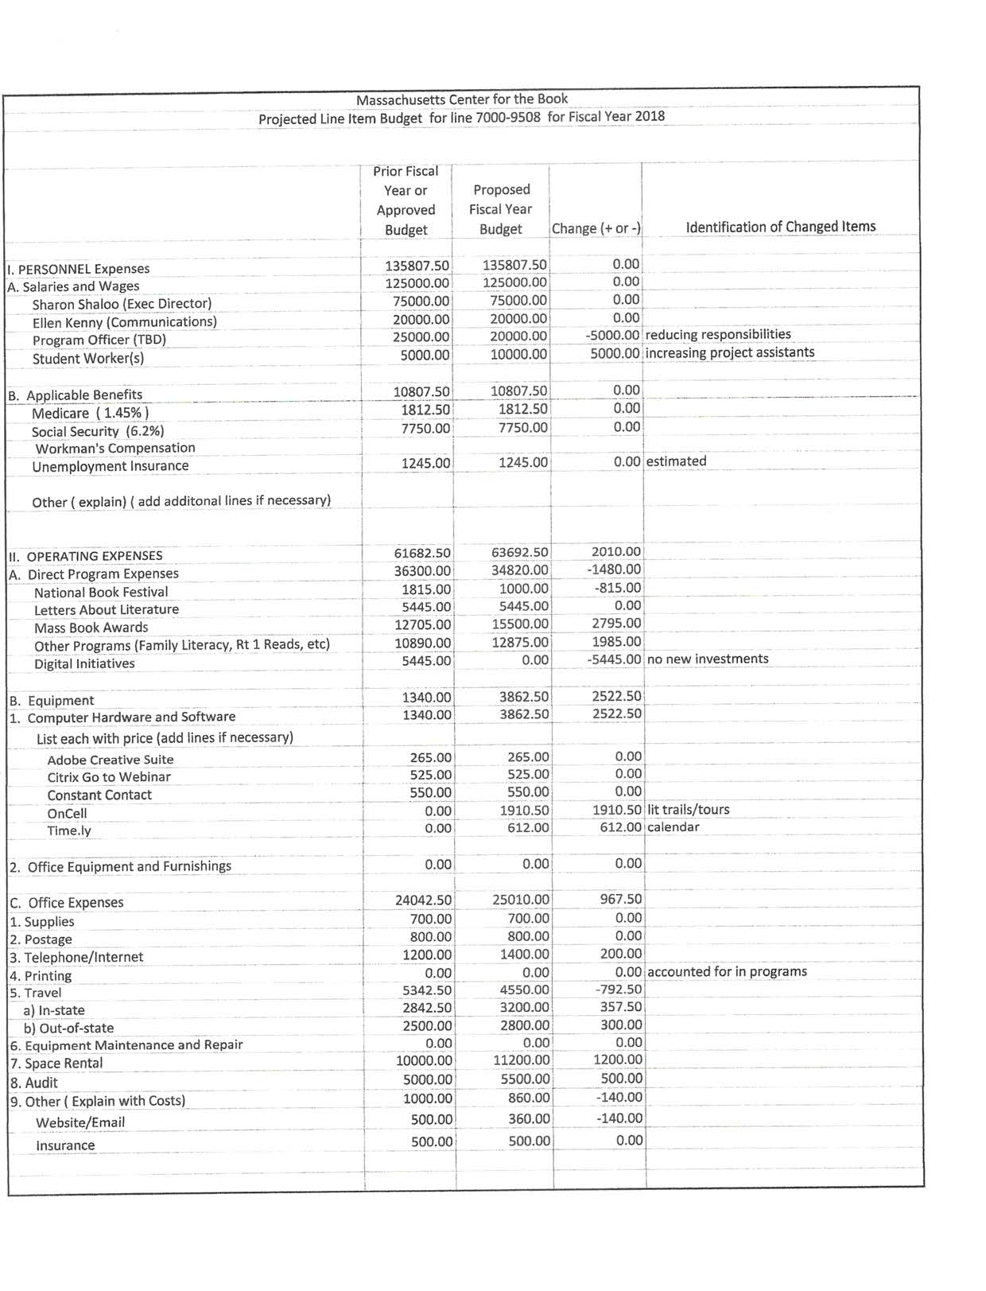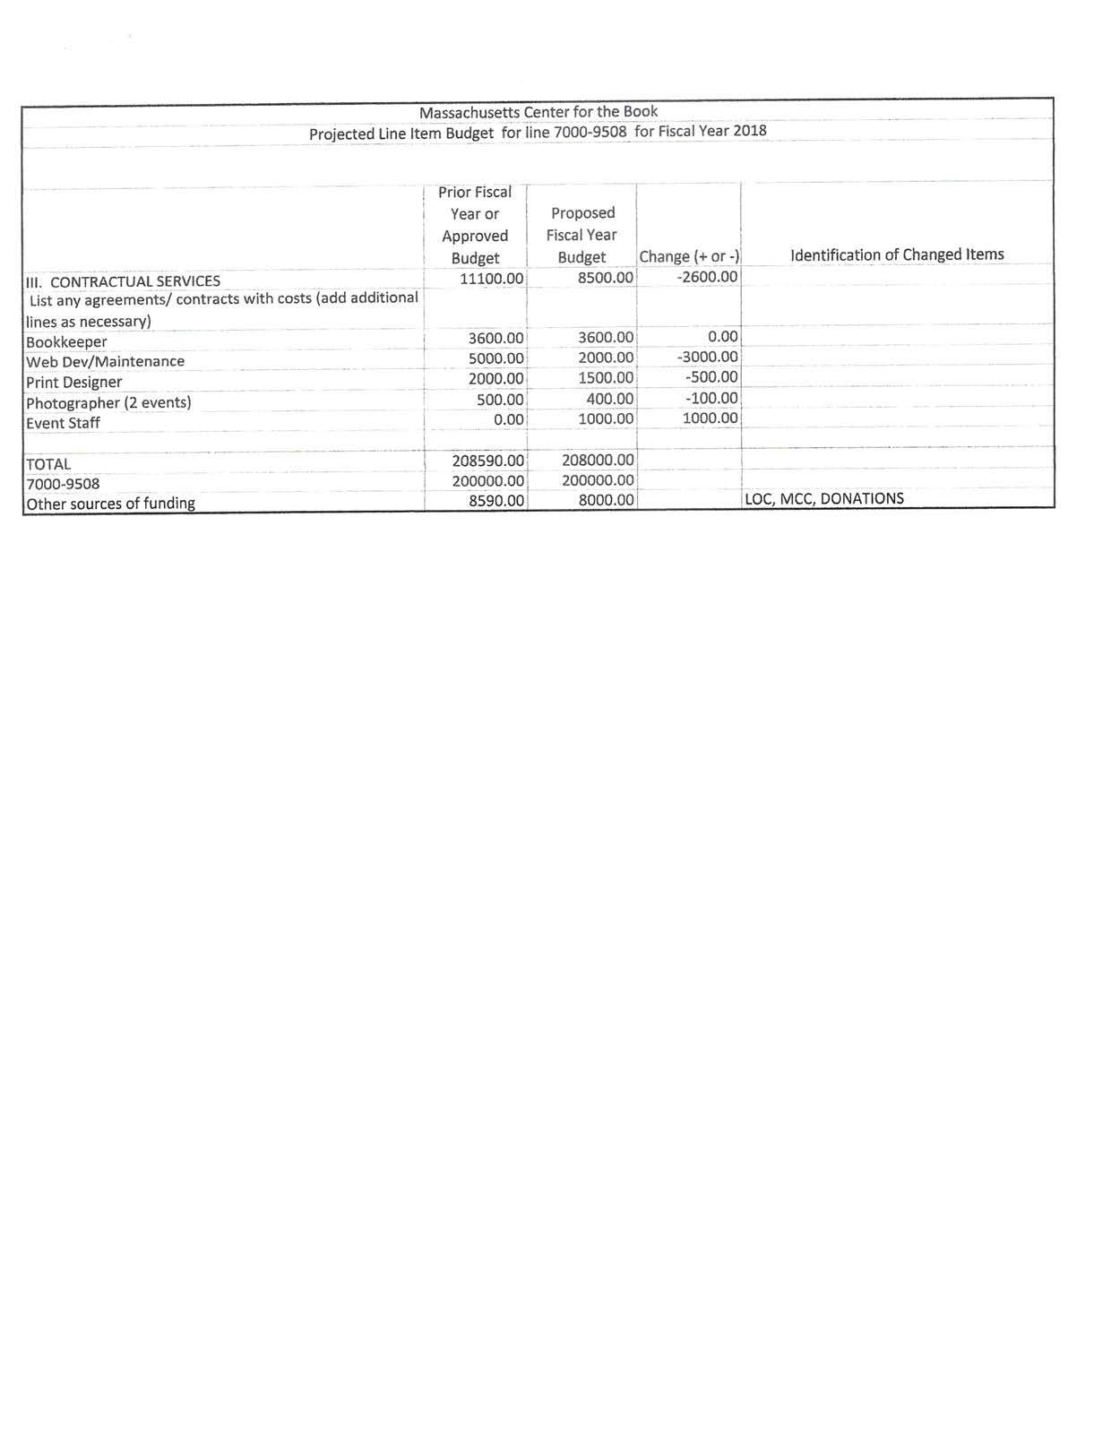

Commissioner Ochsenbein moved and Commissioner Shesko seconded to accept and approve the FY2018 Plan of Service and Program and Budget for the Massachusetts Center for the Book.

The Board voted approval.

REPORT FROM THE MASSACHUSETTS LIBRARY SYSTEM

MLS Executive Director Gregory Pronevitz reported on the following items:

Continuing Education Statistics – July-December

We are pleased to announce that 1,765 attended MLS events; including 779 in-person; 441 online; and 545 at statewide events.

Executive Board Roster Changes

William Hoag, Roxbury Community College, resigned recently. The Executive Board will appoint a replacement on March 20.

Listening Tour

We are planning additional listening tour stops in April and May with the theme, Advocacy.

- Advocacy (Northeast) April
- Advocacy (Southeast) April, if possible
- Mass. School Library Association Conference, Hyannis, May 7
- Mass. Library Association, Hyannis, May 22

Recent events:

Post-Election, Post-Truth: Using Comprehensive Media Literacy to Assess and Evaluate News and Current Events - January 31, 2017, 3:30-4:30pm (online)

Listening Tour with Fake News Theme – February 22 at MLS-Marlborough and March 8 at MLS-Northampton.

REPORT FROM THE LIBRARY FOR THE COMMONWEALTH

Patricia Feeley, Collaborative Services Librarian at the Boston Public Library reported on the following:

Database News
- BPL will be able to keep the A-Z Databases for three more years. This database includes info on 30 million businesses and 220 million residents. It is used for job hunting, demographic reference and mailing list creation.

Boston Bruins PJ Drive
- PJs continue to be collected at all BPL sites.

- The Roslindale Branch posted a photo of their decorated collection box with staff donating PJs to the BPL's staff e-newsletter.

- The Grove Hall branch held a Wear Your PJs to Work day last Wednesday.

Massachusetts Legislative Day

- BPL will have a presence at the State House. Our team will be Gianna Gifford, Chief of Adult Library Services, Tom Blake, Manager of Content Discovery, Anna Fahey-Flynn and Patricia Feeley

Digital Commonwealth

- The Outreach Committee held a Digital Storytelling workshop at the BPL on Tuesday.

- Attendees expressed satisfaction for this program and enthusiasm for a proposed follow up workshop

Update on Strategic Planning Process

Consultant Alan Brickman discussed the outline of the Strategic Plan.

- Background, context, and planning process (with a side note about the leadership transition)

History of MBLC
Description of the various entities in the statewide system
Rationale/motivation to undertake strategic planning at this time
Overview of the planning process

Question: Moderately lengthy intro, or brief intro with detail in appendix?

- MBLC mission and vision (of Mass libraries, of MBLC, and of the statewide system)

Alan will draft
Need some language on the vision of MBLC at the “top of the pyramid” of the statewide system

- Programs and services (both provided directly and funded, with deliverables/metrics)

Format for each program component:
Summary description
Funding and staffing
Partners
Deliverables/metrics

Question: How to organize/group the components?

- State-level partnerships that generate programming and resources for local libraries

We have lots of preliminary ideas.
Need an overarching goal statement.

Question: How do deal with this entire section?
Sample initiatives, with process steps to identify priorities?
Selection of preliminary priorities and process for developing pilots?
Criteria for selecting priorities?

- System coordination and alignment (and stakeholder engagement at all levels)

Description of components of the systems, with roles clarified
Vehicles and processes for ongoing coordination
Opportunities for engagement

- Messaging and external communications strategy

Awareness and advocacy goals
Key messages about:
Libraries
MBLC
State-wide system
Target audiences
Vehicles and activities

- MBLC organizational development

Staff and staff structure (org chart)
Internal operations
Board development
Other aspects of organizational infrastructure

- Finances: state funding, other revenue strategies (and 501c3 vehicle), multi-year budget

Multi-year budget: FY2018 – FY2020
Expenses reflecting directions in the plan
Revenue projections in key categories
Budget notes, as necessary
Narrative regarding revenue development in each category

- Implementation plan

Activities | Responsibility | FY2018 | FY2019 | FY2020
MBLC programs

State-/System-level Partnerships and Alignment

Staffing, Staff Structure, and Operations

Board Development

Messaging and External Communication

Finances and Funding

He also talked about the draft Vision Statement for Massachusetts Libraries

Resources and programming: Libraries in Massachusetts have a robust, diverse, and sustainable resource base that enables them to recruit and retain highly qualified staff for all key functions; maintain attractive, inviting, and well-equipped facilities that support quality programming; and offer a comprehensive array of both on-site and online programs and services that effectively meet the needs of a diverse array of individuals and families in their communities.

Community awareness and engagement: Libraries in Massachusetts are widely recognized and valued as high quality and essential educational, cultural, and social institutions in their communities, have informational resources that are well understood and well regarded by all their community constituencies, and offer quality programs that have consistently high utilization rates.

Strategic partnerships: Libraries in Massachusetts have a diverse group of local, state, and national partners that enable them to expand their programming into areas such as workforce development; K-12, postsecondary, and adult basic education; arts and culture; and the like, thereby positioning them at the very center of civic life in their communities.

Standing Committee and Liaison Reports

Commissioner Resnick gave a report on the Director’s Search:

The Committee met at MLS – Marlboro on February 23. Greg arranged space and phone in capabilities for us. 7 members attended in person, 3 members participated by phone.

Dianne and Rachel set up a dropbox site for us, and we had 11 resumes to evaluate. Dianne and Rachel set up everything for us on Dropbox, so everyone had a chance to review each resume. There was consensus amongst the committee. We selected 5 for preliminary interviews, rejected 4 for insufficient experience in years or types of libraries. 2 are in a hold category. No rejection letters will be sent out until final decisions are made.

We set a calendar for telephone interviews, and Rachel has already scheduled them. We also set date for Skype meetings as second interviews, but do not have a location for those yet. We have no money to reimburse candidates for travel. The preliminary selection meeting adjourned after an hour.

Four of us (Roland, Greg, Karen by phone, and I with Rachel in support) reviewed the interview questions and have begun to refine them.

The Search Process is still on schedule. We hope to have 2-3 candidates for your consideration. Those will require special meetings of the Board.

Commissioner Resnick also gave an update on Massachusetts Center for the Book Board Meeting. She noted that it is a small Board and they are still recruiting.

Commissioner Ochsenbein went to the monthly meeting at Perkins in place of Commissioner Caro who was away.

COMMISSIONER ACTIVITIES

Commissioner Resnick
- 2/3/17 West Springfield Legislative Breakfast
- 2/7/17 Mass. Center for the Book Board Meeting Conference Call
- 2/21/17 MBLC Executive Committee Conference Call
- 2/22/17 eBook Training Session- MLS Northampton
- 2/23/17 Search Committee- MLS Marlborough
- 2/23/17 Welcome Tea for Director Lisa Downing, Forbes Library, Northampton

Commissioner Ochsenbein
- 2/3/17 Legislative Breakfast- Sutton
- 2/14/17 Attended Commonwealth eBook Steering Committee mtg via phone
- 2/17/17 Legislative Breakfast- Clinton
- 2/21/17 Participated in Executive Committee conference call
- 2/22/17 Attended Perkins School Consumer Advisory Board Mtg for Carol Caro
- 2/23/17 Search Committee mtg- MLS Marlborough

Commissioner Kronholm
- 2/3/17 West Springfield Legislative Breakfast

Commissioner Welch
- Attending Legislative Breakfast in Fitchburg 3/3/2017

Commissioner Shesko
- 2/16/17 State Aid Review Meeting, Shrewsbury

Commissioner Murphy
- 2/16/17 State Aid Review Meeting, Shrewsbury
- 2/17/17 Legislative Breakfast- Sudbury

PUBLIC COMMENT

There was no public comment.

OLD BUSINESS

There was no old business.

ADJOURNMENT

There being no further business, Chairman Cluggish adjourned the March 2, 2017 monthly business meeting of the Board of Library Commissioners at 12:34 P.M.

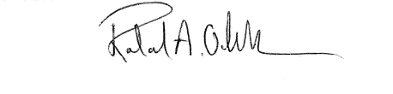

Roland Ochsenbein
Secretary

