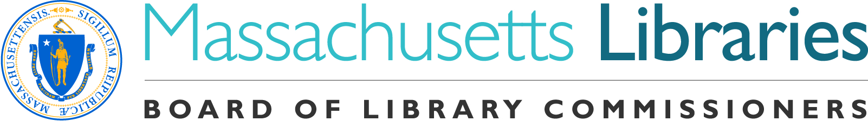
Welcome. Thank you for attending this meeting of the Massachusetts Board of Library Commissioners. Please remember that as part of the meeting agenda there is a time at the end of the meeting for public comment. Should you wish to address the Board during a particular item, please wait to be recognized by the chair.

Note: Agenda may include items not reasonably expected 48 hours before the meeting.

Granby Free Public Library
Granby, Massachusetts

Thursday, April 5, 2018 10:00 A.M.

Agenda

- Call to Order

- Approval of Minutes- March 1, 2018 (ACTION)

Speaker: Mary Ann Cluggish, Chairman

- Chairman’s Report

Speaker: Mary Ann Cluggish, Chairman

- Director’s Report

Speaker: James M. Lonergan, Director

- Legislative Report

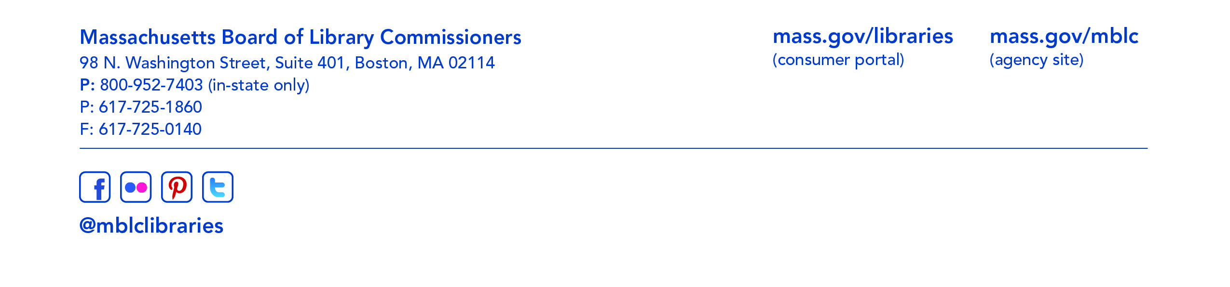
Speaker: Mary Rose Quinn, Head of State Programs/Government Liaison

- Consideration of a request from the Medford Public Library for an extension of time to confirm local funding and accept its provisional grant award in the Massachusetts Public Library Construction Program (ACTION)

Speaker: Barbara Kerr, Library Director, Medford Public Library
Rosemary Waltos, Library Building Consultant
- Consideration of Certificate of Commendation for Irene Gillies, Library Director, Eldredge Public Library, Chatham (ACTION)

Speaker: James M. Lonergan, Director

- Update on Sasaki Study

Speaker: Lauren Stara, Library Building Consultant

- Update on the Strategic Plan

Speaker: James M. Lonergan, Director

- Report on the Massachusetts School Library Commission Study

Speaker: Gregory Pronevitz, Executive Director
Massachusetts Library System

- Report from the Massachusetts Library System

Speaker: Gregory Pronevitz, Executive Director

- Report from the Library for the Commonwealth

Speaker: Anna Fahey-Flynn, Collaborative Library Services Manager,
Boston Public Library

- Standing Committee and Liaison Reports

- Commissioner Activities

- Public Comment

- Old Business

- Adjournment Chairman Cluggish

