Welcome. Thank you for attending this meeting of the Massachusetts Board of Library Commissioners. Please remember that as part of the meeting agenda there is a time at the end of the meeting for public comment. Should you wish to address the Board during a particular item, please wait to be recognized by the chair.

Perkins School, Grousbeck Center for Students and Technology
Watertown, Massachusetts

Thursday, August 3, 2017 10:00 A.M.

Agenda

- Call to Order

- Welcome

Speaker: Kim Charlson, Director, Perkins Braille & Talking Book Library

- Approval of Minutes- July 13, 2017 (ACTION)

Speaker: Mary Ann Cluggish, Chairman

- Chairman’s Report

Speaker: Chairman Cluggish

- Director’s Report

Speaker: James M. Lonergan, Director

- Legislative Report

Speaker: Mary Rose Quinn, Head of State Programs/Government Liaison

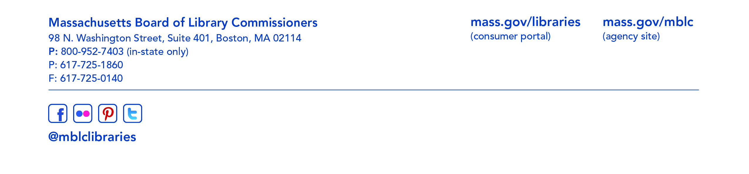

- Marketing Plan Update

Speaker: Celeste Bruno, Communications Director

- Presentation of Strategic Plan

Speakers: Director Lonergan & Consultant Alan Brickman

- Presentation of LSTA Long Range Plan

Speakers: Ruth Urell, Head of Library Advisory and Development

- Update on the Trustee Handbook revisions

Speakers: Erin Williams Hart, Trustee & Friends Information Specialist

- Report from the Massachusetts Library System

Speaker: Gregory Pronevitz, Executive Director
Massachusetts Library System

- Report from the Library for the Commonwealth

Speaker: Anna Fahey-Flynn, Collaborative Library Services Manager,
Boston Public Library

- Standing Committee and Liaison Reports

- Commissioner Activities

- Public Comment

- Old Business

- Adjournment Chairman Cluggish

