Welcome. Thank you for attending this meeting of the Massachusetts Board of Library Commissioners. Please remember that as part of the meeting agenda there is a time at the end of the meeting for public comment. Should you wish to address the Board during a particular item, please wait to be recognized by the chair.

Note: Agenda may include items not reasonably expected 48 hours before the meeting.

MBLC Offices
Boston, Massachusetts

Thursday, December 7, 2017 10:00 A.M.

Agenda

- Call to Order

- Approval of Minutes- November 2, 2017 (ACTION)

Speaker: Mary Ann Cluggish, Chairman

- Chairman’s Report

Speaker: Mary Ann Cluggish, Chairman

- Director’s Report

Speaker: James M. Lonergan, Director

- Legislative Report

Speaker: Mary Rose Quinn, Head of State Programs/Government Liaison
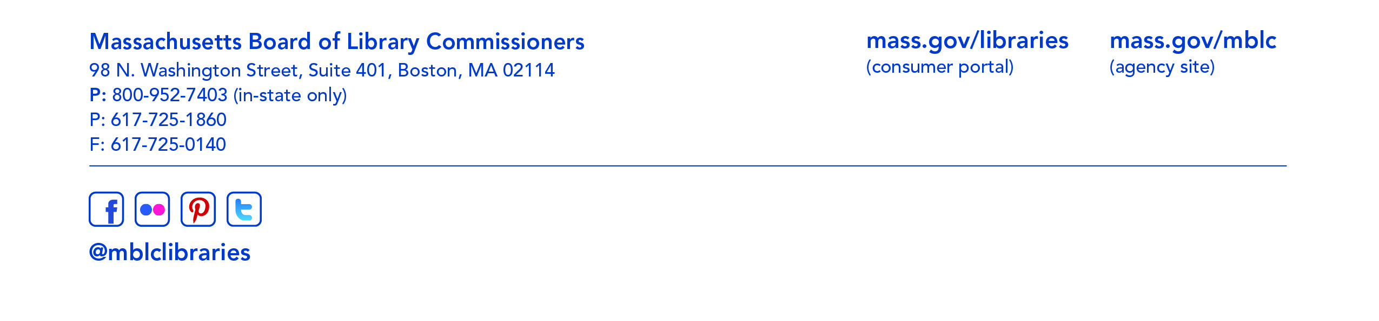
- Consideration of a request from the Medford Public Library for an extension of time to confirm local funding and accept its provisional grant award in the Massachusetts Public Library Construction Program (ACTION)

Speakers: Rosemary Waltos, Library Building Consultant
Ellen Tonello, Trustee Chair, Medford Public Library

- Consideration of approval of municipalities meeting the requirements for the FY2018 State Aid to Public Libraries based on eligibility established in the FY2018 for the Municipal Appropriation Requirement and in FY2017 for the minimum standards (ACTION)

Speaker: Mary Rose Quinn, Head of State Programs/Government Liaison

- Presentation and discussion of the FY2019 Plan of Service and Program and Budget for the Massachusetts Library System and Monthly Report

Speaker: Sarah Sogigian, Consulting and Training Services Director
Massachusetts Library System

- Presentation and discussion of the FY2019 Plan of Service and Program and Budget for the Library for the Commonwealth and Monthly Report

Speaker: Anna Fahey-Flynn, Collaborative Library Services Manager,
Boston Public Library

- Standing Committee and Liaison Reports

- Commissioner Activities

- Public Comment

- Old Business

- Adjournment Chairman Cluggish

To review the Massachusetts Board of Library Commissioners current bylaws
(Organizations and Functions of the Board of Library Commissioners)
visit http://mblc.state.ma.us/mblc/board/MBLC_Bylaws.pdf

