Welcome. Thank you for attending this meeting of the Massachusetts Board of Library Commissioners. Please remember that as part of the meeting agenda there is a time at the end of the meeting for public comment. Should you wish to address the Board during a particular item, please wait to be recognized by the chair.

Note: Agenda may include items not reasonably expected 48 hours before the meeting.

MBLC Office
Boston, Massachusetts

Thursday, February 1, 2018 10:00 A.M.

Agenda

- Call to Order

- Approval of Minutes- January 11, 2018 (ACTION)

Speaker: Mary Ann Cluggish, Chairman

- Chairman’s Report

Speaker: Mary Ann Cluggish, Chairman

- Presentation of check to Weymouth Public Libraries- Tufts Library for Construction Grant

Speaker: Mary Ann Cluggish, Chairman

- Director’s Report

Speaker: James M. Lonergan, Director

- Legislative Report

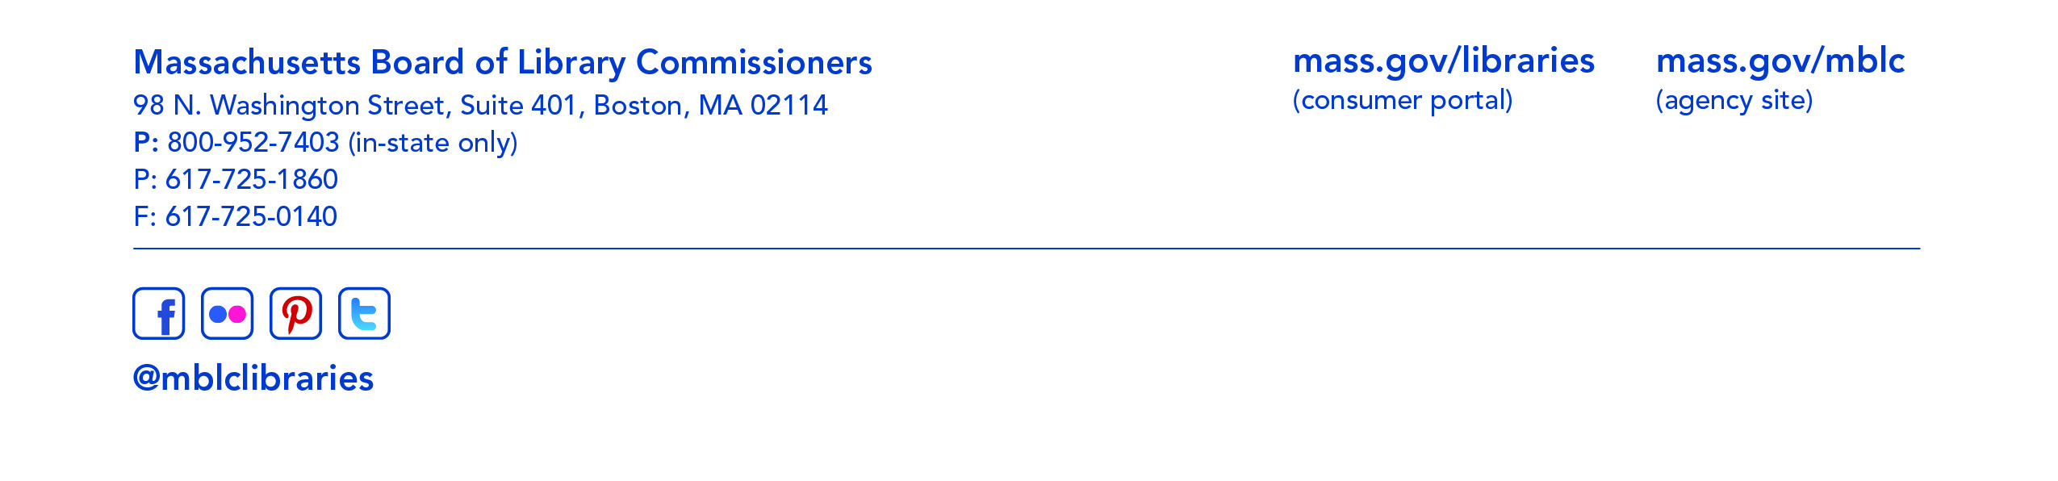
Speaker: Mary Rose Quinn, Head of State Programs/Government Liaison

- Consideration of approval of two provisional grant awards under the Massachusetts Public Library Construction Program (ACTION)

Speaker: Lauren Stara, Library Building Consultant

- Consideration of approval of municipalities meeting the requirements for the FY2018 State Aid to Public Libraries based on eligibility established in the FY2018 for the Municipal Appropriation Requirement and in FY2017 for the minimum standards (ACTION)

Speaker: Liz Babbitt, State Aid Specialist

- Consideration of municipalities requesting waivers for the FY2018 municipal appropriation requirement in in the FY2018 State Aid to Public Libraries program within the 5% threshold (ACTION)

Speaker: Mary Rose Quinn, Head of State Programs

- Consideration of approval of the FY2019 Plan of Service and Program and Budget for the Library for the Commonwealth (ACTION)

Speaker: Anna Fahey-Flynn, Collaborative Library Services Manager,
Boston Public Library

- Presentation and discussion of the FY2019 Plan of Service and Program and Budget for the Massachusetts Center for the Book and Quarterly Report

Speaker: Sharon Shaloo, Executive Director
Massachusetts Center for the Book

- Report from the Massachusetts Library System

Speaker: Gregory Pronevitz, Executive Director

- Report from the Library for the Commonwealth

Speaker: Anna Fahey-Flynn, Collaborative Library Services Manager,
Boston Public Library

- Standing Committee and Liaison Reports

- Commissioner Activities

- Public Comment

- Old Business

- Adjournment Chairman Cluggish

