Welcome. Thank you for attending this meeting of the Massachusetts Board of Library Commissioners. Please remember that as part of the meeting agenda there is a time at the end of the meeting for public comment. Should you wish to address the Board during a particular item, please wait to be recognized by the chair.

Note: Agenda may include items not reasonably expected 48 hours before the meeting.

MBLC Office
Boston, Massachusetts

Thursday, January 11, 2018 10:00 A.M.

Agenda

- Call to Order

- Welcome

Speaker: Mary Ann Cluggish, Chairman

- Approval of Minutes- December 7, 2017 (ACTION)

Speaker: Mary Ann Cluggish, Chairman

- Chairman’s Report

Speaker: Mary Ann Cluggish, Chairman

- Director’s Report

Speaker: James M. Lonergan, Director

- Legislative Report

Speaker: Mary Rose Quinn, Head of State Programs/Government Liaison

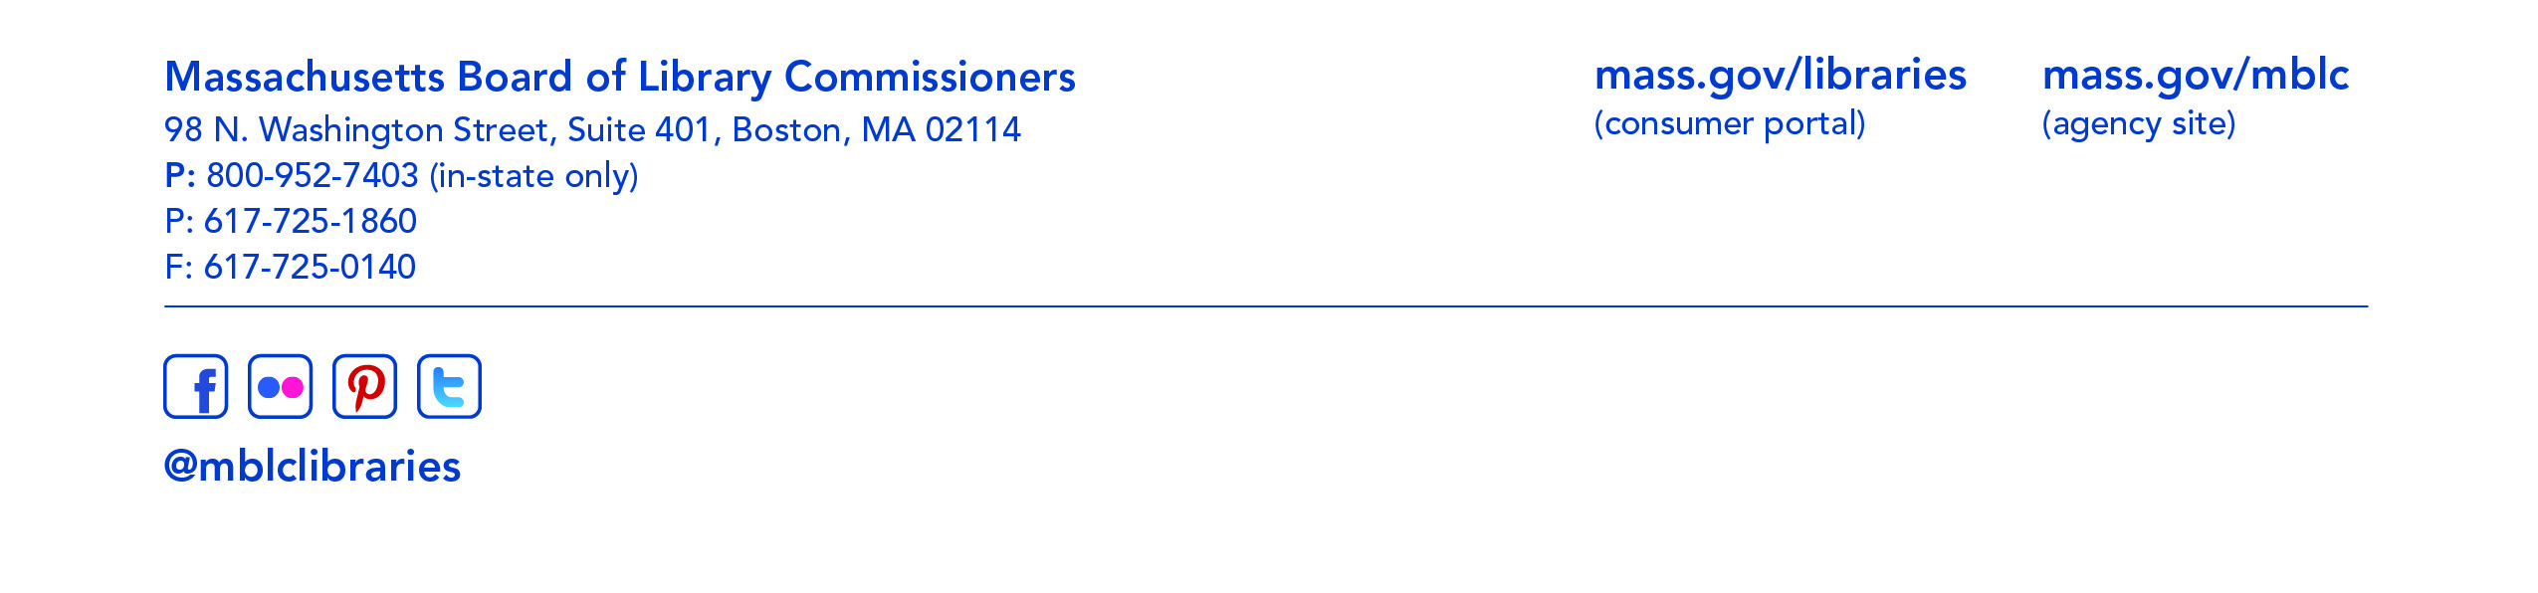

- Marketing Plan Update

Speaker: Celeste Bruno, Communications Director
Matthew Perry, Outreach Coordinator

- Consideration of approval of municipalities meeting the requirements for the FY2018 State Aid to Public Libraries based on eligibility established in the FY2018 for the Municipal Appropriation Requirement and in FY2017 for the minimum standards (ACTION)

Speaker: Liz Babbitt, State Aid Specialist

- Review of municipalities requesting waivers for the FY2018 municipal appropriation requirement in in the FY2018 State Aid to Public Libraries program within the 5% threshold

Speaker: Mary Rose Quinn, Head of State Programs

- Consideration of approval of the FY2019 Plan of Service and Program and Budget for the Massachusetts Library System (ACTION)

Speaker: Gregory Pronevitz, Executive Director,
Massachusetts Library System

- Report from the Massachusetts Library System

Speaker: Gregory Pronevitz, Executive Director

- Presentation and discussion of the FY2019 Plan of Service and Program and Budget for the Library for the Commonwealth and Monthly Report

Speaker: Anna Fahey-Flynn, Collaborative Library Services Manager,
Boston Public Library

- Standing Committee and Liaison Reports

- Commissioner Activities

- Public Comment

- Old Business

- Adjournment Chairman Cluggish

