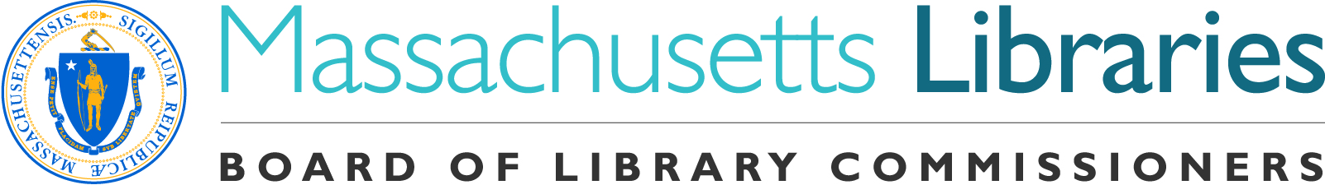
Welcome. Thank you for attending this meeting of the Massachusetts Board of Library Commissioners. Please remember that as part of the meeting agenda there is a time at the end of the meeting for public comment. Should you wish to address the Board during a particular item, please wait to be recognized by the chair.

Note: Agenda may include items not reasonably expected 48 hours before the meeting.

Needham Free Public Library
Needham, Massachusetts

Thursday, July 13, 2017 10 A.M.

Agenda

- Call to Order

- Welcome

Speaker: Mary Ann Cluggish, Chairman

- Approval of Minutes- June 1, 2017 (ACTION)

Speaker: Mary Ann Cluggish, Chairman

- Chairman’s Report

Speaker: Mary Ann Cluggish, Chairman

- Director’s Report

Speaker: James Lonergan, Director

- Legislative Report

Speaker: Mary Rose Quinn, Head of State Programs/Government Liaison

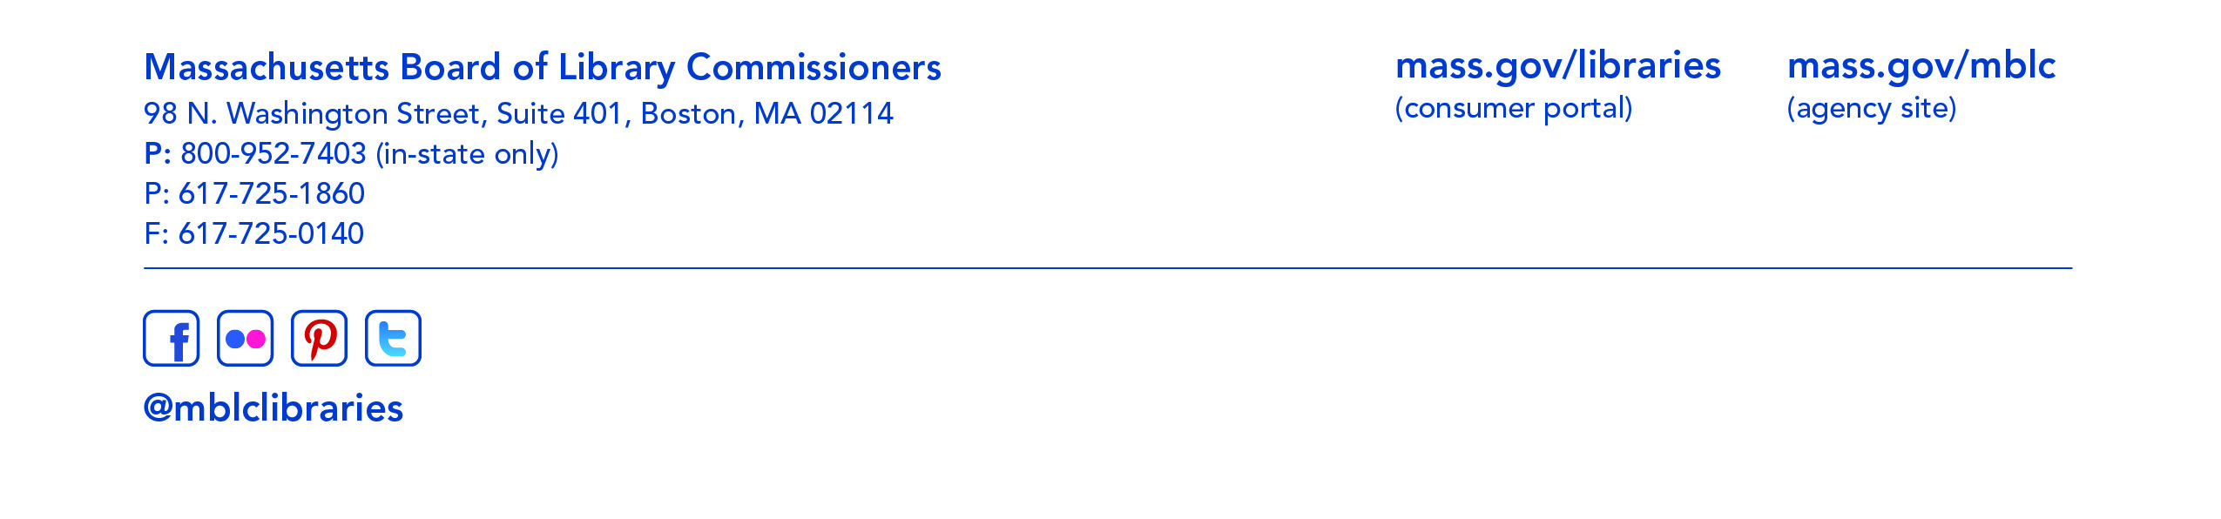
- Consideration of a grant awards under the Massachusetts Public Library Construction Program

- Provisional Grant Awards (ACTION)
- Library Green Incentive (ACTION)
- Waiting List (ACTION)

Speaker: Rosemary Waltos, Library Building Consultant

- Consideration of approval of the FY2018 Library Services and Technology Act (LSTA) Grant Awards

- Citizenship Corners (ACTION)
- Conserving and Digitizing Historical Resources (ACTION)
- Customer Experience (ACTION)
- Financial Literacy for All Ages (ACTION)
- Framework for Health Literacy (ACTION)
- Full STEAM Ahead (ACTION)
- Innovative (ACTION)
- Mind in the Making (ACTION)
- Preservation Assessment (ACTION)
- Preservation/Conservation of Library & Archival Materials (ACTION)
- Science is Everywhere (ACTION)
- Serving People with Disabilities (ACTION)
- Serving Tweens and Teens (ACTION)

Speaker: Jean M. Canosa Albano, Chair, State Advisory Council on Libraries

- Consideration of appointments and re-appointments to the PR Committee (ACTION)

Speaker: Celeste Bruno, Communications Director

- Consideration of a FY2017 Budget Revision for the Library for the Commonwealth (ACTION)

Speaker: Anna Fahey-Flynn, Collaborative Library Services Manager,
Boston Public Library

- Report from the Massachusetts Library System

Speaker: Steve Spohn, Resource Sharing Director
Massachusetts Library System

- Report from the Library for the Commonwealth

Speaker: Anna Fahey-Flynn, Collaborative Library Services Manager,
Boston Public Library

- Standing Committee and Liaison Reports

- Commissioner Activities

- Public Comment

- Old Business

- Election of Officers for FY2018 (ACTION)

Speaker: Frank Murphy

- Adjournment Chairman Cluggish

