Welcome. Thank you for attending this meeting of the Massachusetts Board of Library Commissioners. Please remember that as part of the meeting agenda there is a time at the end of the meeting for public comment. Should you wish to address the Board during a particular item, please wait to be recognized by the chair.

Note: Agenda may include items not reasonably expected 48 hours before the meeting.

Hopkinton Public Library
Hopkinton, Massachusetts

Thursday, June 7, 2018 10:00 A.M.

Agenda

- Call to Order

- Welcome

Speaker: Heather Backman, Director

- Approval of Minutes- May 3, 2018 (ACTION)

Speaker: Mary Ann Cluggish, Chairman

- Chairman’s Report

Speaker: Mary Ann Cluggish, Chairman

- Director’s Report

Speaker: James M. Lonergan, Director

- Legislative Report

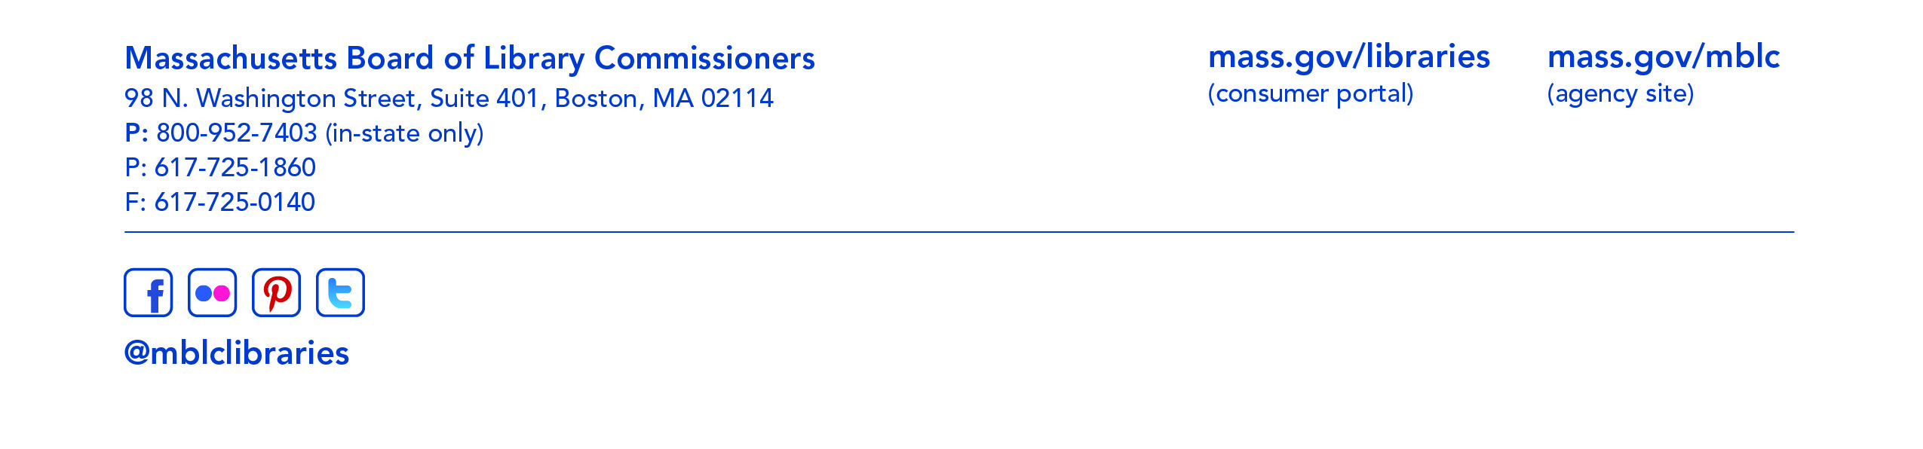
Speaker: Mary Rose Quinn, Head of State Programs/Government Liaison

- Consideration of approval of the FY2019 Plan of Service and Program and Budget for the Massachusetts Center for the Book (ACTION)

Speaker: Krista McLeod, Director of Nevins Memorial Library, Methuen
Board Member, Massachusetts Center for the Book

- Consideration of approval of three provisional grant awards under the Massachusetts Public Library Construction Program (ACTION)

Speaker: Rosemary Waltos, Library Building Consultant

- Consideration of a FY2019 Grant Round for 7000-9506, Library Technology and Resource Sharing, including Telecommunications for Resource Sharing, Resource Sharing Program, Network Infrastructure, and Small Libraries in Networks Expansion (ACTION)

Speaker: Paul Kissman, Library Information Systems Specialist

- Consideration of Joining Networks Grant Award Recommendation (ACTION)

Speaker: Paul Kissman, Library Information Systems Specialist

- Presentation of Sasaki Study

Speaker: Lauren Stara, Library Building Consultant

- Presentation of State Aid Annual Summary LibGuide

Speaker: Liz Babbitt, State Aid Specialist

- Report from the Massachusetts Library System

Speaker: Sarah Sogigian, Consulting and Training Services Director
Massachusetts Library System (MLS)

- Report from the Library for the Commonwealth

Speaker: Anna Fahey-Flynn, Collaborative Library Services Manager
Boston Public Library

- Standing Committee and Liaison Reports

- Commissioner Activities

- Public Comment

- Old Business

- Adjournment Chairman Cluggish

