Welcome. Thank you for attending this meeting of the Massachusetts Board of Library Commissioners. Please remember that as part of the meeting agenda there is a time at the end of the meeting for public comment. Should you wish to address the Board during a particular item, please wait to be recognized by the chair.

Note: Agenda may include items not reasonably expected 48 hours before the meeting.

MBLC Office
Boston, Massachusetts

Thursday, March 1, 2018 10:00 A.M.

Agenda

- Call to Order

- Approval of Minutes- February 1, 2018 (ACTION)

Speaker: Mary Ann Cluggish, Chairman

- Chairman’s Report

Speaker: Mary Ann Cluggish, Chairman

- Director’s Report

Speaker: James M. Lonergan, Director

- Legislative Report

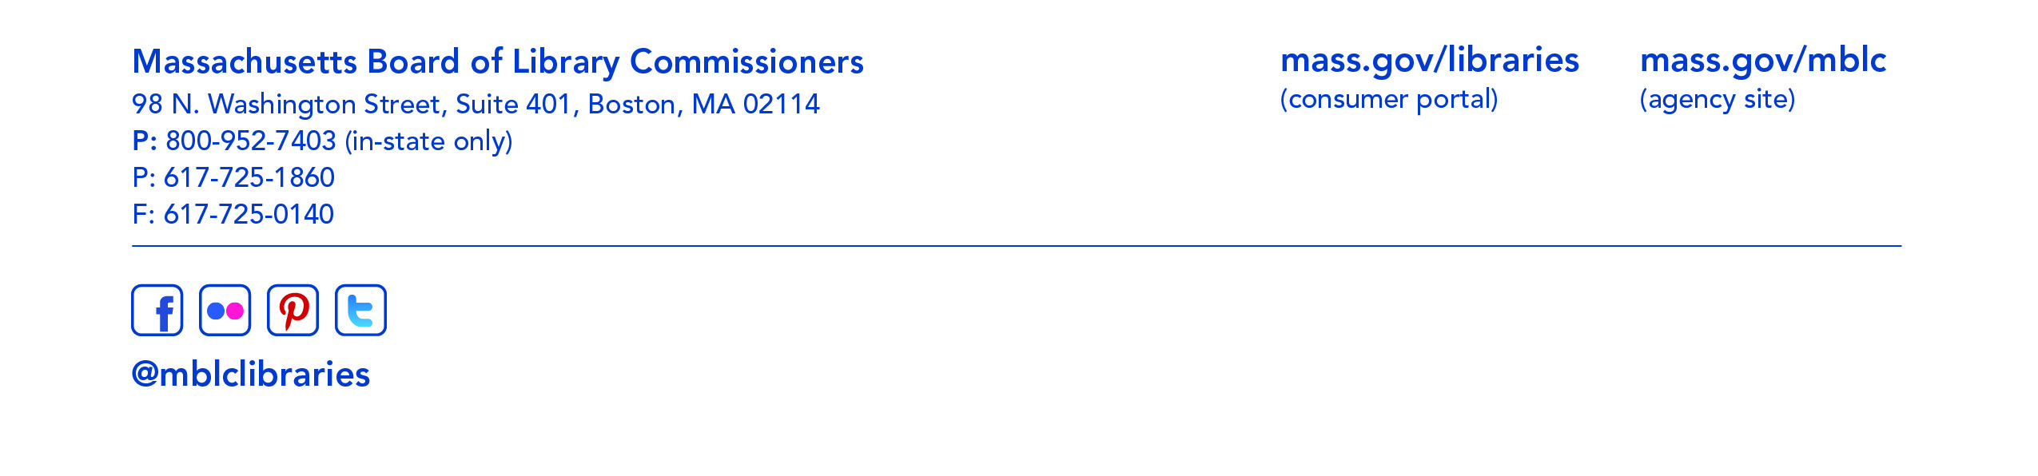
Speaker: Mary Rose Quinn, Head of State Programs/Government Liaison

- Marketing Plan Update

Speaker: Celeste Bruno, Communications Director
Matthew Perry, Outreach Coordinator

- Consideration of FY2019 Plan of Service and Program and Budget for the Massachusetts Center for the Book (ACTION)

Speaker: Sharon Shaloo, Executive Director
Massachusetts Center for the Book

- Report from the Massachusetts Library System

Speaker: Gregory Pronevitz, Executive Director
Massachusetts Library System

- Report from the Library for the Commonwealth

Speaker: Anna Fahey-Flynn, Collaborative Library Services Manager,
Boston Public Library

- Standing Committee and Liaison Reports

- Commissioner Activities

- Public Comment

- Old Business

- Adjournment Chairman Cluggish

