Welcome. Thank you for attending this meeting of the Massachusetts Board of Library Commissioners. Please remember that as part of the meeting agenda there is a time at the end of the meeting for public comment. Should you wish to address the Board during a particular item, please wait to be recognized by the chair.

Note: Agenda may include items not reasonably expected 48 hours before the meeting.

West Tisbury Free Public Library
West Tisbury, Massachusetts

Thursday, May 3, 2018 11:00 A.M.

Agenda

- Call to Order

- Welcome

Speaker: Beth Kramer, Library Director

- Approval of Minutes- April 5, 2018 (ACTION)

Speaker: Mary Ann Cluggish, Chairman

- Chairman’s Report

Speaker: Mary Ann Cluggish, Chairman

- Director’s Report

Speaker: James M. Lonergan, Director

- Legislative Report

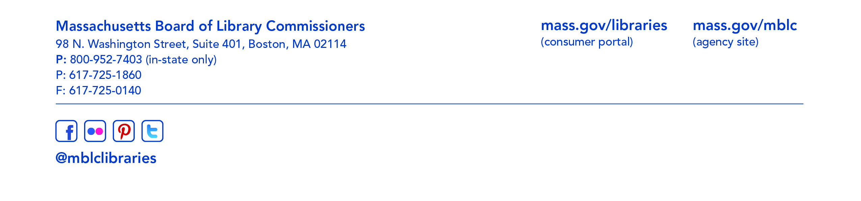
Speaker: Mary Rose Quinn, Head of State Programs/Government Liaison

- Update on Marketing Plan

Speaker: Celeste Bruno, Communications Director

- Update on the Strategic Plan

Speaker: James M. Lonergan, Director

- Discussion of Net Neutrality

Speaker: Mary Rose Quinn, Head of State Programs/Government Liaison

- Update on LSTA Project

Speaker: Beth Kramer, Director

- Report from the Massachusetts Library System

Speaker: Gregory Pronevitz, Executive Director

- Standing Committee and Liaison Reports

- Commissioner Activities

- Public Comment

- Old Business

- Adjournment Chairman Cluggish

