Welcome. Thank you for attending this meeting of the Massachusetts Board of Library Commissioners. Please remember that as part of the meeting agenda there is a time at the end of the meeting for public comment. Should you wish to address the Board during a particular item, please wait to be recognized by the chair.

Note: Agenda may include items not reasonably expected 48 hours before the meeting.

Boston Public Library, Orientation Room
Boston, Massachusetts

Thursday, November 2, 2017 10:00 A.M.

Agenda

- Call to Order

- Welcome

Speaker: David Leonard, President, BPL

- Approval of Minutes- October 5, 2017 (ACTION)

Speaker: Mary Ann Cluggish, Chairman

- Chairman’s Report

Speaker: Mary Ann Cluggish, Chairman

- Director’s Report

Speaker: James M. Lonergan, Director

- Legislative Report

Speaker: Mary Rose Quinn, Head of State Programs/Government Liaison

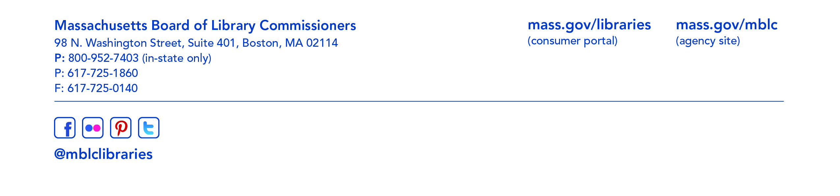

- Consideration of approval of municipalities meeting the requirements for the FY2018 State Aid to Public Libraries based on eligibility established in the FY2018 for the Municipal Appropriation Requirement and in FY2017 for the minimum standards (ACTION)

Speaker: Liz Babbitt, State Aid Specialist

- Consideration of approval of the FY2019 Library Services and Technology Act (LSTA) Direct Grant Round Program & Budget (ACTION)

Speaker: Ruth Urell, Head of Library Advisory & Development

- Report from the Massachusetts Library System

Speaker: Gregory Pronevitz, Executive Director
Massachusetts Library System

- Report from the Library for the Commonwealth

Speaker: Anna Fahey-Flynn, Collaborative Library Services Manager,
Boston Public Library

- Standing Committee and Liaison Reports

- Commissioner Activities

- Public Comment

- Old Business

- Adjournment Chairman Cluggish

To review the Massachusetts Board of Library Commissioners current bylaws
(Organizations and Functions of the Board of Library Commissioners)
visit http://mblc.state.ma.us/mblc/board/MBLC_Bylaws.pdf

