Welcome. Thank you for attending this meeting of the Massachusetts Board of Library Commissioners. Please remember that as part of the meeting agenda there is a time at the end of the meeting for public comment. Should you wish to address the Board during a particular item, please wait to be recognized by the chair.

Note: Agenda may include items not reasonably expected 48 hours before the meeting.

Brockton Public Library
Brockton, Massachusetts

Thursday, September 7, 2017 10:00 A.M.

Agenda

- Call to Order

- Welcome

Speaker: Paul Engle, Director, Brockton Public Library

- Approval of Minutes- August 3, 2017 (ACTION)

Speaker: Mary Ann Cluggish, Chairman

- Chairman’s Report

Speaker: Mary Ann Cluggish, Chairman

- Director’s Report

Speaker: James M. Lonergan, Director

- Legislative Report

Speaker: Mary Rose Quinn, Head of State Programs/Government Liaison

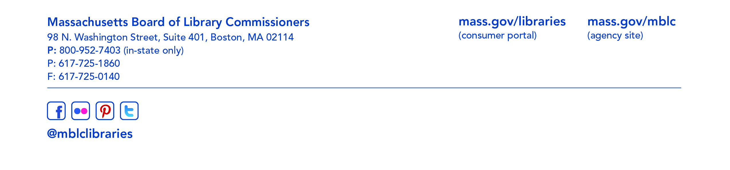
- Marketing Plan Update/ Legislative Agenda

Speaker: Celeste Bruno, Communications Director

- Consideration of appointments to the State Advisory Council on Libraries (SACL) (ACTION)

Speaker: Ruth Urell, Head of Library Advisory & Development

- Adoption of the LSTA Long Range Plan (ACTION)

Speaker: Ruth Urell, Head of Library Advisory & Development

- MLS FY2018 Budget Revision 1 approval request (ACTION)

Speaker: Gregory Pronevitz, Executive Director
Massachusetts Library System

- Discussion/ review of policies for the FY2020 State Aid to Public Libraries Program

Speaker: Liz Babbitt, State Aid Specialist

- Presentation of the final report from the State Aid Review Task Force

Speaker: Mary Rose Quinn, Head of State Programs/Government Liaison

- Discussion of Strategic Plan

Speaker: James M. Lonergan, Director

- Update on the status of the Public Library Space Survey and Planning Framework Study

Speaker: Lauren Stara, Library Building Consultant

- Report from the Massachusetts Library System

Speaker: Gregory Pronevitz, Executive Director
Massachusetts Library System

- Report from the Library for the Commonwealth

Speaker: Anna Fahey-Flynn, Collaborative Library Services Manager,
Boston Public Library
- Standing Committee and Liaison Reports

- Commissioner Activities

- Public Comment

- Old Business

- Adjournment Chairman Cluggish

To review the Massachusetts Board of Library Commissioners current bylaws
(Organizations and Functions of the Board of Library Commissioners)
visit http://mblc.state.ma.us/mblc/board/MBLC_Bylaws.pdf

