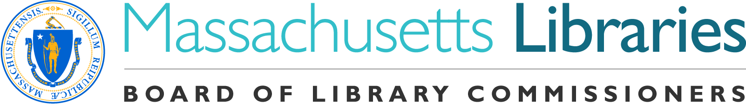
Welcome. Thank you for attending this meeting of the Massachusetts Board of Library Commissioners. Please remember that as part of the meeting agenda there is a time at the end of the meeting for public comment. Should you wish to address the Board during a particular item, please wait to be recognized by the chair.

Note: Agenda may include items not reasonably expected 48 hours before the meeting.

Perkins School, Grousbeck Center for Students and Technology
Watertown, Massachusetts

Thursday, August 2, 2018 10 A.M.

Agenda

- Call to Order

- Welcome

Speaker: Kim Charlson, Director, Perkins Braille & Talking Book Library

- Approval of Minutes- July 12, 2018 (ACTION)

Speaker: Roland Ochsenbein, Chairman

- Chairman’s Report

Speaker: Roland Ochsenbein, Chairman

- Director’s Report

Speaker: James Lonergan, Director

- Legislative Report

Speaker: Mary Rose Quinn, Head of State Programs/Government Liaison

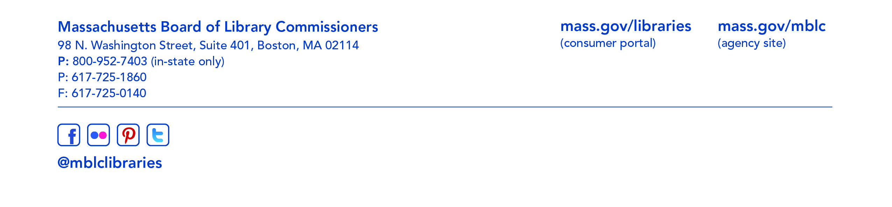
- Discussion and consideration of the FY2020 Legislative Agenda

Speaker: James Lonergan, Director
Mary Rose Quinn, Head of State Programs/Government Liaison

- Marketing Plan Update

Speaker: Celeste Bruno, Communications Director
Matt Perry, Outreach Coordinator

- Consideration of Certificate of Commendation for Cynthia Dadd, Library Director, Newburyport (ACTION)

Speaker: Mary Rose Quinn, Head of State Programs/Government Liaison

- Consideration of reappointment of Statewide Public Relations Advisory Committee members
(ACTION)

Speaker: Celeste Bruno, Communications Director
Matt Perry, Outreach Coordinator

- Report from the Massachusetts Library System

Speaker: Sarah Sogigian, Interim Director
Massachusetts Library System (MLS)

- Report from the Library for the Commonwealth

Speaker: Anna Fahey-Flynn, Collaborative Library Services Manager
Boston Public Library

- Standing Committee and Liaison Reports

- Commissioner Activities

- Public Comment

- Old Business

- Adjournment Chairman Ochsenbein

