Welcome. Thank you for attending this meeting of the Massachusetts Board of Library Commissioners. Please remember that as part of the meeting agenda there is a time at the end of the meeting for public comment. Should you wish to address the Board during a particular item, please wait to be recognized by the chair.

Note: Agenda may include items not reasonably expected 48 hours before the meeting.

MBLC Offices
Boston, Massachusetts

Thursday, December 6, 2018 10:00 A.M.

Agenda

- Call to Order

- Approval of Minutes- November 1, 2018 (ACTION)

Speaker: Roland Ochsenbein, Chairman

- Chairman’s Report

Speaker: Roland Ochsenbein, Chairman

- Director’s Report

Speaker: James M. Lonergan, Director

- Legislative Report

Speaker: Mary Rose Quinn, Head of State Programs/Government Liaison

- Marketing Plan Update

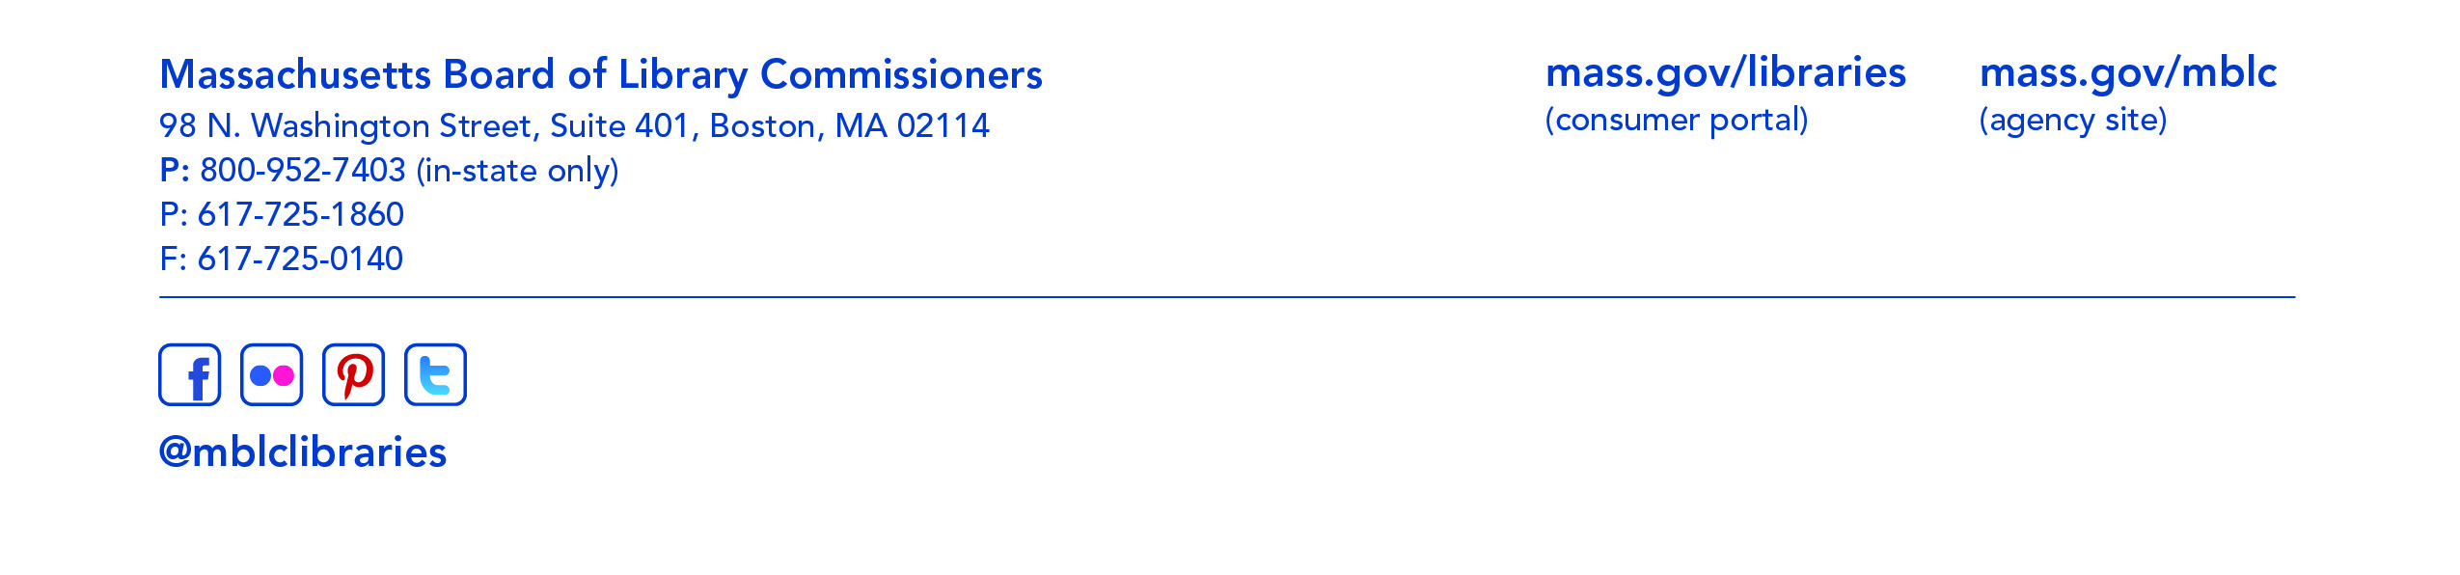
Speaker: Celeste Bruno, Communications Director
- Consideration of approval of municipalities meeting the requirements for the FY2019 State Aid to Public Libraries based on eligibility established in the FY2019 for the Municipal Appropriation Requirement and in FY2018 for the minimum standards (ACTION)

Speaker: Mary Rose Quinn, Head of State Programs/Government Liaison

- Consideration to establish a committee to review, evaluate and make recommendations concerning the Library Evolving Ecosystem Study (ACTION)

Speaker: Mary Rose Quinn, Head of State Programs/Government Liaison

- Consideration to establish a State Aid Advisory Group to provide ongoing input and recommendations to MBLC staff on the State Aid to Public Libraries Program (ACTION)

Speaker: Mary Rose Quinn, Head of State Programs/Government Liaison

- Presentation and discussion of the FY2020 Plan of Service and Program and Budget for the Massachusetts Library System and Monthly Report

Speaker: Sarah Sogigian, Interim Director
Massachusetts Library System (MLS)

- Report from Library for the Commonwealth

Speaker: Catherine Halpin, Collaborative Services Coordinator
Boston Public Library

- Standing Committee and Liaison Reports

- Commissioner Activities

- Public Comment

- Old Business

- Adjournment Roland Ochsenbein, Chairman

To review the Massachusetts Board of Library Commissioners current bylaws
(Organizations and Functions of the Board of Library Commissioners)
visit http://mblc.state.ma.us/mblc/board/MBLC_Bylaws.pdf

