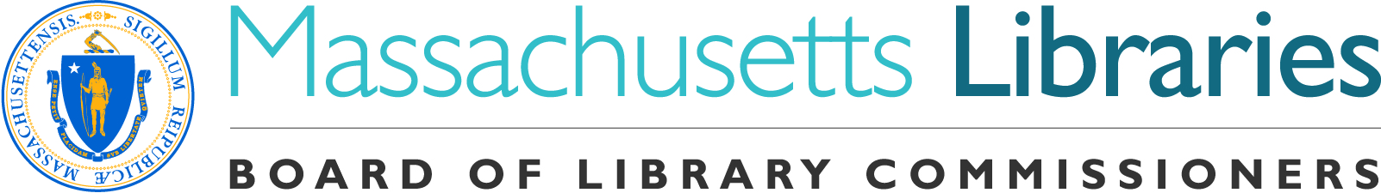
Welcome. Thank you for attending this meeting of the Massachusetts Board of Library Commissioners. Please remember that as part of the meeting agenda there is a time at the end of the meeting for public comment. Should you wish to address the Board during a particular item, please wait to be recognized by the chair.

Note: Agenda may include items not reasonably expected 48 hours before the meeting.

MBLC Offices
Boston, Massachusetts

Thursday, February 7, 2019 10:00 A.M.

Agenda

- Call to Order

- Approval of Minutes- January 3, 2019 (ACTION)

Speaker: Roland Ochsenbein, Chairman

- Chairman’s Report

Speaker: Roland Ochsenbein, Chairman

- Director’s Report

Speaker: James M. Lonergan, Director

- Legislative Report

Speaker: James M. Lonergan, Director

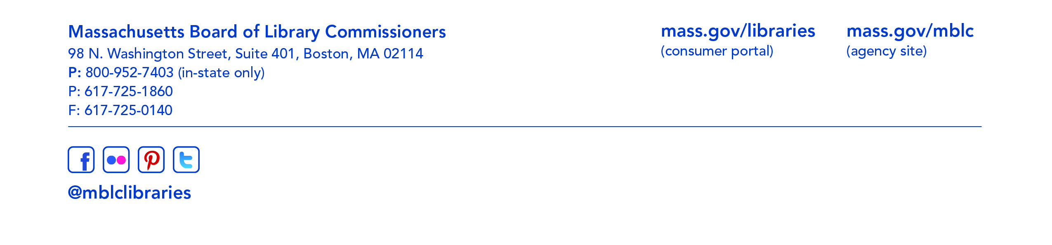
- Marketing Plan Update

Speaker: Celeste Bruno, Communications Director

- Consideration of approval of municipalities meeting the requirements for the FY2019 State Aid to Public Libraries based on eligibility established in the FY2019 for the Municipal Appropriation Requirement and in FY2018 for the minimum standards (ACTION)

Speaker: Liz Babbitt, State Aid Specialist

- Consideration of municipalities requesting waivers for the FY2019 municipal appropriation requirement in the FY2019 State Aid to Public Libraries program within the 5% threshold (ACTION)

Speaker: Liz Babbitt, State Aid Specialist

- Consideration of petition for a waiver of the municipal appropriation requirement for the FY2019 State Aid to Public Libraries Program above the 5% threshold (ACTION)

- Millville -68.5%

- Consideration of approval of the FY2020 Plan of Service and Program and Budget for the Library for the Commonwealth and Monthly Report (ACTION)

Speaker: Catherine Halpin, Collaborative Library Services Coordinator
Boston Public Library

- Consideration of request for size reduction for the Hingham Public Library Construction Project (ACTION)

Speaker: Lauren Stara, Library Building Consultant

- Update on New Summer Learning Grants

Speaker: Lyndsay Forbes, Project Manager & Grant Specialist

- Presentation and discussion of the FY2020 Plan of Service and Program and Budget for the Massachusetts Center for the Book and Monthly Report

Speaker: Krista McLeod, Director, Nevins Memorial Library, Methuen
Board Member, Massachusetts Center for the Book

- Report from the Massachusetts Library System

Speaker: Sarah Sogigian, Interim Director
Massachusetts Library System (MLS)

- Report from Library for the Commonwealth

Speaker: Catherine Halpin, Collaborative Library Services Coordinator
Boston Public Library

- Standing Committee and Liaison Reports

- Commissioner Activities

- Public Comment

- Old Business

- Adjournment Roland Ochsenbein, Chairman

To review the Massachusetts Board of Library Commissioners current bylaws
(Organizations and Functions of the Board of Library Commissioners)
visit http://mblc.state.ma.us/mblc/board/MBLC_Bylaws.pdf

