Welcome. Thank you for attending this meeting of the Massachusetts Board of Library Commissioners. Please remember that as part of the meeting agenda there is a time at the end of the meeting for public comment. Should you wish to address the Board during a particular item, please wait to be recognized by the chair.

Note: Agenda may include items not reasonably expected 48 hours before the meeting.

MBLC Offices
Boston, Massachusetts

Thursday, January 3, 2019 10:00 A.M.

Agenda

- Call to Order

- Approval of Minutes- December 6, 2018 (ACTION)

Speaker: Roland Ochsenbein, Chairman

- Chairman’s Report

Speaker: Roland Ochsenbein, Chairman

- Director’s Report

Speaker: James M. Lonergan, Director

- Legislative Report

Speaker: Mary Rose Quinn, Head of State Programs/Government Liaison

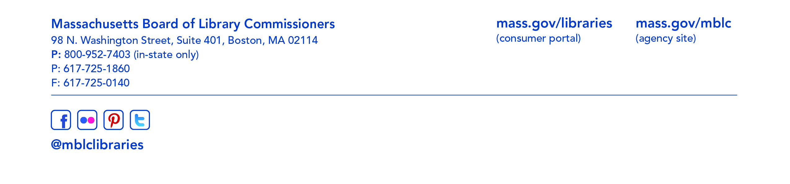
- Consideration of approval of municipalities meeting the requirements for the FY2019 State Aid to Public Libraries based on eligibility established in the FY2019 for the Municipal Appropriation Requirement and in FY2018 for the minimum standards (ACTION)

Speaker: Liz Babbitt, State Aid Specialist

- Review of municipalities requesting waivers for the FY2019 municipal appropriation requirement in the FY2019 State Aid to Public Libraries program within the 5% threshold

Speaker: Mary Rose Quinn, Head of State Programs/Government Liaison

- Review and presentation of petition for a waiver of the municipal appropriation requirement for the FY2019 State Aid to Public Libraries Program above the 5% threshold

- Millville -68.5%

Speaker: Colleen Anderson, Library Director
Colleen Curis, Trustee Chair

- Consideration to establish a State Aid Advisory Group to provide ongoing input and recommendations to MBLC staff on the State Aid to Public Libraries Program (ACTION)

Speaker: Mary Rose Quinn, Head of State Programs/Government Liaison

- Consideration of approval for the FY2020 Plan of Service and Program and Budget for the Massachusetts Library System (ACTION)

Speaker: Sarah Sogigian, Interim Director
Massachusetts Library System (MLS)

- Presentation and discussion of the FY2020 Plan of Service and Program and Budget for the Library for the Commonwealth and Monthly Report

Speaker: Catherine Halpin, Collaborative Library Services Coordinator
Boston Public Library

- Presentation and discussion of the FY2020 Plan of Service and Program and Budget for the Massachusetts Center for the Book and Monthly Report

Speaker: TBD

- Report from Library for the Commonwealth

Speaker: Catherine Halpin, Collaborative Library Services Coordinator
Boston Public Library

- Standing Committee and Liaison Reports

- Commissioner Activities

- Public Comment

- Old Business

- Adjournment Roland Ochsenbein, Chairman

To review the Massachusetts Board of Library Commissioners current bylaws
(Organizations and Functions of the Board of Library Commissioners)
visit http://mblc.state.ma.us/mblc/board/MBLC_Bylaws.pdf

