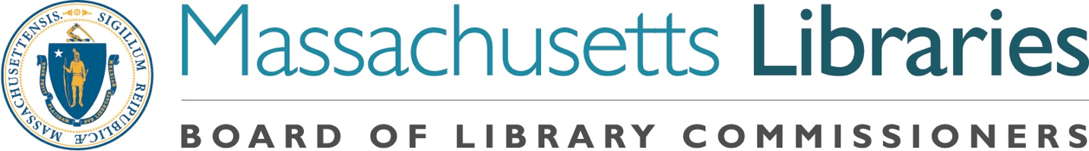
Welcome. Thank you for attending this meeting of the Massachusetts Board of Library Commissioners. Please remember that as part of the meeting agenda there is a time at the end of the meeting for public comment. Should you wish to address the Board during a particular item, please wait to be recognized by the chair.

Note: Agenda may include items not reasonably expected 48 hours before the meeting.

MBLC Office
Boston, Massachusetts

Thursday, July 12, 2018 10 A.M.

Agenda

- Call to Order

- Welcome

Speaker: Mary Ann Cluggish, Chairman

- Approval of Minutes- June 7, 2018 (ACTION)

Speaker: Mary Ann Cluggish, Chairman

- Chairman’s Report

Speaker: Mary Ann Cluggish, Chairman

- Director’s Report

Speaker: James Lonergan, Director

- Legislative Report

Speaker: Mary Rose Quinn, Head of State Programs/Government Liaison

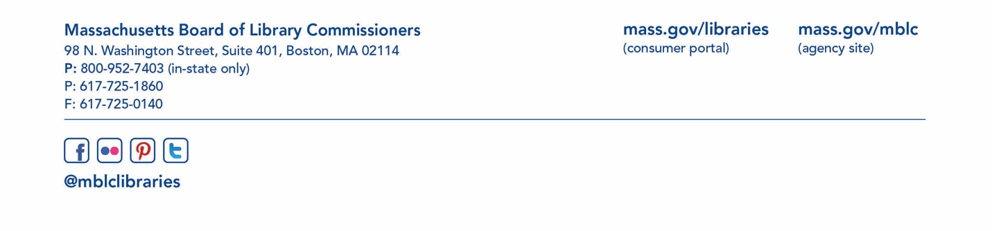
- Consideration of approval of three provisional grant awards under the Massachusetts Public Library Construction Program (ACTION)

Speaker: Lauren Stara, Library Building Consultant

- Consideration of approval of the FY2019 Library Services and Technology Act (LSTA) Grant Awards

- Access for All (ACTION)
- Anytime STEM Learning (ACTION)
- Citizenship Corners & Expanded English Language Services (ACTION)
- Civic Hub (ACTION)
- Conserving & Digitizing Historical Resources (ACTION)
- First Contact (ACTION)
- Go Local (ACTION)
- IdeaLab (ACTION)
- Innovative/Open Grant (ACTION)
- Manuscripts Arrangement and Description (ACTION)
- Mind in the Making (ACTION)
- Pathways to Success (ACTION)
- Preservation Assessment (ACTION)
- Preservation Assessment – MBLC Recommendation (ACTION)
- Preservation/Conservation of Library & Archival Materials (ACTION)
- Serving ‘Tweens and Teens(ACTION)
- Town-Wide Preservation Assessment (ACTION)

Speaker: Rob Favini, Head of Library Advisory and Development

- Report from the Massachusetts Library System

Speaker: Sarah Sogigian, Consulting and Training Services Director
Massachusetts Library System (MLS)

- Report from the Library for the Commonwealth

Speaker: Anna Fahey-Flynn, Collaborative Library Services Manager,
Boston Public Library

- Standing Committee and Liaison Reports

- Commissioner Activities

- Public Comment

- Old Business

- Election of Officers for FY2019 (ACTION)

Speaker: Greg Shesko

- Adjournment Chairman Cluggish

