Welcome. Thank you for attending this meeting of the Massachusetts Board of Library Commissioners. Please remember that as part of the meeting agenda there is a time at the end of the meeting for public comment. Should you wish to address the Board during a particular item, please wait to be recognized by the chair.

Note: Agenda may include items not reasonably expected 48 hours before the meeting.

MBLC Offices
Boston, Massachusetts

Thursday, March 7, 2019 10:00 A.M.

Agenda

- Call to Order

- Approval of Minutes- February 7, 2019 (ACTION)

Speaker: Roland Ochsenbein, Chairman

- Chairman’s Report

Speaker: Roland Ochsenbein, Chairman

- Director’s Report

Speaker: James M. Lonergan, Director

- Legislative Report

Speaker: Mary Rose Quinn, Head of State Programs/ Government Liaison

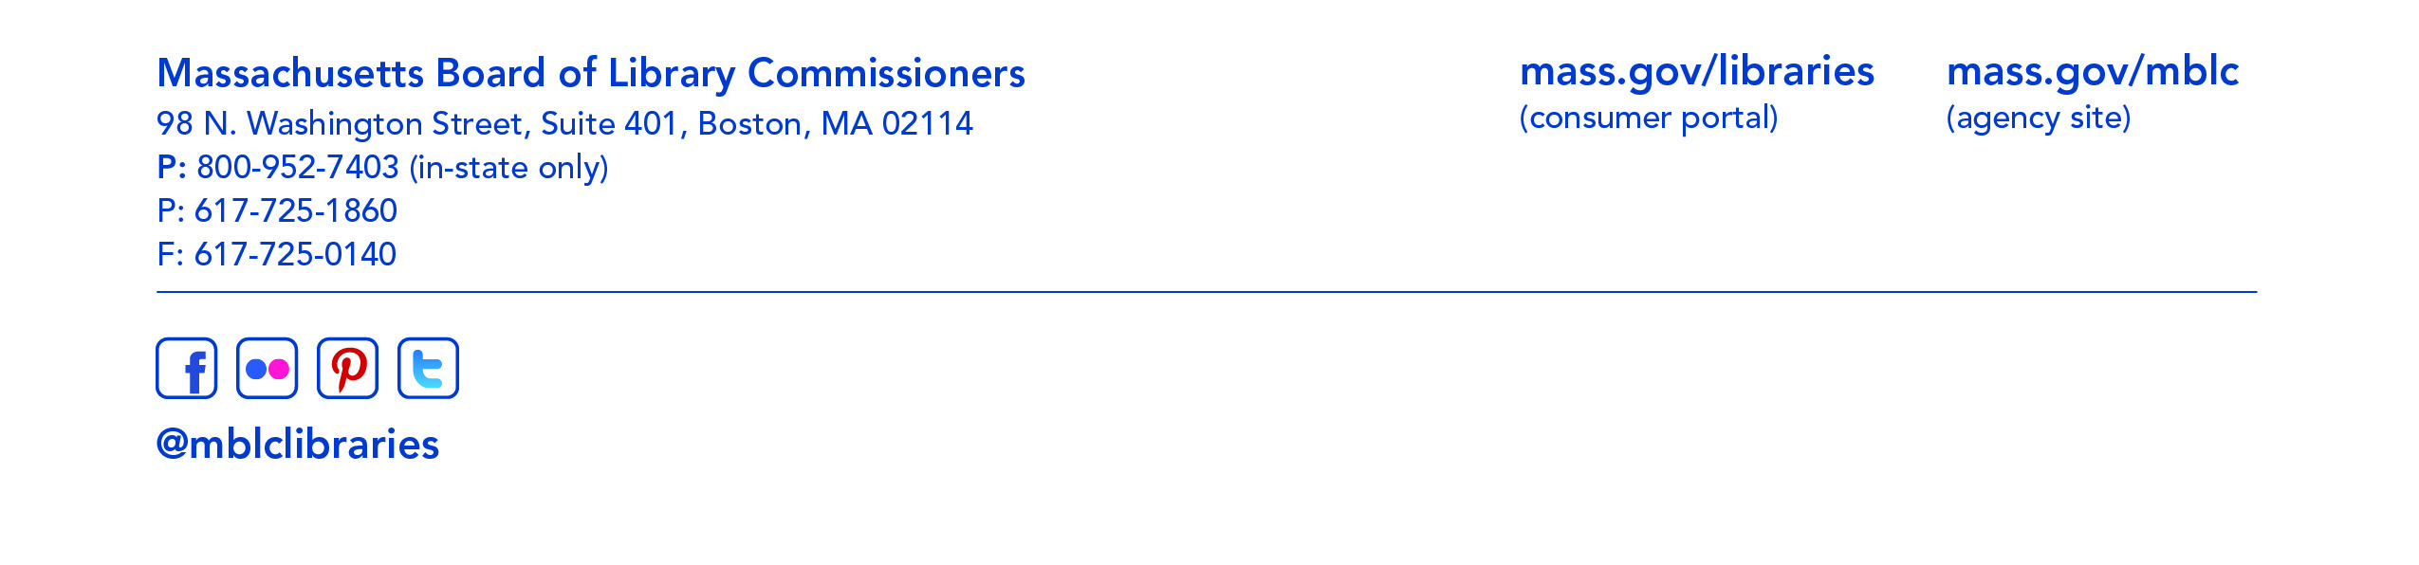

- Consideration of approval of additional members to the Evolving Ecosystem Committee (ACTION)

Speaker: Mary Rose Quinn, Head of State Programs/ Government Liaison

- Consideration of approval of additional members to the State Aid Advisory Committee (ACTION)

Speaker: Mary Rose Quinn, Head of State Programs/ Government Liaison

- Consideration of approval of new member to the Perkins Braille and Talking Book Library’s Consumer Advisory Board (ACTION)

Speaker: Mary Rose Quinn, Head of State Programs/ Government Liaison

- Consideration of approval for Supplemental Network Resource Sharing Program Award (ACTION)

Speaker: Paul Kissman, Library Information Systems Specialist

- Consideration of new appointments to the State Advisory Council on Libraries (SACL) (ACTION)

Speaker: Rob Favini, Head of Library Advisory & Development

- Consideration of approval FY2020 Plan of Service and Program and Budget for the Massachusetts Center for the Book (ACTION)

Speaker: Krista McLeod, Director, Nevins Memorial Library, Methuen
Board Member, Massachusetts Center for the Book

- Report from the Massachusetts Library System

Speaker: Betsy Meaden, Business and Human Resources Director
Steve Spohn, Resource Sharing Director
Massachusetts Library System (MLS)

- Report from Library for the Commonwealth

Speaker: Catherine Halpin, Collaborative Library Services Coordinator
Boston Public Library (BPL)

- Standing Committee and Liaison Reports

- Commissioner Activities

- Public Comment

- Old Business

- Adjournment Roland Ochsenbein, Chairman

To review the Massachusetts Board of Library Commissioners current bylaws
(Organizations and Functions of the Board of Library Commissioners)
visit http://mblc.state.ma.us/mblc/board/MBLC_Bylaws.pdf

