Welcome. Thank you for attending this meeting of the Massachusetts Board of Library Commissioners. Please remember that as part of the meeting agenda there is a time at the end of the meeting for public comment. Should you wish to address the Board during a particular item, please wait to be recognized by the chair.

Note: Agenda may include items not reasonably expected 48 hours before the meeting.

Reading Public Library
Reading, Massachusetts

Thursday, November 1, 2018 10:00 A.M.

Agenda

- Call to Order

- Welcome

Speaker: Amy Lannon, Director
Reading Public Library

- Approval of Minutes- October 4, 2018 (ACTION)

Speaker: Roland Ochsenbein, Chairman

- Chairman’s Report

Speaker: Roland Ochsenbein, Chairman

- Director’s Report

Speaker: James M. Lonergan, Director

- Legislative Report

Speaker: Mary Rose Quinn, Head of State Programs/Government Liaison

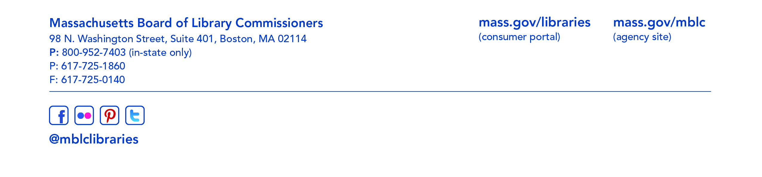
- Consideration of a request from the Greenfield Public Library for an extension of time to confirm local funding and accept its provisional grant award in the Massachusetts Public Library Construction Program (ACTION)

Speakers: Lauren Stara, Library Building Consultant
Ellen Boyer, Director, Greenfield Public Library

- Consideration of a request from the Hingham Public Library for an extension of time to confirm local funding and accept its provisional grant award in the Massachusetts Public Library Construction Program (ACTION)

Speakers: Lauren Stara, Library Building Consultant
Linda Harper, Director, Hingham Public Library

- Consideration of approval of municipalities meeting the requirements for the FY2019 State Aid to Public Libraries based on eligibility established in the FY2019 for the Municipal Appropriation Requirement and in FY2018 for the minimum standards (ACTION)

Speaker: Liz Babbitt, State Aid Specialist

- Consideration of approval of the FY2020 Library Services and Technology Act (LSTA) Direct Grant Round Program & Budget (ACTION)

Speaker: Rob Favini, Head of Library Advisory & Development

- Consideration of Updated Social Media Policies (ACTION)

Speaker: Celeste Bruno, Communications Director
Kate Butler, Electronic Systems Specialist

- Consideration of approval of budget revision for Perkins Library (ACTION)

Speaker: Mary Rose Quinn, Liaison, Perkins Library

- Discussion to establish a committee to review, evaluate and make recommendations concerning the Library Evolving Ecosystem Study

Speaker: Mary Rose Quinn, Head of State Programs/Government Liaison

- Discussion to establish a State Aid Advisory Group to provide ongoing input and recommendations to MBLC staff on the State Aid to Public Libraries Program

Speaker: Mary Rose Quinn, Head of State Programs/Government Liaison

- Report from the Massachusetts Library System

Speaker: Sarah Sogigian, Interim Director
Massachusetts Library System (MLS)

- Report from the Library for the Commonwealth

Speaker: Anna Fahey-Flynn, Central Library Manager
Boston Public Library

- Report from the Massachusetts Center for the Book

Speaker: Krista McLeod, Director, Nevins Memorial Library, Methuen
Board Member, Massachusetts Center for the Book

- Standing Committee and Liaison Reports

- Commissioner Activities

- Public Comment

- Old Business

- Adjournment Roland Ochsenbein, Chairman

To review the Massachusetts Board of Library Commissioners current bylaws
(Organizations and Functions of the Board of Library Commissioners)
visit http://mblc.state.ma.us/mblc/board/MBLC_Bylaws.pdf

