Welcome. Thank you for attending this meeting of the Massachusetts Board of Library Commissioners. Please remember that as part of the meeting agenda there is a time at the end of the meeting for public comment. Should you wish to address the Board during a particular item, please wait to be recognized by the chair.

Note: Agenda may include items not reasonably expected 48 hours before the meeting.

Berkshire Athenaeum
Pittsfield, Massachusetts

Thursday, October 4, 2018 10:00 A.M.

Agenda

- Call to Order

- Welcome

Speaker: Alex Reczkowski, Director
Berkshire Athenaeum, Pittsfield

- Approval of Minutes- September 6, 2018 (ACTION)

Speaker: Roland Ochsenbein, Chairman

- Chairman’s Report

Speaker: Roland Ochsenbein, Chairman

- Director’s Report

Speaker: James M. Lonergan, Director

- Legislative Report

Speaker: Mary Rose Quinn, Head of State Programs/Government Liaison

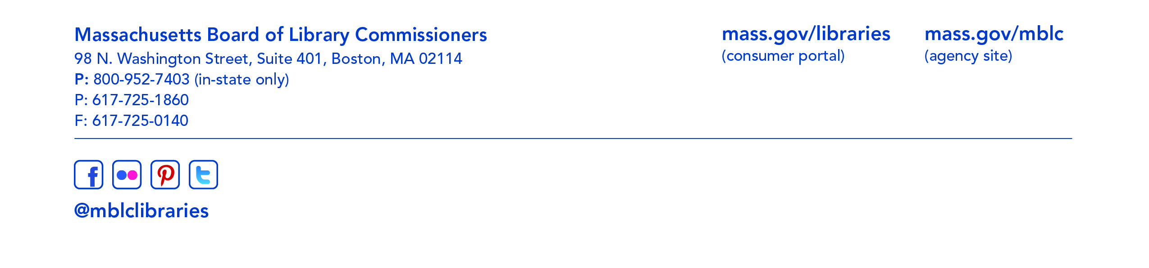
- Marketing Plan Update

Speaker: Celeste Bruno, Communications Director

- Discussion and consideration of the FY2020 Legislative Agenda (ACTION)

Speaker: James Lonergan, Director
Mary Rose Quinn, Head of State Programs/Government Liaison

- Consideration of approval of policies for the State Aid to Public Libraries Program
- Extending a Grace Period for Increased Population-Based Minimum Standards (ACTION)
- Minimum Standards of Hours of Service for Public Libraries (ACTION)
- Minimum Materials Expenditure Standard Calculation (ACTION)
- Materials Expenditure and Hours Open Accommodation Policy (ACTION)
- Municipal Appropriation Requirement Calculation (ACTION)
- Determining Eligibility for a Waiver for the FY2021 Municipal Appropriation Requirement (ACTION)
- The Closure of a Public Library (ACTION)
- Determining Eligibility for a Waiver of the FY2020 Municipal Appropriation Requirement (ACTION)

Speaker: Liz Babbitt, State Aid Specialist

- Consideration of Grant Awards under account 7000-9506
- FY2019 Resource Sharing Program Recommendation (ACTION)
- FY2019 Telecommunications for Resource Sharing Recommendation (ACTION)
- FY2019 Network Infrastructure Recommendation (ACTION)
- FY2019 Small Libraries in Network Recommendation (ACTION)

Speaker: Paul Kissman, Library Information System Specialist

- Consideration of new appointments and a reappointment to the State Advisory Council on Libraries (SACL) (ACTION)

Speaker: Rob Favini, Head of Library Advisory & Development

- Discussion of Updated Social Media Policies

Speaker: Celeste Bruno, Communications Director
Kate Butler, Electronic Systems Specialist

- Update on Strategic Plan

Speaker: James M. Lonergan, Director

- Update of MBLC Budget

Speaker: Tracey Dimant, Head of Operations and Budget

- Presentation from Trial Court Library

Speaker: Barbara Schneider
Berkshire Law Library

- Reports from the Affiliates

- Standing Committee and Liaison Reports

- Commissioner Activities

- Public Comment

- Old Business

- Adjournment Roland Ochsenbein, Chairman

To review the Massachusetts Board of Library Commissioners current bylaws
(Organizations and Functions of the Board of Library Commissioners)
visit http://mblc.state.ma.us/mblc/board/MBLC_Bylaws.pdf

