Welcome. Thank you for attending this meeting of the Massachusetts Board of Library Commissioners. Please remember that as part of the meeting agenda there is a time at the end of the meeting for public comment. Should you wish to address the Board during a particular item, please wait to be recognized by the chair.

Note: Agenda may include items not reasonably expected 48 hours before the meeting.

Scituate Town Library
Scituate, Massachusetts

Thursday, September 6, 2018 10:00 A.M.

Agenda

- Call to Order

- Welcome

Speaker: Jessi Finnie, Director, Scituate Town Library

- Approval of Minutes- August 2, 2018 (ACTION)

Speaker: Roland Ochsenbein, Chairman

- Chairman’s Report

Speaker: Roland Ochsenbein, Chairman

- Director’s Report

Speaker: James M. Lonergan, Director

- Legislative Report

Speaker: Mary Rose Quinn, Head of State Programs/Government Liaison

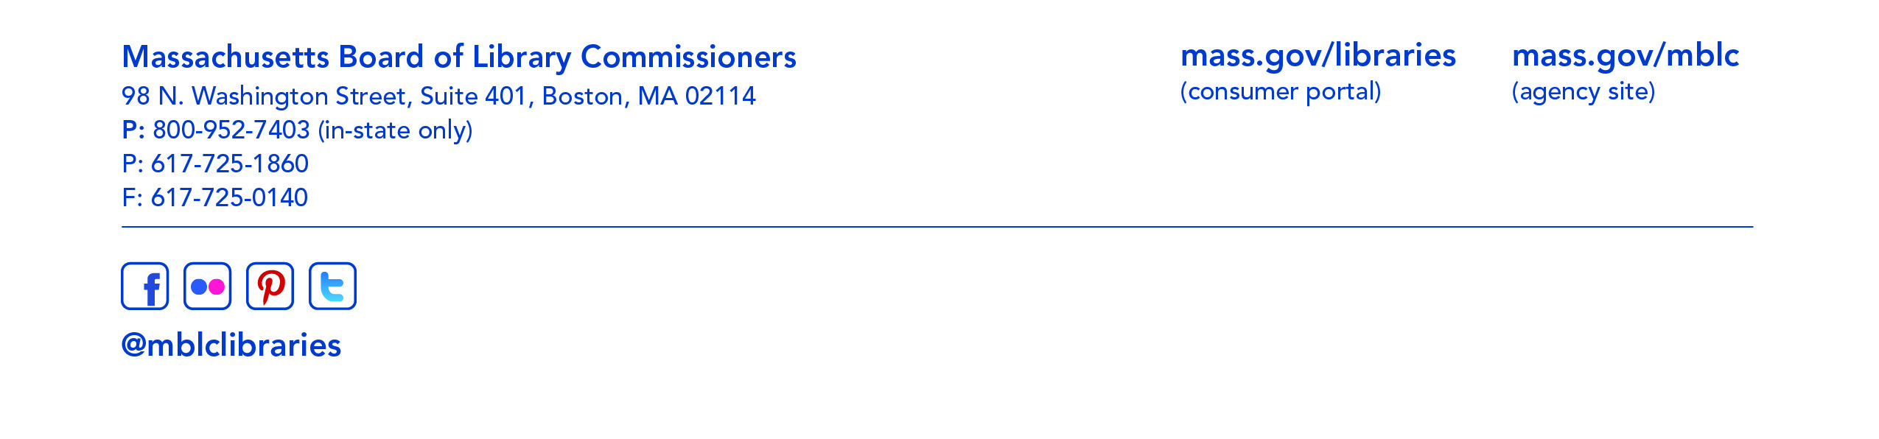

- Discussion and consideration of the FY2020 Legislative Agenda (ACTION)

Speaker: Mary Rose Quinn, Head of State Programs/Government Liaison

- MLS FY2019 Budget Revision 1 approval request (ACTION)

Speaker: Steve Spohn, Resource Sharing Director
Massachusetts Library System (MLS)

- Discussion/ review of policies for the FY2020 & FY2021 State Aid to Public Libraries Program

Speaker: Liz Babbitt, State Aid Specialist

- Update from Massachusetts School Library Association (MSLA)

Speaker: Greg Pronevitz, Consultant

- Report from the Massachusetts Library System

Speaker: Steve Spohn, Resource Sharing Director
Massachusetts Library System (MLS)

- Report from the Library for the Commonwealth

Speaker: Anna Fahey-Flynn, Collaborative Library Services Manager,
Boston Public Library

- Standing Committee and Liaison Reports

- Commissioner Activities

- Public Comment

- Old Business

- Adjournment Chairman Ochsenbein

To review the Massachusetts Board of Library Commissioners current bylaws
(Organizations and Functions of the Board of Library Commissioners)
visit http://mblc.state.ma.us/mblc/board/MBLC_Bylaws.pdf

