MINUTES OF THE special strategic planning meeting of the BOARD OF LIBRARY COMMISSIONERS

Date: Friday, June 5, 2020

Time: 1:00 P.M.

Place: Zoom Teleconference

Commissioners: Roland A. Ochsenbein, Chair; Mary Ann Cluggish, Vice Chair; Mary Kronholm, Secretary; Deb Abraham; Les Ball; Stacy DeBole; Philip Madell, Esq.; Gina Perille; N. Janeen Resnick

Staff Participants:
James Lonergan, Director; Celeste Bruno, Communications Director; Andrea Bunker, Library Building Specialist; Tracey Dimant, Head of Operations & Budget; Maura Deedy, Library Advisory Specialist; Rob Favini, Head of Library Advisory and Development; Paul Kissman, Library Information Systems Specialist; Rachel Masse, Assistant to the Director; Matthew Perry, Outreach Coordinator; Mary Rose Quinn, Head of State Programs / Government Liaison; Lauren Stara, Library Building Specialist

Observers Participants:
Jane Darling, Senior Associate, Maverick & Boutique; Ron Gagnon, Executive Director, North of Boston Library Exchange (NOBLE); Jeannette Lundgren, Network Administrator, CW MARS, Inc.; Abby Straus, Consultant, Maverick & Boutique

Meeting Called to Order by Chair Ochsenbein
Chair Ochsenbein called the meeting to order at 1:00 P.M.

The purpose of this special meeting is for the new strategic planning process.

Questions to be addressed:
- Thinking about libraries in our state and the communities they serve, what are key challenges and opportunities that we should focus on in this round of strategic planning? Please consider both pre-COVID and now, including needs highlighted by the pandemic that should be prioritized.

- Thinking about both pre-COVID and present time, what is MBLC doing really well that we want the organization to do more of? What are its strengths?
- What might be improved, and how, to realize more benefit, either internally to MBLC itself, to its partners and constituents?

- How is the BLC working as a team? How are they doing as partners within MBLC and with other organizations?
- Other thoughts/comments?

List of documents for the June 5, 2020 Special Strategic Planning Meeting:

- Agenda for the June 5, 2020 for Special Meeting

ADJOURNMENT

There being no further business, Commissioner Cluggish moved and Commissioner Resnick seconded to adjourn the June 5, 2020 special meeting of the Board of Library Commissioners at 2:29 P.M.

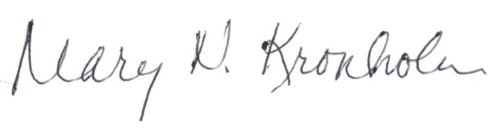

Mary Kronholm
Secretary

