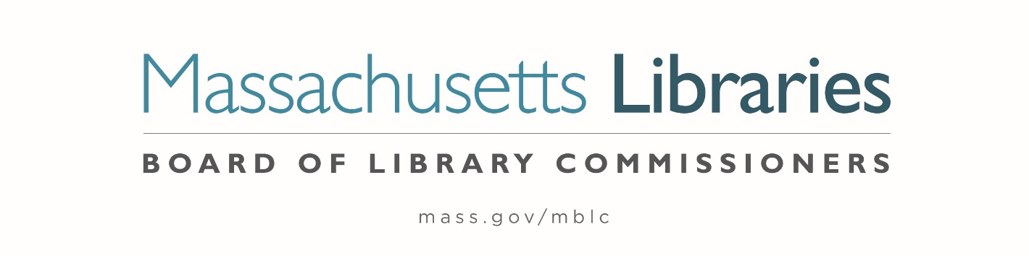

*Welcome. Thank you for attending this meeting of the Massachusetts Board of Library Commissioners. Please remember that as part of the meeting agenda there is a time at the end of the meeting for public comment. Should you wish to address the Board during a particular item, please wait to be recognized by the chair.*

*Note: Agenda may include items not reasonably expected 48 hours before the meeting.*

**Thursday, August 1, 2024 ⦁ 10:00 A.M./ Refreshments 9:30 A.M.**

**Perkins School, Grousbeck Center, Watertown**

|  |
| --- |
| Zoom Meeting Information <https://us02web.zoom.us/j/81988926269?pwd=abL3POau4Uum7eEam1UXgmrmSGiAvC.1>  Meeting ID: 819 8892 6269/ Passcode: August  Dial in number: (646) 558-8656/ Meeting ID: 819 8892 6269 |

Agenda- Regular Monthly Meeting

1. Call to order
2. Welcome

***Speaker:*** *Kim Charlson, Library Director*

1. Roll Call of Commissioners

***Speaker:*** *Vicky Biancolo, Chair*

1. Approval of Minutes- July 11, 2024 Minutes **(ACTION)**

***Speaker:*** *Vicky Biancolo, Chair*

1. Chair’s Report

***Speaker:*** *Vicky Biancolo, Chair*

1. Commissioner Reports

***Speaker:*** *Vicky Biancolo, Chair*

Posted: Friday, July 26, 2024 at 5:00 P.M.

1. Director’s Report

***Speaker:*** *Maureen Amyot, Director*

1. Perkins Report

***Speaker:*** *Kim Charlson, Executive Director*

*Perkins School Library*

1. Legislative Report

***Speaker:*** *Rob Favini, Government Liaison*

1. Presentation of New Consumer Portal

***Speakers:*** *Celeste Bruno, Communications Director*

*Kate Butler, Library Information Systems Specialist*

*Jaccavrie McNeely, Electronic Services Specialist*

1. Report from Massachusetts Library System (MLS)

***Speaker:*** *Sarah Sogigian, Executive Director*

*Massachusetts Library System (MLS)*

1. Report from the Library for the Commonwealth (LFC)

***Speaker:*** *Sarah Jackson, Network Administrator*

*Boston Public Library (BPL)*

1. Preliminary discussion of the FY2025 Legislative Agenda

***Speakers:*** *Maureen Amyot, Director*

*Rob Favini, Government Liaison*

1. Public Comment
2. Old Business
3. Adjournment *Vicky Biancolo, Chair*

**Lunch will be provided after the meeting.**

*To review the Massachusetts Board of Library Commissioners current bylaws*

*(Organizations and Functions of the Board of Library Commissioners)*

Visit <https://mblc.state.ma.us/about-us/commissioners/index.php>