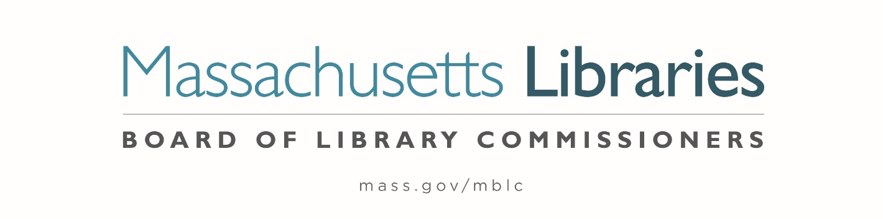

*Welcome. Thank you for attending this meeting of the Massachusetts Board of Library Commissioners. Please remember that as part of the meeting agenda there is a time at the end of the meeting for public comment. Should you wish to address the Board during a particular item, please wait to be recognized by the chair.*

*Note: Agenda may include items not reasonably expected 48 hours before the meeting.*

**Thursday, December 5, 2024 ⦁ 10:00 A.M./ Refreshments 9:30 A.M.**

**MBLC Offices, Boston**

|  |
| --- |
| Zoom Meeting Information <https://us02web.zoom.us/meeting/register/tZ0sc-yuqToiHNUrUhjj1IDhgHqZeOzTyNJc>  Dial in number: (646) 558-8656/ Meeting ID: 891 4567 1861 |

Agenda- Regular Monthly Meeting

1. Call to order
2. Welcome
3. Roll Call of Commissioners

***Speaker:*** *Karen Traub, Secretary*

1. Approval of Minutes- November 7, 2024 Minutes **(ACTION)**

***Speaker:*** *Vicky Biancolo, Chair*

1. Chair’s Report

***Speaker:*** *Vicky Biancolo, Chair*

1. Commissioner Reports

***Speaker:*** *Vicky Biancolo, Chair*



1. Director’s Report

***Speaker:*** *Maureen Amyot, Director*

1. Legislative Report

***Speaker:*** *Rob Favini, Government Liaison*

1. Consideration of approval of municipalities meeting the requirements for the FY2025 State Aid to Public Libraries based on eligibility established in FY2025 for the Municipal Appropriation Requirement and in FY2024 for the minimum standards **(ACTION)**

***Speakers:*** *Cate Merlin, Head of State Programs*

*Jen Inglis, State Aid Specialist*

1. Consideration of an extension request by the Jones Library, Amherst for the deadline to sign a contract with a general contractor to March 31, 2025. In accordance with the 2015 Massachusetts Public Library Construction Program’s regulations, the deadline for this milestone was June 30, 2024, which was extended at the Town and Library's  request to December 31, 2024. **(ACTION)**

***Speakers:*** *Sharon Sharry, Director, Jones Library, Amherst*

*Maureen Amyot, Director*

*Andrea Bono-Bunker, Library Building Consultant*

1. Report from Massachusetts Library System (MLS)

***Speaker:*** *Sarah Sogigian, Executive Director*

*Massachusetts Library System (MLS)*

1. Report from the Library for the Commonwealth (LFC)

***Speaker:*** *Sarah Jackson, Network Administrator*

*Boston Public Library (BPL)*

1. Quarterly Report from Worcester Talking Book Library

***Speaker:*** *Lee Anne Hooley, Worcester Talking Book Library*

1. Staff Service Pins

***Speaker:*** *Maureen Amyot, Director*

1. Unfinished Business and General Orders
2. Public Comment
3. Adjournment *Vicky Biancolo, Chair*

*To review the Massachusetts Board of Library Commissioners current bylaws*

*(Organizations and Functions of the Board of Library Commissioners)*

Visit <https://mblc.state.ma.us/about-us/commissioners/index.php>