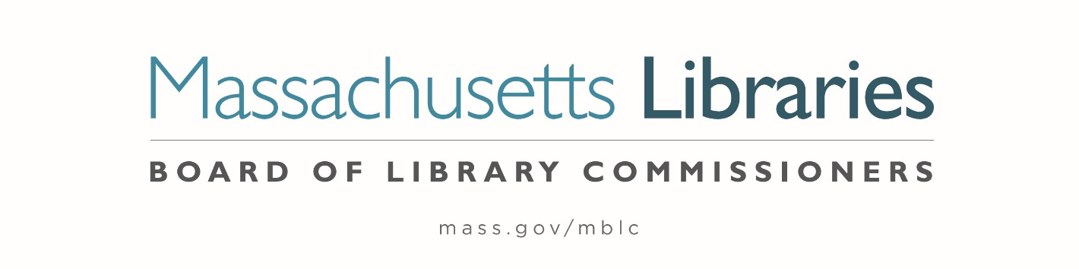

*Welcome. Thank you for attending this meeting of the Massachusetts Board of Library Commissioners. Please remember that as part of the meeting agenda there is a time at the end of the meeting for public comment. Should you wish to address the Board during a particular item, please wait to be recognized by the chair.*

*Note: Agenda may include items not reasonably expected 48 hours before the meeting.*

**Thursday, February 6, 2025 ⦁ 10:00 A.M./ Refreshments 9:30 A.M.**

**MBLC Offices, Boston**

|  |
| --- |
| Zoom Meeting Information <https://us02web.zoom.us/j/86913995310?pwd=NR7NSPSEQuArivMHaCacUpExSr2esd.1>  Dial in number: (646) 558-8656/ Meeting ID: 890 0234 4762 |

Agenda- Regular Monthly Meeting

1. Call to order
2. Welcome- Lieutenant Governor Kim Driscoll
3. Roll Call of Commissioners

***Speaker:*** *Karen Traub, Secretary*

1. Approval of Minutes- January 9, 2025 Minutes

***Speaker:*** *Vicky Biancolo, Chair*

1. Chair’s Report

***Speaker:*** *Vicky Biancolo, Chair*

1. Commissioner Reports

***Speaker:*** *Vicky Biancolo, Chair*



1. Director’s Report

***Speaker:*** *Maureen Amyot, Director*

1. Legislative Report

***Speaker:*** *Rob Favini, Government Liaison*

1. Consideration of approval of municipalities requesting waivers for the FY2025 municipal appropriation requirement in the FY2025 State Aid to Public Libraries Program within the 5% threshold **(ACTION)**

***Speakers:*** *Cate Merlin, Head of State Programs*

1. Consideration of approval of a petition for a waiver of the municipal appropriation requirement for the FY2025 State Aid to Public Libraries Program above the 5% threshold **(ACTION)**

a.      Wales         6.11%

***Speaker:****Cate Merlin, Head of State Programs*

1. Consideration of approval of the FY2026 Plan of Service and Program and Budget for the Massachusetts Center for the Book **(ACTION)**

***Speaker:*** *Courtney Andree, Executive Director*

*Massachusetts Center for the Book*

1. Presentation and discussion of the FY2026 Plan of Service and Program and Budget for the Massachusetts Library System (MLS) and Monthly Report

***Speaker:*** *Sarah Sogigian, Executive Director*

*Massachusetts Library System (MLS)*

1. Report from the Library for the Commonwealth

***Speaker:*** *Sarah Jackson, Network Administrator*

*Library for the Commonwealth/ Boston Public Library (BPL)*

1. Quarterly Report from the Perkins Talking Book Library

***Speaker:*** *Kim Charlson, Library Director*

*Perkins Talking Book Library, Watertown*

1. Unfinished Business and General Orders
2. Establish a subcommittee to update the Commissioners’ Roles and Responsibilities
3. Public Comment
4. Adjournment *Vicky Biancolo, Chair*

*To review the Massachusetts Board of Library Commissioners current bylaws*

*(Organizations and Functions of the Board of Library Commissioners)*

Visit <https://mblc.state.ma.us/about-us/commissioners/index.php>