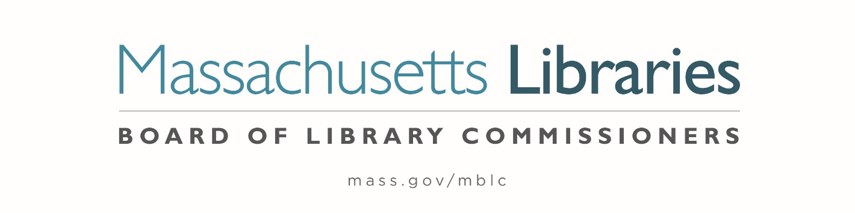

*Welcome. Thank you for attending this meeting of the Massachusetts Board of Library Commissioners. Please remember that as part of the meeting agenda there is a time at the end of the meeting for public comment. Should you wish to address the Board during a particular item, please wait to be recognized by the chair.*

*Note: Agenda may include items not reasonably expected 48 hours before the meeting.*

**Thursday, January 9, 2025 ⦁ 10:00 A.M./ Refreshments 9:30 A.M.**

**MBLC Offices, Boston**

|  |
| --- |
| Zoom Meeting Information <https://us02web.zoom.us/j/86913995310?pwd=NR7NSPSEQuArivMHaCacUpExSr2esd.1>  Dial in number: (646) 558-8656/ Meeting ID: 869 1399 5310 |

Agenda- Regular Monthly Meeting

1. Call to order
2. Welcome
3. Roll Call of Commissioners

***Speaker:*** *Karen Traub, Secretary*

1. Approval of Minutes- December 5, 2024 Minutes

***Speaker:*** *Vicky Biancolo, Chair*

1. Chair’s Report

***Speaker:*** *Vicky Biancolo, Chair*

1. Commissioner Reports

***Speaker:*** *Vicky Biancolo, Chair*



1. Director’s Report

***Speaker:*** *Maureen Amyot, Director*

1. Legislative Report

***Speaker:*** *Rob Favini, Government Liaison*

1. Consideration of approval of municipalities meeting the requirements for the FY2025 State Aid to Public Libraries based on eligibility established in FY2025 for the Municipal Appropriation Requirement and in FY2024 for the minimum standards **(ACTION)**

***Speakers:*** *Cate Merlin, Head of State Programs*

*Jen Inglis, State Aid Specialist*

1. Review of municipalities requesting waivers for the FY2025 municipal appropriation requirement in the FY2025 State Aid to Public Libraries Program within the 5% threshold

***Speaker:****Cate Merlin, Head of State Programs*

1. Review and presentation of petition for a waiver of the municipal appropriation requirement for the FY2025 State Aid to Public Libraries Program above the 5% threshold

a.      Wales

***Speaker:****Cate Merlin, Head of State Programs*

1. Consideration of approval for the 2023-2024 Planning and Design Grant Round
2. Small Tier **(ACTION)**
3. Medium Tier **(ACTION)**
4. Large Tier **(ACTION)**

***Speakers:****Andrea Bono-Bunker, Library Building Consultant*

*Heather Backman, Library Building Specialist*

1. Report from Massachusetts Library System (MLS)

***Speaker:*** *Sarah Sogigian, Executive Director*

*Massachusetts Library System (MLS)*

1. Report from the Library for the Commonwealth (LFC)

***Speaker:*** *Sarah Jackson, Network Administrator*

*Boston Public Library (BPL)*

1. Presentation and discussion of the FY2026 Plan of Service and Program and Budget for the Massachusetts Center for the Book and Monthly Report

***Speaker:*** *Courtney Andree, Executive Director*

*Massachusetts Center for the Book*

1. Establish a subcommittee to update the Commissioners’ Roles and Responsibilities

***Speaker:*** *Karen Traub, Secretary*

1. Unfinished Business and General Orders
2. Public Comment
3. Adjournment *Vicky Biancolo, Chair*

*To review the Massachusetts Board of Library Commissioners current bylaws*

*(Organizations and Functions of the Board of Library Commissioners)*

Visit <https://mblc.state.ma.us/about-us/commissioners/index.php>