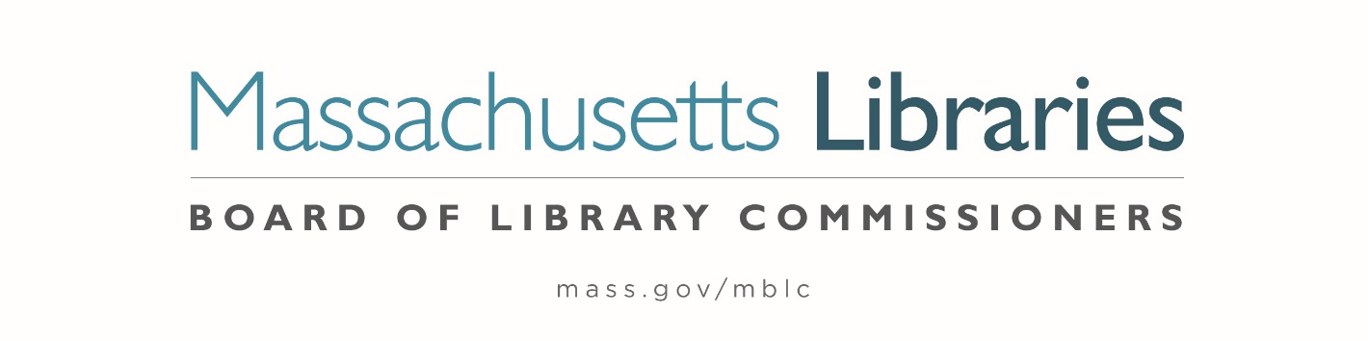

*Welcome. Thank you for attending this meeting of the Massachusetts Board of Library Commissioners. Please remember that as part of the meeting agenda there is a time at the end of the meeting for public comment. Should you wish to address the Board during a particular item, please wait to be recognized by the chair.*

*Note: Agenda may include items not reasonably expected 48 hours before the meeting.*

**Thursday, March 6, 2025 ⦁ 10:00 A.M./ Refreshments 9:30 A.M.**

**Massachusetts Library System, Marlborough**

|  |
| --- |
| Zoom Meeting Information [https://us02web.zoom.us/j/87969276770?pwd=tfn9r18bGH1Xqpdk2jxrkjhyYu4Uhp.1](https://us02web.zoom.us/j/87969276770?pwd=tfn9r18bGH1Xqpdk2jxrkjhyYu4Uhp.1" \t "_blank)  Dial in number: (646) 558-8656/ Meeting ID: 879 6927 6770 |

Agenda- Regular Monthly Meeting

1. Call to order

***Speaker:*** *Betsy Meaden, Business/ HR Director*

*Massachusetts Library System (MLS)*

1. Roll Call of Commissioners

***Speaker:*** *Karen Traub, Secretary*

1. Approval of Minutes- February 6, 2025 Minutes

***Speaker:*** *Vicky Biancolo, Chair*

1. Chair’s Report

***Speaker:*** *Vicky Biancolo, Chair*

1. Commissioner Reports

***Speaker:*** *Vicky Biancolo, Chair*



1. Director’s Report and Legislative Report

***Speaker:*** *Vicky Biancolo, Chair*

1. Consideration of an extension request by the Jones Library, Amherst for the deadline to sign a contract with a general contractor to April 30, 2025. In accordance with the 2015 Massachusetts Public Library Construction Program’s regulations, the deadline for this milestone was June 30, 2024, which was extended at the Town and Library's  request to December 31, 2024 then March 31, 2025. **(ACTION)**

***Speakers:*** *Sharon Sharry, Director, Jones Library, Amherst*

*Maureen Amyot, Director*

*Andrea Bono-Bunker, Library Building Consultant*

1. Consideration of approval of the FY2026 Plan of Service and Program and Budget for the Massachusetts Library System (MLS) and Monthly Report **(ACTION)**

***Speaker:*** *Betsy Meaden, Business/ HR Director*

*Massachusetts Library System (MLS)*

1. Discussion/ review of policies for the FY2027 State Aid to Public Libraries Program

***Speakers:*** *Cate Merlin, Head of State Programs*

*Jen Inglis, State Aid Specialist*

1. Presentation and discussion of the FY2026 Plan of Service and Program and Budget for the Library for the Commonwealth (LFC) and Monthly Report

***Speaker:*** *Sarah Jackson, Network Administrator*

*Library for the Commonwealth/ Boston Public Library (BPL)*

1. Quarterly Report from the Worcester Talking Book Library

***Speaker:*** *Lee Anne Hooley, Library Director*

*Worcester Talking Book Library*

1. Unfinished Business and General Orders
2. Public Comment
3. Adjournment *Vicky Biancolo, Chair*

*To review the Massachusetts Board of Library Commissioners current bylaws*

*(Organizations and Functions of the Board of Library Commissioners)*

Visit <https://mblc.state.ma.us/about-us/commissioners/index.php>