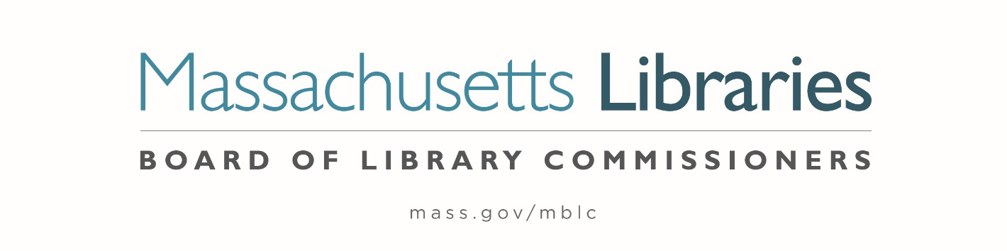

*Welcome. Thank you for attending this meeting of the Massachusetts Board of Library Commissioners. Please remember that as part of the meeting agenda there is a time at the end of the meeting for public comment. Should you wish to address the Board during a particular item, please wait to be recognized by the chair.*

*Note: Agenda may include items not reasonably expected 48 hours before the meeting.*

**Thursday, November 7, 2024 ⦁ 10:00 A.M./ Refreshments 9:30 A.M.**

**Greenfield Public Library**

|  |
| --- |
| Zoom Meeting Information <https://us02web.zoom.us/j/83736126133?pwd=zaexN2aSNcg7d9h1SboiLYaQ7kCJxG.1>  Meeting ID: 837 3612 6133/ Passcode: November  Dial in number: (646) 558-8656/ Meeting ID: 837 3612 6133 |

Agenda- Regular Monthly Meeting

1. Call to order
2. Welcome

***Speaker:*** *Anna Bognolo, Library Director*

1. Roll Call of Commissioners

***Speaker:*** *Karen Traub, Secretary*

1. Approval of Minutes- October 3, 2024 Minutes **(ACTION)**

***Speaker:*** *Vicky Biancolo, Chair*

1. Chair’s Report

***Speaker:*** *Vicky Biancolo, Chair*

1. Commissioner Reports

***Speaker:*** *Vicky Biancolo, Chair*



1. Director’s Report

***Speaker:*** *Maureen Amyot, Director*

1. Legislative Report

***Speaker:*** *Rob Favini, Government Liaison*

1. Consideration of approval of municipalities meeting the requirements for the FY2025 State Aid to Public Libraries based on eligibility established in FY2025 for the Municipal Appropriation Requirement and in FY2024 for the minimum standards **(ACTION)**

***Speakers:*** *Cate Merlin, Head of State Programs*

*Jen Inglis, State Aid Specialist*

1. Consideration of approval of the FY2026 Library Services and Technology Act (LSTA) Direct Grant Round Program & Budget **(ACTION)**

***Speaker:*** *Rob Favini, Head of Library Advisory & Development*

1. Consideration of appointments to the State Advisory Council on Libraries (SACL) **(ACTION)**

***Speaker:*** *Rob Favini, Head of Library Advisory & Development*

1. Updated totals for Small Libraries in Networks Grants and Resource Sharing Grants **(ACTION)**

***Speakers:*** *Kate Butler, Library Information Systems Specialist*

*Rob Favini, Head of Library Advisory & Development*

1. Report from Massachusetts Library System (MLS)

***Speaker:*** *Sarah Sogigian, Executive Director*

*Massachusetts Library System (MLS)*

1. Report from the Library for the Commonwealth (LFC)

***Speaker:*** *Sarah Jackson, Network Administrator*

*Boston Public Library (BPL)*

1. Quarterly Report from Perkins Library

***Speaker:*** *Kim Charlson, Library Director*

*Perkins Library*

1. Report from Simmons University

***Speakers:*** *Eric Poulin, Assistant Professor & Director of SLIS West*

*Dr. Sandra Erdelez, Dean of the School of Library & Information Science*

1. Unfinished Business and General Orders
2. Public Comment
3. Adjournment *Vicky Biancolo, Chair*

*To review the Massachusetts Board of Library Commissioners current bylaws*

*(Organizations and Functions of the Board of Library Commissioners)*

Visit <https://mblc.state.ma.us/about-us/commissioners/index.php>