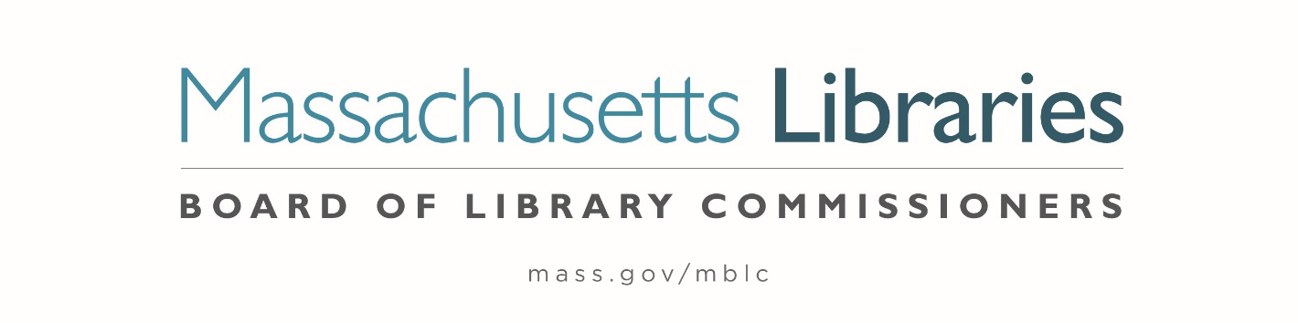

*Welcome. Thank you for attending this meeting of the Massachusetts Board of Library Commissioners. Please remember that as part of the meeting agenda there is a time at the end of the meeting for public comment. Should you wish to address the Board during a particular item, please wait to be recognized by the chair.*

*Note: Agenda may include items not reasonably expected 48 hours before the meeting.*

**Thursday, October 3, 2024 ⦁ 10:00 A.M./ Refreshments 9:30 A.M.**

**North Branch Library, Dartmouth**

|  |
| --- |
| Zoom Meeting Information <https://us02web.zoom.us/j/83027873646?pwd=xEQoIuGivDoksp9irunqq2MgQrZeWe.1>  Meeting ID: 830 2787 3646/ Passcode: October  Dial in number: (646) 558-8656/ Meeting ID: 830 2787 3646 |

Agenda- Regular Monthly Meeting

1. Call to order
2. Welcome

***Speaker:*** *Dina St. Pierre, Director of Libraries*

1. Roll Call of Commissioners

***Speaker:*** *Vicky Biancolo, Chair*

1. Approval of Minutes- September 5, 2024 Minutes **(ACTION)**

***Speaker:*** *Vicky Biancolo, Chair*

1. Chair’s Report

***Speaker:*** *Vicky Biancolo, Chair*

1. Commissioner Reports

***Speaker:*** *Vicky Biancolo, Chair*



1. Director’s Report

***Speaker:*** *Maureen Amyot, Director*

1. Legislative Report

***Speaker:*** *Rob Favini, Government Liaison*

1. Consideration of Network Grant Awards under account 7000-9506

a. FY2025 Small Libraries in Networks Recommendation **(ACTION)**

b. FY2025 Telecommunications for Resource Sharing Recommendation **(ACTION)**

c. FY2025 Network Infrastructure Recommendation **(ACTION)**

d. FY2025 Resource Sharing Program Recommendation **(ACTION)**

***Speaker:*** *Kate Butler,* Library Information Systems Specialist

1. Consideration of approval for the Library eBooks and Audiobooks (LEA) Content Grants

**(ACTION)**

***Speaker:*** *Jaccavrie McNeely, Electronic Systems Specialist*

1. Consideration of approval of two Planning and Design Grants for the Small Population Grant Type **(ACTION)**

***Speakers:*** *Andrea Bono-Bunker, Library Building Consultant*

*Heather Backman, Library Building Specialist*

1. Presentation of FY2025 MBLC Budget

***Speaker:*** *Tracey Dimant, Head of Operations and Budget*

1. Report from Massachusetts Library System (MLS)

***Speaker:*** *Sarah Sogigian, Executive Director*

*Massachusetts Library System (MLS)*

1. Report from the Library for the Commonwealth (LFC)

***Speaker:*** *Sarah Jackson, Network Administrator*

*Boston Public Library (BPL)*

1. Quarterly Report from Massachusetts Center for the Book

***Speaker:*** *Courtney Andree, Executive Director*

*Massachusetts Center for the Book*

1. Public Comment
2. Old Business
3. Adjournment *Vicky Biancolo, Chair*

*To review the Massachusetts Board of Library Commissioners current bylaws*

*(Organizations and Functions of the Board of Library Commissioners)*

Visit <https://mblc.state.ma.us/about-us/commissioners/index.php>