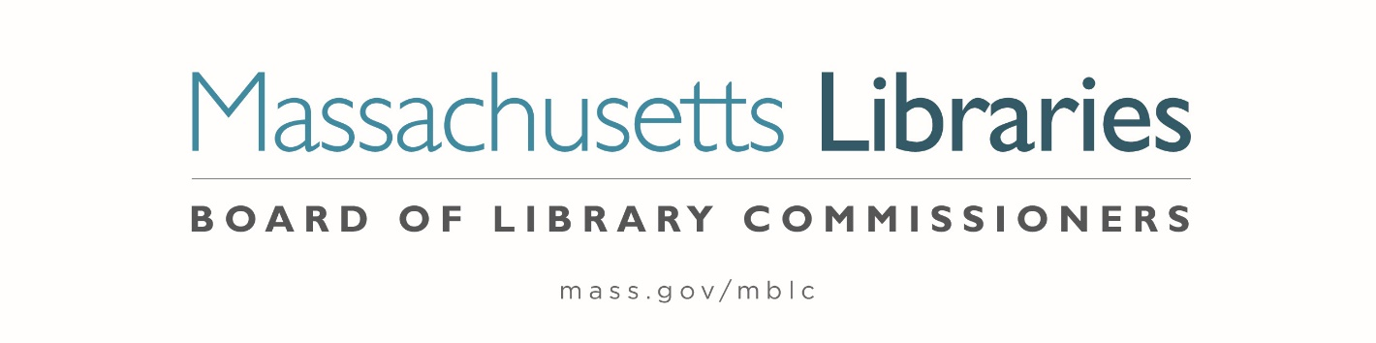

Welcome. Thank you for attending this meeting of the Massachusetts Board of Library Commissioners. Please remember that as part of the meeting agenda there is a time at the end of the meeting for public comment. Should you wish to address the Board during a particular item, please wait to be recognized by the chair.
Note: Agenda may include items not reasonably expected 48 hours before the meeting.
Massachusetts Board of Library Commissioners Monthly Board Meeting
Thursday, April 2, 2026
HYBRID*
Sawyer Free Library, Gloucester
2 Dale Avenue, Gloucester, MA
Meeting to Start: 10:00 AM

*Pursuant to Chapter 2 of the Acts of 2025- An Act Extending Certain COVID-19 Measures Adopted During the State of Emergency, this meeting will be conducted in person and via remote means, in accordance with applicable law. This means that members of the public body as well as members of the public may access this meeting in person, or via virtual means. In person attendance will be at the Sawyer Free Library in Gloucester and it is possible that or all members of the public body may attend remotely, with in-person attendance consisting of members of the public. This meeting may be accessed remotely via:

Register in advance for this meeting:
https://us02web.zoom.us/meeting/register/Xdv8sYKfTzWX-zGg_BJ4yg

When required by law or allowed by the Chair, persons wishing to provide public comment or otherwise participate in the meeting, may do so by in-person attendance, or by accessing the meeting remotely, as noted above.

- Call to order

- Welcome

Speaker: Jenny Benedict, Library Director

- Roll Call of Commissioners

Speaker: Commissioner Linehan, Secretary

- Approval of Minutes- March 5, 2026 Minutes

Speaker: Vicky Biancolo, Chair
- Chair’s Report

Speaker: Vicky Biancolo, Chair

- Commissioner Reports

Speaker: Vicky Biancolo, Chair

- Director’s Report

Speaker: Maureen Amyot, Director

- Legislative Report

Speaker: Rob Favini, Government Liaison
- Consideration of approval 2023-2024 Grant Round Construction Phase Provisional Grant Award

- Small Population- Otis (ACTION)
- Small and Medium Tiers: Freetown, Hanson, and Yarmouth (ACTION)
- Large Tier: Waltham (ACTION)

Speakers: Andrea Bono-Bunker, Library Building Consultant
Heather Backman, Library Building Specialist

- Monthly Report from Massachusetts Library System (MLS)

Speaker: Sarah Sogigian, Executive Director
Massachusetts Library System

- Monthly Report from the Library for the Commonwealth (LFC)

Speaker: Sarah Jackson, Network Administrator
Library for the Commonwealth/ Boston Public Library (BPL)

- Quarterly Report from the Massachusetts Center for the Book

Speaker: Courtney Andree, Executive Director
Massachusetts Center for the Book

- Reports from Library Partners

- Unfinished Business and General Orders

- Public Comment

- Adjournment Vicky Biancolo, Chair

To review the Massachusetts Board of Library Commissioners current bylaws
(Organizations and Functions of the Board of Library Commissioners)
Visit https://mblc.state.ma.us/about-us/commissioners/index.php

