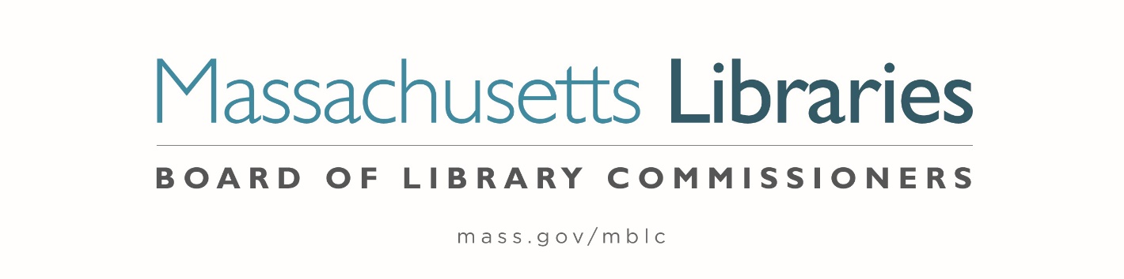

Welcome. Thank you for attending this meeting of the Massachusetts Board of Library Commissioners. Please remember that as part of the meeting agenda there is a time at the end of the meeting for public comment. Should you wish to address the Board during a particular item, please wait to be recognized by the chair.
Note: Agenda may include items not reasonably expected 48 hours before the meeting.
Massachusetts Board of Library Commissioners Monthly Board Meeting
Thursday, January 8, 2026
HYBRID*
Massachusetts Board of Library Commissioners Offices
90 Canal Street, Suite 500, Boston, MA
Meeting to Start: 10:00 AM

*Pursuant to Chapter 2 of the Acts of 2025- An Act Extending Certain COVID-19 Measures Adopted During the State of Emergency, this meeting will be conducted in person and via remote means, in accordance with applicable law. This means that members of the public body as well as members of the public may access this meeting in person, or via virtual means. In person attendance will be at the Massachusetts Board of Library Commissioners Offices and it is possible that or all members of the public body may attend remotely, with in-person attendance consisting of members of the public. This meeting may be accessed remotely via:

Register in advance for this meeting:
https://us02web.zoom.us/meeting/register/0DF-sbM8SaKx49zfPZE_AA

When required by law or allowed by the Chair, persons wishing to provide public comment or otherwise participate in the meeting, may do so by in-person attendance, or by accessing the meeting remotely, as noted above.

- Call to order

- Welcome

- Roll Call of Commissioners

Speaker: Commissioner Linehan, Secretary

- Approval of Minutes- November 6, 2025 & December 4, 2025 Minutes

Speaker: Vicky Biancolo, Chair

- Chair’s Report

Speaker: Vicky Biancolo, Chair

- Commissioner Reports

Speaker: Vicky Biancolo, Chair

- Director’s Report

Speaker: Maureen Amyot, Director

- Legislative Report

Speaker: Rob Favini, Government Liaison

- Consideration of approval for 2 Board policies (ACTION)

Speaker: Maureen Amyot, Director

- Consideration of approval of municipalities meeting the requirements for the FY2026 State Aid to Public Libraries based on eligibility established in FY2026 for the Municipal Appropriation Requirement and in FY2025 for the minimum standards (ACTION)

Speakers: Cate Merlin, Head of State Programs
Jen Inglis, State Aid Specialist

- Review of municipalities requesting waivers for the FY2026 municipal appropriation requirement in the FY2026 State Aid to Public Libraries Program within the 5% threshold

Speaker: Cate Merlin, Head of State Programs

- Review and presentation of petition for a waiver of the municipal appropriation requirement for the FY2026 State Aid to Public Libraries Program above the 5% threshold

  - Norwell
  - Stoneham

Speaker: Cate Merlin, Head of State Programs

- Presentation and discussion of the FY2027 Plan of Service and Program and Budget for the Massachusetts Library System and Monthly Report

Speaker: Sarah Sogigian, Executive Director
Massachusetts Library System

- Presentation and discussion of the FY2027 Plan of Service and Program and Budget for the Massachusetts Center for the Book and Quarterly Report

Speaker: Courtney Andree, Executive Director
Massachusetts Center for the Book

- Report from the Library for the Commonwealth (LFC)

Speaker: Sarah Jackson, Network Administrator
Library for the Commonwealth/ Boston Public Library

- Discussion about legislative breakfasts

- Reports from Library Partners

- Unfinished Business and General Orders

- Public Comment

- Adjournment Vicky Biancolo, Chair

To review the Massachusetts Board of Library Commissioners current bylaws
(Organizations and Functions of the Board of Library Commissioners)
Visit https://mblc.state.ma.us/about-us/commissioners/index.php

