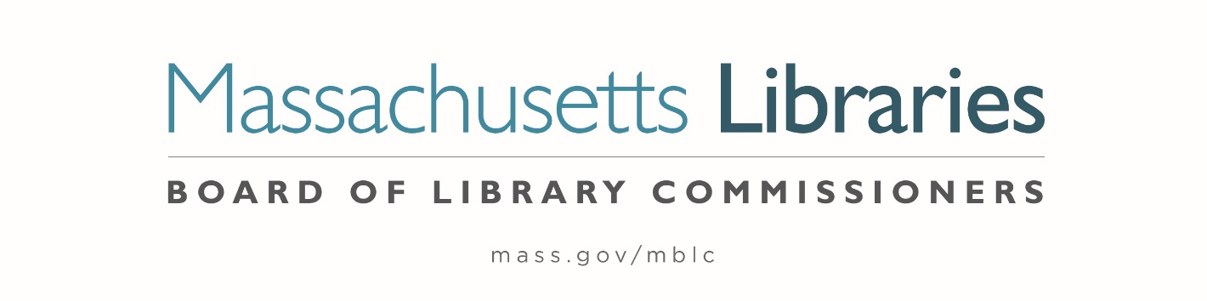

Welcome. Thank you for attending this meeting of the Massachusetts Board of Library Commissioners. Please remember that as part of the meeting agenda there is a time at the end of the meeting for public comment. Should you wish to address the Board during a particular item, please wait to be recognized by the chair.
Note: Agenda may include items not reasonably expected 48 hours before the meeting.
Massachusetts Board of Library Commissioners Monthly Board Meeting
Thursday, July 10, 2025
HYBRID*
MBLC Offices, 90 Canal Street, Suite 500, Boston, MA 02114
10:00 AM (Refreshments 9:30 AM)

*Pursuant to Chapter 2 of the Acts of 2025- An Act Extending Certain COVID-19 Measures Adopted During the State of Emergency, this meeting will be conducted in person and via remote means, in accordance with applicable law. This means that members of the public body as well as members of the public may access this meeting in person, or via virtual means. In person attendance will be at Massachusetts Board of Library Commissioners Offices, Boston and it is possible that or all members of the public body may attend remotely, with in-person attendance consisting of members of the public. This meeting may be accessed remotely via:

Register in advance for this meeting:
https://us02web.zoom.us/meeting/register/0FwBdG1RRhmk1BJtEh9wFQ

When required by law or allowed by the Chair, persons wishing to provide public comment or otherwise participate in the meeting, may do so by in-person attendance, or by accessing the meeting remotely, as noted above.

- Call to order

Speaker: Vicky Biancolo, Chair

- Roll Call of Commissioners

Speaker: Karen Traub, Secretary

- Approval of Minutes- June 5, 2025 Minutes

Speaker: Vicky Biancolo, Chair

- Chair’s Report

Speaker: Vicky Biancolo, Chair
- Commissioner Reports

Speaker: Vicky Biancolo, Chair

- Director’s Report

Speaker: Maureen Amyot, Director

- Legislative Report

Speaker: Rob Favini, Government Liaison

- Report from the Massachusetts Library System (MLS)

Speaker: Sarah Sogigian, Executive Director
Massachusetts Library System (MLS)

- Report from the Library for the Commonwealth

Speaker: Sarah Jackson, Network Administrator
Library for the Commonwealth/ Boston Public Library (BPL)

- Quarterly Report from the Massachusetts Center for the Book

Speaker: Courtney Andree, Executive Director
Massachusetts Center for the Book

- Election of Officers for FY2026 (ACTION)

Speaker: Karen Traub, Secretary

- Unfinished Business and General Orders

- Public Comment

- Adjournment Vicky Biancolo, Chair
To review the Massachusetts Board of Library Commissioners current bylaws
(Organizations and Functions of the Board of Library Commissioners)
Visit https://mblc.state.ma.us/about-us/commissioners/index.php

