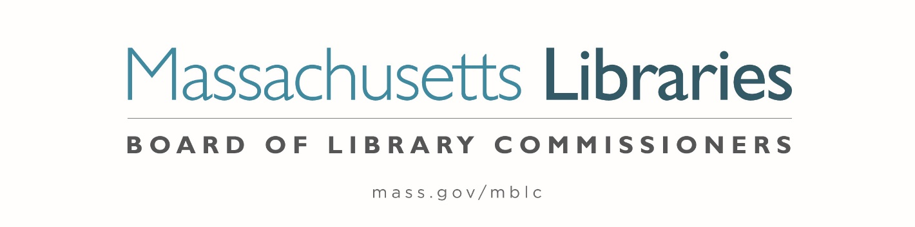

Welcome. Thank you for attending this meeting of the Massachusetts Board of Library Commissioners. Please remember that as part of the meeting agenda there is a time at the end of the meeting for public comment. Should you wish to address the Board during a particular item, please wait to be recognized by the chair.
Note: Agenda may include items not reasonably expected 48 hours before the meeting.
Massachusetts Board of Library Commissioners Monthly Board Meeting
Thursday, June 4, 2026
HYBRID*
Berkshire Athenaeum
I Wendell Avenue, Pittsfield, MA
Meeting to Start: 11:00 AM

*Pursuant to Chapter 2 of the Acts of 2025- An Act Extending Certain COVID-19 Measures Adopted During the State of Emergency, this meeting will be conducted in person and via remote means, in accordance with applicable law. This means that members of the public body as well as members of the public may access this meeting in person, or via virtual means. In person attendance will be at the Berkshire Athenaeum, Pittsfield and it is possible that or all members of the public body may attend remotely, with in-person attendance consisting of members of the public. This meeting may be accessed remotely via:

Join Zoom Meeting
https://us02web.zoom.us/j/89665920115?pwd=lewbFrdyE2f0o7h0b8bogIo9ZJM26s.1
Meeting ID: 896 6592 0115/ Passcode: June
One tap mobile: +16469313860,,89665920115# US

When required by law or allowed by the Chair, persons wishing to provide public comment or otherwise participate in the meeting, may do so by in-person attendance, or by accessing the meeting remotely, as noted above.

- Call to order

- Welcome

Speaker: Alex Reczkowski, Library Director

- Roll Call of Commissioners

Speaker: Commissioner Linehan, Secretary

- Approval of Minutes- April 2, 2026 & May 7, 2026

Speaker: Vicky Biancolo, Chair

- Chair’s Report

Speaker: Vicky Biancolo, Chair

- Commissioner Reports

Speaker: Vicky Biancolo, Chair

- Director’s Report

Speaker: Maureen Amyot, Director

- Legislative Report

Speaker: Maureen Amyot, Director

- Consideration of approval of FY27 grants for the networks – Resource Sharing, Telecommunications, Network Infrastructure and Small Libraries in Networks (ACTION)

Speaker: Kate Butler, Library Information Systems Specialist

- Consideration of the FY27 LEA Grant Round (ACTION)

Speaker: Jaccavrie McNeely, Library Information Specialist

- Monthly Report from Massachusetts Library System (MLS)

Speaker: Sarah Sogigian, Executive Director
Massachusetts Library System

- Monthly Report from the Library for the Commonwealth (LFC)

Speaker: Sarah Jackson, Network Administrator
Library for the Commonwealth/ Boston Public Library (BPL)

- Quarterly Report from the Worcester Talking Book

Speaker: Lee Anne Hooley, Executive Director

- Reports from Library Partners

- Public Comment

- Adjournment Vicky Biancolo, Chair

To review the Massachusetts Board of Library Commissioners current bylaws
(Organizations and Functions of the Board of Library Commissioners)
Visit https://mblc.state.ma.us/about-us/commissioners/index.php

