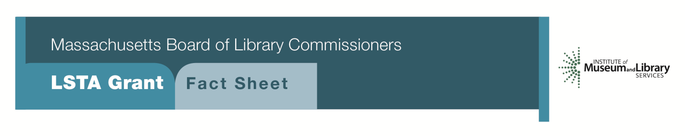
Citizenship Corners and Expanded English Language Services for New Americans

Program Description
This program would provide $7,500 to $15,000 to develop a range of services for New Americans. The Citizenship Corners would be a one-year program and would be funded at no more than $7,500.

Should the library seek to expand existing English for Speakers of Other Languages (ESOL) classes or create a Conversation Circle program, they could apply for the higher range of funds. Libraries applying for this range would need to commit to a two-year time frame.
Components of the project will include the following:
Citizenship Corners - One-Year Grant
- Set up a special area of the library as a Citizenship Corner
- Feature information on immigration and naturalization provided by USCIS
- Partner with community organizations to offer a series of workshops on citizenship and naturalization at least twice during the grant year
- Commit to maintaining citizenship information as part of library services
- Cultural training for staff
- Materials and support of citizenship and English language learning

Expanded English Language Services – Two-Year Grant
- Create or expand a small group instruction program to learn and practice English using trained volunteers supervised by library staff
- Offer classes that focus on vocabulary building through informal conversation and topics of practical interest
- Include a Citizenship Corner as a designated area of the library
- Partners include USCIS and the Office for Refugees and Immigrants
- Cultural training for staff
- Materials and support of citizenship and English language learning
Eligibility
Any public library that meets standard eligibility requirements for Direct Grant programs may apply.
Public Libraries must have identified a need to serve the Newcomer population and have identified the language and learning needs of a diverse population in their long range plans.

Interested?
Applicants must submit a Letter of Intent form with either Citizenship Corners or Expanded English Language Services option checked off. If you need more information about this program, call Shelley Quezada at the MBLC at 1-800-952-7403 ext. 235 or email shelley.quezada@state.ma.us.

Background
According to the U.S. Census, 15.5% of Massachusetts population is foreign-born. Libraries are the natural location to find resources to learn and practice English. Additionally, libraries play a critical role as informal education centers where they offer structured programs to learn about the citizenship and naturalization process in a safe and trusted environment. These programs aid in the acculturation process by increasing knowledge of American culture and customs. They also serve as a forum for community members to meet and interact with others from different cultures.

2018-2022 Massachusetts Long Range Plan Goal & Objective
Goal 1: Promoting Learning
Objective 2: Improve users’ general knowledge and skills

