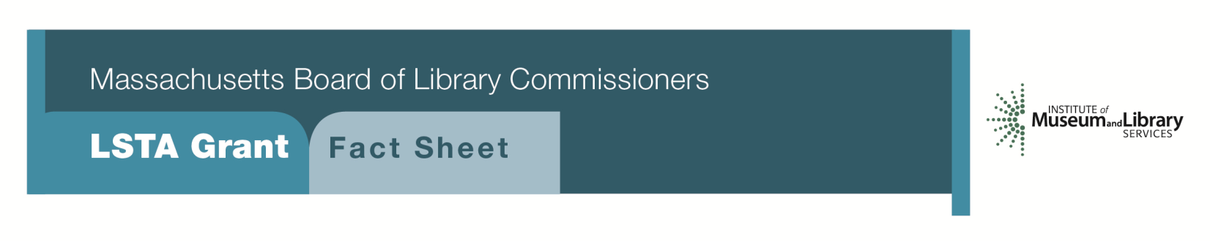
Conserving & Digitizing Historical Resources

PROGRAM DESCRIPTION
This program will provide $5,000 to $30,000 to support the conservation of library and/or archival research materials with significant long-term research value. The conservation and digitization component of this program focuses on those collections/volumes that need hands-on conservation work before they can be digitized. The digitization component of the project must follow all appropriate and applicable standards and best practices. Proof of ownership will be required for any project that involves the direct treatment of materials.
As part of the grant, libraries will be expected to:
- Maintain digital files and make them available to researchers for the foreseeable future both in-house and through the Digital Commonwealth
- Provide a current finding aid for the manuscript and/or archival collection(s) based on current practices recommended by the Society of American Archivists

Eligibility
Any library that meets standard eligibility requirements for Direct Grant programs may apply. Libraries may apply up to three times for different projects under this grant category. To apply for funds, a library must have completed a Preservation Assessment within the past five years and developed a Preservation Long Range Plan based on this assessment.

Interested?
Applicants must submit a Letter of Intent form with the “Conserving & Digitizing Historical Resources” option checked off. If you need more information about this program, contact Gregor Trinkaus-Randall at the MBLC at 1-800-952-7403 ext. 236 or by e-mail at gregor.trinkaus-randall@state.ma.us.
Background
Throughout the Commonwealth, repositories house irreplaceable collections of books, as well as private and public documents that serve as a rich resource for researchers and others involved in local, state, regional, national, and international studies. Many of these collections are in need of conservation work to prolong their lives. Digitizing these unique collections provides access locally and remotely, increasing opportunities for use and discovery.
2018-2022 Massachusetts Long Range Plan Goal & Objective
Goal 2: Enabling Access
Objective 2: Improve users’ ability to obtain and/or use information resources

