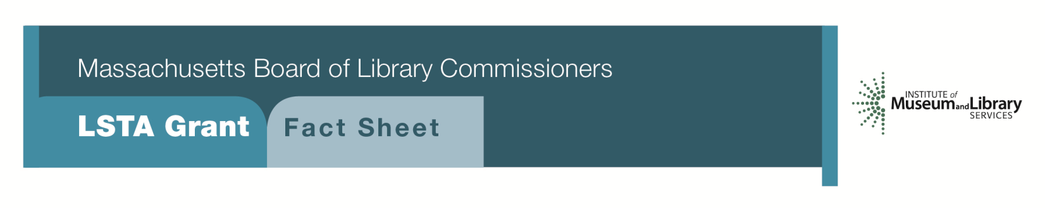
Customer Experience in the Digital Age

PROGRAM DESCRIPTION
Grants of up to $10,000 will be awarded to public libraries to develop a two-pronged approach to customer service, focusing on traditional elements while embracing emerging technologies. Libraries must conduct pre-and post-surveys of the community as a part of this project.

As part of the grant, libraries will be expected to:
- provide for all staff training in the use of emerging technologies and digital media such as downloadable content, social media, and online resources
- incorporate best practices in technology planning, assessment, and evaluation of current policies related to customer service
- provide basic customer service training for all staff, using in person and online trainings
- use funds for public relations and/or consultant services to redesign or improve the library’s online presence including website, online services, and social media
- consider purchasing digital materials, such as eBooks and apps for library-owned devices, e.g. iPads, Kindles
- partner with appropriate local high schools, colleges, or other institutions that can provide technical advice and assistance as applicable

Project budgets should reflect roughly equal amounts for staff training, consultant services, and technology development.

ELIGIBILITY
Open to all public libraries that have not received a customer service LSTA grant in the past 3 years.

INTERESTED?
Applicants must submit a Letter of Intent form with the “Customer Experience in the Digital Age” option checked off. If you need more information about this program, call Lyndsay Forbes at the MBLC at 1-800-952-7403 ext. 252 or email Lyndsay.forbes@state.ma.us
Background
As economic and digital divides continue to grow, libraries are increasingly called on to play a role in narrowing those divides; this is especially true when it comes to providing not only access to technology, but also training in the use of various technologies. Library users expect library staff to have knowledge and skills in all areas of technology, and they expect quality customer service from well-trained staff.

2018-2022 Massachusetts Long Range Plan Goal & Objective
Goal 3: Strengthening Libraries
Objective 1: Provide training and professional development to enhance the skills of the library workforce and leadership

