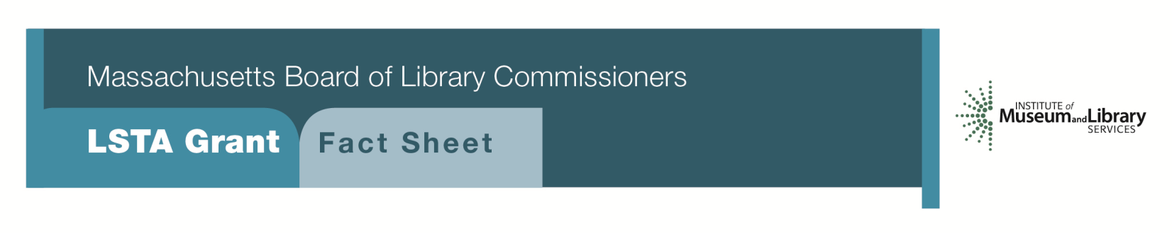
Financial Literacy for All Ages

Program Description
Grants of up to $7,500 will be awarded to libraries to strengthen their role as a resource for improving financial literacy in their community or organization. Libraries will design and implement a one-year grant project guided by Financial Literacy Education for Libraries: Guidelines and Best Practices for Service (ALA’s Business and Reference Services Section of the Reference and User Services Association, http://www.ala.org/rusa/sites/ala.org.rusa/files/content/FLEGuidelines_Final_September_2014.pdf).
As part of the grant, libraries will be expected to:
- Enhance or develop current multimedia consumer financial literacy collection
- Provide staff training on financial information resources
- Plan and hold workshops and programming to meet the needs of the project audience
- Create or update library web pages relevant to the grant theme that highlight financial education resources and programming
- Provide opportunities for the project audience to learn skills that enable them to make informed choices regarding their financial planning and needs
- Collaborate with appropriate municipal government departments, local community organizations, educational institutions, and businesses. Libraries are also encouraged to form an advisory group with these organizations as well as a member of the project audience as appropriate to help the library carry out the grant
- School and academic libraries must coordinate with faculty and staff to embed literacy skills into the school’s curriculum and services. School libraries are required to collaborate with the public library
Eligibility
Open to all public, school, and academic libraries that meet standard eligibility requirements for Direct Grant Programs.

INTERESTED?
Applicants must submit a Letter of Intent form with the “Financial Literacy for All Ages” option checked off. For additional information about this program, please contact Lyndsay Forbes at the MBLC at 1-800-952-7403 ext. 252 or email lyndsay.forbes@state.ma.us.

BACKGRound
According to the President’s Advisory Council on Financial Capability, the financial crisis of 2008 demonstrated a widespread and costly lack of understanding of basic financial management information and skills in the United States. They pointed to the need for financial literacy education to begin as early as high school, and to be the responsibility of families, schools, and the local community. Libraries can play a key role in providing programs and resources that help people improve their understanding of financial matters and help parents and teachers model and teach good personal finances.

2018 -2022 MASSACHUSETTS LONG RANGE PLAN GOAL & OBJECTIVE
Goal 5: Developing Skills
Objective 1: Improve users’ ability to understand and apply information that furthers personal and family competencies in universal areas such as health, finances, and other life skills

