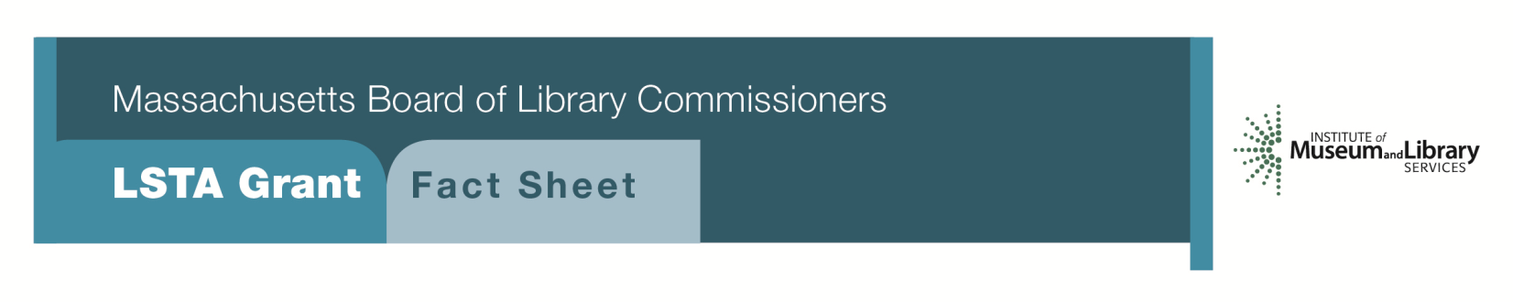
A Framework for Health Literacy

Program Description
Grants of up to $7,500 will be awarded to libraries to strengthen their role as a resource for improving the health literacy in their community or organization. Libraries will agree to design and implement a one-year grant project.
As part of the grant, libraries will be expected to:
- Enhance or develop current multimedia consumer health collection
- Provide staff training on health information resources
- Create or update library web pages relevant to the grant theme that highlight health resources and programming
- Plan and hold workshops and programming to meet the needs of the project audience
- Provide opportunities for the project audience to learn skills that enable them to make informed choices regarding their health decisions
- Collaborate with appropriate municipal government departments, local community organizations, educational institutions, and businesses. Libraries are also encouraged to form an advisory group with these organizations, as well as a member of the project audience as appropriate, to help the library carry out the grant
- School and academic libraries must coordinate with faculty and staff to embed health literacy skills into the school’s curriculum and services. The school libraries are required to collaborate with the public library
Eligibility
Open to all public, school, and academic libraries that meet standard eligibility requirements for Direct Grant Programs.
Interested?
Applicants must submit a Letter of Intent form with the “Framework for Health Literacy” option checked off. For additional information about this program, please contact Lyndsay Forbes at the MBLC at 1-800-952-7403 ext. 252 or email lyndsay.forbes@state.ma.us.

Background
The Centers for Disease Control and Prevention states that “Nine out of ten adults struggle to understand and use health information when it is unfamiliar, complex or jargon-filled,” and that “limited health literacy costs the healthcare system money and results in higher than necessary morbidity and mortality.” The Centers for Disease Control and Prevention also notes that health literacy is critical not only for people who need health information and services, but also for people and organizations that provide health information and services to others. In addition to libraries providing resources and programs to help their community members build health literacy skills, it is imperative that libraries provide their own staffs with at least minimal health literacy training (i.e. build organizational health literacy) in order to better help patrons navigate complex and confusing health information.

2018-2022 MASSACHUSETTS LONG RANGE PLAN GOAL & OBJECTIVE
Goal 5: Developing Skills
Objective 1: Improve users’ ability to understand and apply information that furthers personal and family competencies in universal areas such as health, finances, and other life skills

