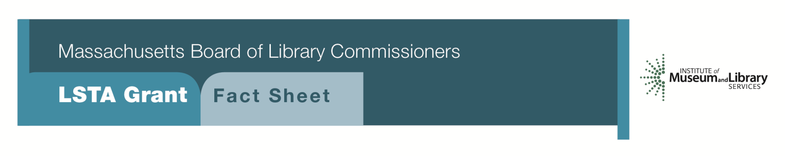
Innovative “Open” Grant Program

Program Description
This category provides the opportunity to satisfy the needs of library customers that are not being met by current programs. It is a priority of the federal program to encourage innovation and risk-taking. The Innovative Program will allow applicants to apply new methods to solve problems, build programs, and best carry out their library’s mission and plan. These projects must meet the needs of a specific target audience. It is important that applicants speak with a consultant about their project ideas for feedback and guidance prior to submitting an application.
The Innovative LSTA grant program allows applicants as much flexibility in the development of their projects as possible. Applicants can seek grant funds for projects that otherwise do not fall under the current LSTA program offerings. The Innovative Program encourages creative program development and rewards those librarians willing to engage in a higher level of effort and to take those risks.
The “Open” grant program also allows applicants to develop a grant proposal for “great grants from the past” — grants such as “Reader’s Advisory”, “Community Languages”, or “Mother Goose on the Loose” — grants that aren’t specifically offered in the current round that libraries would like to pursue.

Eligibility
Any library or cooperating group that meets standard eligibility requirements for Direct Grant programs may apply. A cooperating group may apply on behalf of one or more of its members, however, as well as the entire group.

Budget/Funding
Projects may be funded for one or two years. It is anticipated that funding requests will be in a range of $5,000 to $15,000 total. Applicants are reminded that a significant program component is required for any project to assure that the target population will be directly served. Measurable, outcome-based goals and objectives are important for a project’s approval. Requests that are largely for materials, equipment, or staff will not be considered. As a general guide, none of these budget elements should exceed 30% of the total amount requested. A significant local in-kind contribution is expected. Requests for library automation systems or for retrospective conversion cannot be accepted under this program.
Interested?
Applicants must submit a Letter of Intent form with the “Innovative” option checked off. Applicants must include a project abstract (150-200 words), including goals and activities of the project with the letter of intent to help us put you in touch with the appropriate consultant.

Where to Begin?
Contact us at 1-800-952-7403:
- Gregor Trinkaus-Randall, Preservation Specialist, ext. 236
gregor.trinkaus-randall@state.ma.us

- Shelley Quezada, Underserved Populations Specialist, ext. 235
shelley.quezada@state.ma.us

- Lyndsay Forbes, Project Manager &Grant Specialist, ext. 252
Lyndsay.forbes@state.ma.us

2018-2022 Massachusetts Long Range Plan Goal & Objective
The project must address a goal of the Massachusetts Long Range Plan 2018-2022

