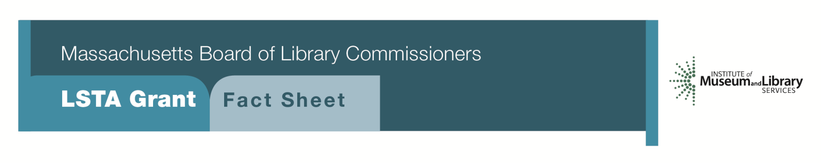
Mind in the Making:
Engaging Young Children in Interactive Learning and Doing

Program Description
This program allows public libraries to apply for a one-year grant ranging from $7,500 to $10,000 to carry out a program to establish or enhance play spaces for children ages 0-6 in public libraries. These play spaces are aimed at early learning and social interaction among children and their caregivers.

Suggested components include:
- Creating an interactive play and flexible learning space
- Designating a space for tinkering and invention
- Offering activities such as a Countdown to Kindergarten program, family programs on “Brain Building in Progress” or creation of Creativity Kits to be borrowed by parents and caregivers and used in local preschools
- Purchasing materials supporting emergent reading, writing, and fine motor skills
- Developing collections of print, digital materials, and realia

Eligibility
Any public library that meets standard eligibility requirements for Direct Grant programs and has identified a need to serve young children in their long range plans may apply.

Interested?
Applicants must submit a Letter of Intent form with the “Mind in the Making” option checked off. If you need more information about this program, call Shelley Quezada at the MBLC at 1-800-952-7403 ext. 235 or email shelley.quezada@state.ma.us

BACKGROUND
Ellen Galinsky’s book Mind in the Making highlights the seven essential life skills children need most: focus and self-control, perspective taking, communicating, making connections, critical thinking, taking on challenges, and self-directed, engaged learning. In their report Growing Young Minds, IMLS highlights how libraries can support these types of skills through hands-on experiences. By providing play and inquiry-based programs, libraries increase the opportunities for young children to participate in activities that will help develop critical skills and result in their becoming more confident and engaged learners.

2018-2022 MASSACHUSETTS LONG RANGE PLAN GOAL & OBJECTIVE
Goal 1: Promoting Learning
Objective 1: Improve users’ general knowledge and skills

