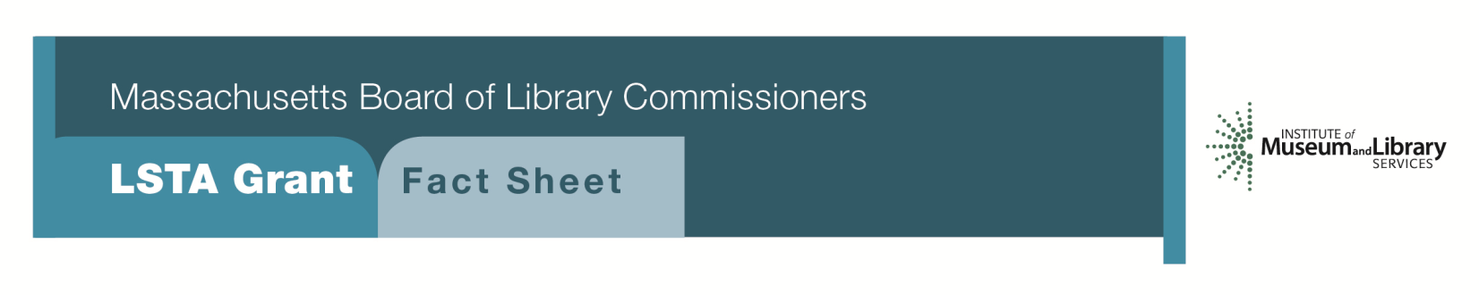
Preservation Assessment

Program Description
This program provides a grant award of $4,200 for an institutional preservation assessment. The institution will contract with a preservation consultant to provide a report that will:
- Focus attention on preservation concerns and will identify the types of work that this might entail, including actual treatment as well as storage, handling, and security suggestions
- Help the library staff determine the treatment priorities of those items in need of work and the steps necessary to accomplish it
- Examine the library building and make suggestions as to steps to be taken to prolong the life of the materials, including environmental conditions and controls
- Review policies and procedures for collection management

Once the assessment has been completed, it will be up to the library to pursue the recommendations of the consultant. LSTA funds may be available through another grant category to address these recommendations.

As part of the grant, libraries will be expected to:
- Produce a five-year Preservation Long-Range Plan, based on the recommendations of the consultant. This plan, a copy of the assessment report, and an update to the library’s Critical Collections Questionnaire should be filed with the MBLC at the completion of the project.
Eligibility
Any library that meets standard eligibility requirements for Direct Grant programs may apply. Libraries must have completed a “Critical Collections Questionnaire” as it relates to the library’s “special collections” and have it on file at the MBLC by the time of the application due date.
INTERESTED?
Applicants must submit a Letter of Intent form with the "Preservation Assessment” option checked off. If you need more information about this program, please call Gregor Trinkaus-Randall at the MBLC at 1-800-952-7403 ext. 236 or e-mail gregor.trinkaus-randall@state.ma.us.

Background
Libraries often realize that there are preservation problems with their collections, but they may have little idea about where to start or what their options might be. Working with a qualified preservation assessor can help libraries understand the full scope of their collection and its condition as well as formulate a plan that prioritizes preservations needs. Such planning can help a library commit to protecting the most critical and unique items of a collection for future use.
2018-2022 Massachusetts Long-Range Plan Goal & Objective
Goal 2: Enabling Access
Objective 2: Improve users’ ability to obtain and/or use information resources

