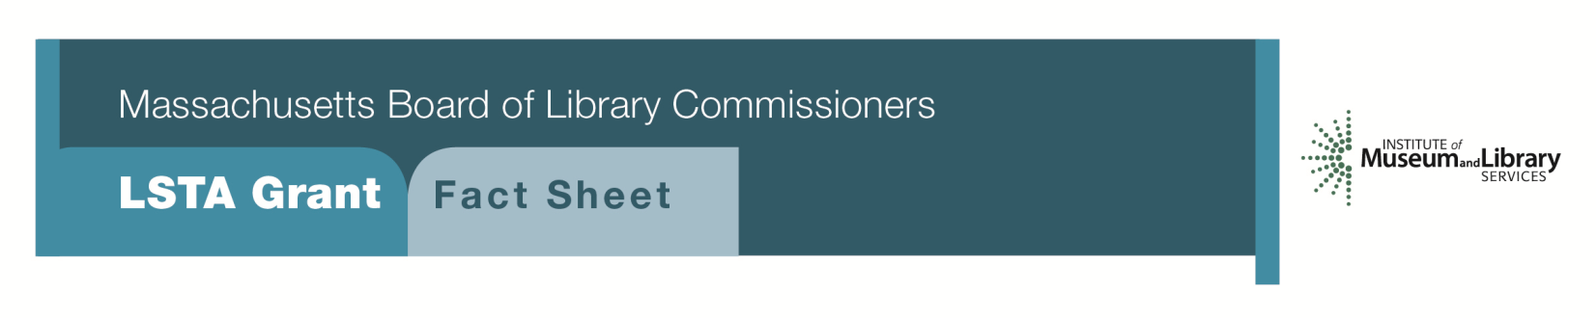
Serving ‘Tweens and Teens

PROGRAM DESCRIPTION
This program will allow public libraries to apply for grants ranging from $10,000 to $15,000 over a two year period to carry out a targeted program aimed at middle and high school-aged “tweens” and “teens.” Libraries must conduct a preliminary needs assessment including surveys or focus groups with teens as well as interviews with community leaders, parents, and teachers.
As part of the grant, libraries will be expected to:

- Utilize the Massachusetts Library Association’s “Standards for Public Library Service to Young Adults” and YALSA’s National Guidelines, including their “Teen Space Guidelines”, along with their library’s long range or strategic plan for direction in planning their project and proposal
- Form or strengthen a Teen Advisory Board (TAB)
- With input from the TAB, develop creative programming strategies which will reach out and meet the needs of ‘tweens and teens
- Develop collections of materials including books, audiobooks, CDs, magazines, games, graphic novels, DVDs, and digital content. Collections should be aligned, in part, with material needed by the middle and high school students as part of Massachusetts state standards and curriculum
- Examine the library’s “teen space.” It should meet or move towards meeting the goals set by the teen board. This may include limited redesign
- Collaboration with middle/high school librarians, school personnel and local youth organizations such as Boys & Girls clubs, YMCA/YWCA, scouts, sports facilities, religious organizations or community centers

Eligibility
Any public library that meets standard eligibility requirements for Direct Grant programs and has identified a need to serve middle and high school students in their long range plans may apply.
Interested?
Applicants must submit a Letter of Intent form with the “Serving ‘Tweens and Teens” option checked off. If you need more information about this program, please call Lyndsay Forbes at the MBLC at 1-800-952-7403 ext. 252 or email lyndsay.forbes@state.ma.us.

BACKGROUND
According to the PEW Internet report, “Parents, Children, Libraries & Reading”, 94% of parents say libraries are important for their children, 81% say a major reason libraries are important is that libraries provide their children with information and resources not available at home and almost every parent (97%) says it is important for libraries to offer programs and classes for children and teens. The need for programs, services, and space for tweens and teens in libraries is apparent, but this audience can be hard to reach with reduced budgets and a lack of trained staff.

2018-2022 Massachusetts Long Range Plan Goal & Objective
Goal 1: Promoting Learning
Objective 1: Improve users’ general knowledge and skills

