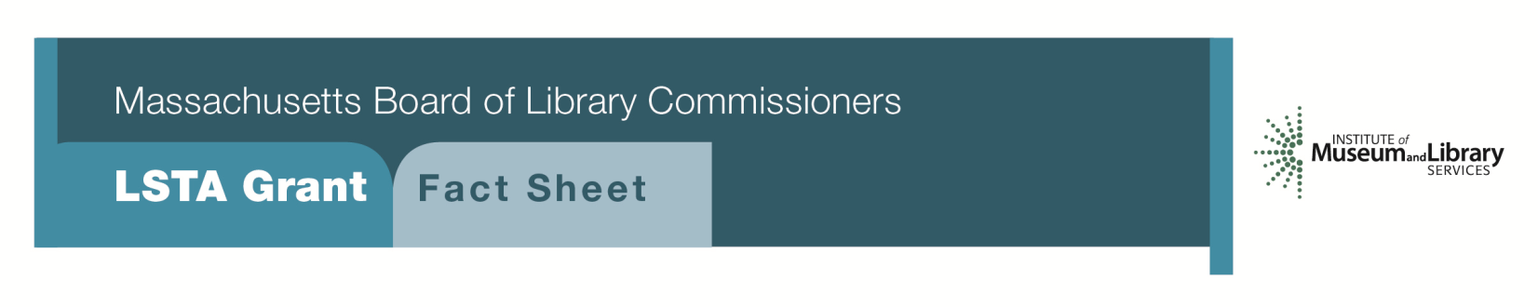
Access for All

Program Description
Libraries will be eligible to apply for grants ranging from $7,500-$20,000 to plan and implement a project to improve accessibility to library services based on the specific needs identified by the library. The MBLC will make available information on how to conduct a library scan and community assessment of unmet needs. These grants will be funded on a two-year implementation schedule.
Components of the project will include the following:
- Libraries must conduct a library and community scan of possible and potential services for their user population as part of the needs assessment and prior to submitting the application.
- If appropriate, utilize the document Planning for Library Accessibility: A guide for meeting the needs of patrons who are blind or visually impaired
- Based on results of the scan, a library will determine whether it will broadly implement services to a range of people with disabilities or, as a result of the scan they may choose to focus on service to a specific population in need, i.e. people who are visually impaired, people who are Deaf or Hard of Hearing.
- Libraries will provide equipment, materials, and services that allow people to utilize the library more effectively.
- Identify key staff who will work to develop public relations strategies that attract people with disabilities to the library. They will outline how they will work in partnership with community agencies serving people in this population and reach out to other local libraries.
- Libraries will provide training for all staff in the use of adaptive equipment and how best to serve patrons with a variety of special needs.
- Grants may be used for training, assistive technology, equipment, and staffing but are not intended for renovation of facilities, e.g. automatic doors, ramps, etc.

Eligibility
All types of libraries may apply for this grant.

Interested?
Applicants must submit a Letter of Intent form with the “Access for All” option checked off. If you need more information about this program, call Shelley Quezada at the MBLC 1 800-952-7403 ext. 235 or email shelley.quezada@state.ma.us.

Background
Under the Library Services and Technology Act Massachusetts Five Year Plan (2018-2022), the MBLC identified issues for libraries seeking to provide service for people who face special challenges using libraries. Many residents of Massachusetts cannot fully utilize libraries for a variety of reasons including disabling conditions such as visual, hearing, and mobility impairments. Moreover, many libraries lack adaptive equipment, current library collections may be inadequate; and the staff may lack the appropriate training to serve a more diverse group of library users. The MBLC encourages all types of libraries to consider their role as an information access point for all, including those members of the community who are traditionally under-represented among library users.

To aid libraries in developing services for people with disabilities, the library should begin by conducting a scan of services (using a document provided by MBLC) to help better assess user needs within their communities. MBLC staff will work with libraries to identify the appropriate steps to integrate new accessible services into the library's existing long-range plan.

2018-2022 Massachusetts Long Range Plan Goal & Objective
Goal 2: Enabling Access

Objective 2 : Improve users’ ability to obtain and/or use information resources

*Library and Community Scan Document available from MBLC
** Planning for Library Accessibility: A guide for meeting the needs of patrons who are blind or visually impaired will be available from the Braille and Talking Book Library at Perkins School for the Blind

