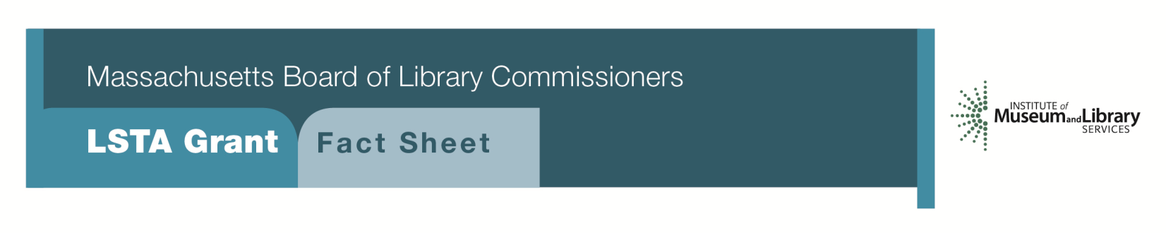
CIVIC HUB: Extending Conversations on Civic Engagement

Program Description
Libraries can strengthen their role as a source for dependable print and media resources while serving as trusted spaces to start and continue community conversations. By serving as public forum and civic engagement ‘incubators’, libraries can support informed, issue-oriented public programs and structured opportunities for discussion.
Promoting civic literacy requires active engagement around issues specific to each community. For example, concerns about the exploding opioid crisis or local conflicts about land conservation might serve as a touchstone for organized dialogue. Paramount to the vision of an informed community is the democratic values of openness, inclusion, participation, empowerment, and the common pursuit of truth and the public interest. Libraries should demonstrate partnership with local municipal and state organizations, institutions of higher education and interested civic organizations such as The League of Women Voters.
Successful projects might include but are not limited to a range of activities. For example, the Hayward Library (CA) Book-to-Action series pairs author/expert talks with community-wide book discussions and community action events. The Hartford (CT) Public Library created the Center for Civic Engagement to promote community dialogues that have reached hundreds of people around issues such as voter engagement, workforce development and other social issues. The Skokie Public Library’s Civic Lab is a pop-up library featuring themed collections and information on a range of topics designed to support dialogue on issues affecting the community. A number of libraries across the country serve as partners with municipal government to offer Citizen Academies that educate citizens through interactive sessions, optional tours of facilities and present a comprehensive look at how and why government and local programs and services are provided. Finally, for a number of years, libraries have offered sessions using material from the National Issues Forum (NIF), a nonpartisan program of public-issue discussions designed to enable citizens to have a more effective voice in American politics.

ELIGIBILITY
Public, academic and school libraries that meet standard eligibility requirements for Direct Grant programs may apply for the Civic Hub grant. Funds will be available for grants are up to $7,500. A significant program component is required for this project but may also include requests for materials and equipment to carry out project objectives. Limited funds may be used for staff as needed and some funding may be used to train staff in facilitation techniques.
Interested?
Applicants must submit a Letter of Intent form with the “CIVIC HUB” ” option checked off. If you need more information about this program, call Shelley Quezada at the MBLC 1-800-952-7403 ext. 235 or email shelley.quezada@state.ma.us.

BACKGROUND
A recent report of The Knight Commission, Informing Communities: Sustaining Democracy in the Digital Age proposed new thinking and aggressive action to improve the vitality of our democracy. By making information opportunities available to all, it observes that libraries have a key role in supporting “informed communities” that meet peoples’ personal and civic information needs. Promoting healthy civic communities begins by ensuring access for all, along with education and training, public engagement and government transparency. The report of the Commission further states, “Information is as vital to the healthy functioning of communities as clean air, safe streets, good schools and public health”. The fundamental objectives of this vision suggest:
- Maximizing the availability of relevant and credible information in communities
- Strengthening the capacity of individuals to engage with information
- Promoting individual engagement with the information and the life of the community

The need to impart skills to participate in a strong democracy provides an ideal opportunity for libraries in academic, school and public settings, not only to inform but to engage and educate community members in a safe and neutral environment.

2018-2022 Massachusetts Long Range Plan GOAL AND OBJECTIVE
GOAL 6 Connecting Communities

Project 2: Civic HUB

