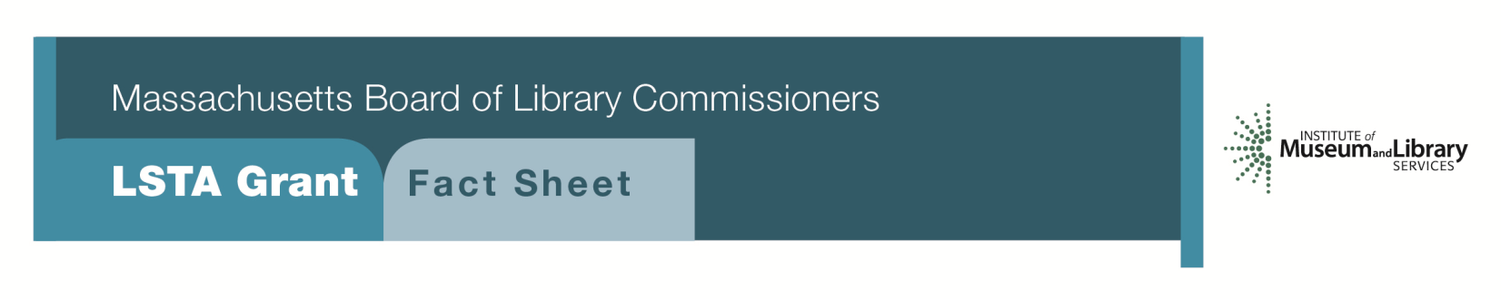
IdeaLab: Rethinking library spaces to create and inspire

PrOgram Description
Makerspaces are everywhere. They may be a specially designed area serving as a digital media lab, or a standalone cart in the library’s teen section or community room. As a unique place to design and create, the IdeaLab serves as a discrete learning space to use new tools and material not available at home. It can be a place to produce videos, learn about electronics or simply try out new skills.
IdeaLab activities may be STEM based or focus on art/creativity/media creation. Libraries can provide access and instruction in the use of simple hand tools, machines, new software and other equipment for crafting, sewing and art. Many tools require access to electrical power and Internet connectivity. Even small libraries can offer training on audio and video production equipment and 3D printers. ALA’s Make it at your library website has a wealth of ideas to get started http://makeitatyourlibrary.org/
Successful project designs should identify an individual to manage the IdeaLab who is comfortable with the equipment and materials being showcased. This person will teach IdeaLab users about materials and equipment as well as train selected staff members to continue to offer services. Selected finished projects could be displayed in the library and used to promote opportunities for hands-on learning throughout the grant period and beyond.
As appropriate, the library may collaborate with offerings from local vocational/technical High Schools, art schools, museums or other organizations supporting industry and the arts. The library should also seek out community agencies, organizations and businesses that may serve as partners to share skills useful to those working in the IdeaLab. The target audience may be adults, children or both.
This project will support the development of “third space” services, and extend high-demand maker and technology programming to children or individuals who would not likely have access to tools and materials for DYI and other creative projects.
ELIGIBILITY
School, public, and academic libraries that meet standard eligibility requirements for direct grant programs are encouraged to apply. Funding ranges from $7,500- $15,000 depending on project requirements and program design and two-year proposals will be considered.

BACKGROUND
According to a recent IMLS report Learning Labs in Libraries and Museums, across the country and around the world, libraries are placing themselves at the center of innovative research and practice about how to create and share knowledge, powered by a combination of digital media and traditional tools. Since 2011, IMLS has invested over $10 million in learning through making in museums and libraries that underscores growing recognition of the importance of the maker movement to a competitive workforce and an engaged citizenry.
Community-based technology centers in libraries provide access for people of all ages to pursue their interests, gain expertise, share municipal information and have meaningful experiences. Learning spaces in libraries present a trusted place for people to gain new skills in a rapidly changing world, to follow their passions and inspire one another. These programs embody the sound principles of Connected Learning—learning that is interest-driven, socially relevant, and aimed at expanding educational or economic opportunities. Local school, public and academic library users can flourish in an atmosphere supported by mentors trained in new digital media, traditional tools and techniques.
Interested?
Applicants must submit a Letter of Intent form with “Idealab: Rethinking library spaces to create and inspire” option checked off. If you need more information about this program, call Shelley Quezada at the MBLC at 1-800-952-7403 ext. 235 or email shelley.quezada@state.ma.us.

2018-2022 Massachusetts Long Range Plan Goal & Objective
GOAL 1: Promoting LEARNING
Objective 1: Improve Users’ General Knowledge and Skills

