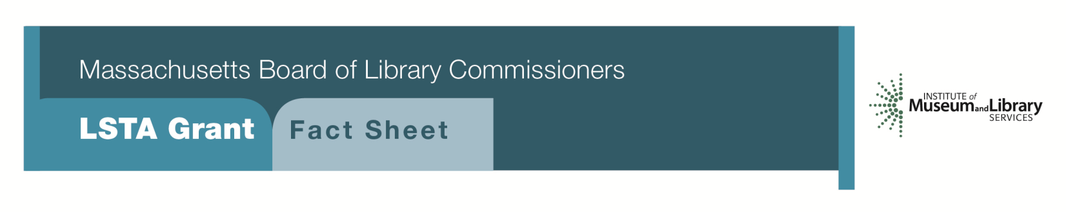
Manuscripts Arrangement and Description

PROJECT DESCRIPTION
This program will provide $5,000 to $10,000 for the arrangement and description of archival materials according to currently accepted national standards, assistance with collection development and other appropriate policies, training for staff in basic archival theory and practice, and preparation of finding aids at the collection level for increased access. These steps and training for this project will be done by contracting with an archival consultant who has been approved by the MBLC.
Each applicant will be required to:
- provide information as to the quantity, overall condition, and general subject matter of the manuscripts in their library
- show how these relate to local, regional, state, or national issues
- provide a description of the current state of their arrangement and description and storage, including the environment and security
- provide a description of any archival training that staff have received

ELIGIBILITY
Any library or cooperating group that meets standard eligibility requirements for Direct Grant programs may apply. A cooperating group may apply on behalf of one or more of its members. To be eligible to apply for funds this program, a library or cooperating group must have completed a Preservation Assessment within the past five years and developed a Preservation Long-Range Plan based on this Assessment.

INTERESTED?
Applicants must submit a Letter of Intent form with the “Manuscript Arrangement and Description” option checked off. If you need more information about this program, contact Gregor Trinkaus-Randall at the MBLC at 1-800-952-7403 ext. 236 or by e-mail at gregor.trinkaus-randall@state.ma.us.

BACKGROUND
Much of the archival material housed in libraries remains unorganized and inaccessible due to the lack of staff with archival training. Additionally, many libraries do not have collection development policies that would help in defining the scope and subject areas of the institution’s archival holdings. Working with an archival consultant, libraries can address these deficiencies and take steps to increase the knowledge of and access to their unique collections.

2018-2022 Massachusetts Long Range Plan Goal & Objective
Goal 2: Enabling Access
Objective 2: Improve users’ ability to obtain and/or use information resources

